

**实 验 报 告**

|  |  |
| --- | --- |
| **课程名称：** | **政企大数据系统** |
| **学生姓名：** | **刘博严** |
| **学生学号：** | **202030390308** |
| **学生专业：** | **电子商务** |
| **开课学期：** | **2022-2023-2** |

**电子商务系**

**2023年5月**

**目 录**

实验一 熟悉常用的Linux和Hadoop操作 1

实验二 熟悉常用的HDFS操作 11

实验三 熟悉常用的”HBase”操作 44

实验四 NoSQL和关系数据库的操作比较 64

实验五 MapReduce初级编程实践 86

实验六 熟悉Hive的基本操作 93

实验七 Spark初级编程实践 103

**实验八 Flink初级编程实践……………………………………………109**

# 实验一 **熟悉常用的Linux和Hadoop操作**

|  |  |  |  |  |
| --- | --- | --- | --- | --- |
| **地 点：** | B10楼 | 303房； | **实验台号：** |  |
| **实验日期与时间：** | 2023/3/16 | | **评 分：** |  |
| **预习检查纪录：** |  | | **实验教师：** | 焦青松 |

1. **实验目的**

**Hadoop运行在Linux系统上，因此，需要学习实践一些常用的Linux命令。本实验旨在熟悉常用的Linux操作和Hadoop操作，为顺利开展后续其他实验奠定基础。**

1. **实验平台**

(1).操作系统：Linux

(2).Hadoop版本：3.3.5

1. **实验步骤（包括实验结果/截图）**

**1.熟悉Linux操作**

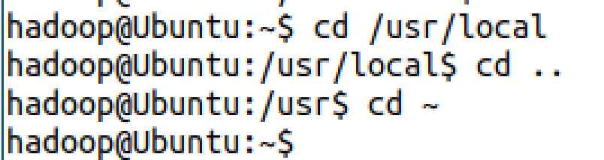

**Ls命令**

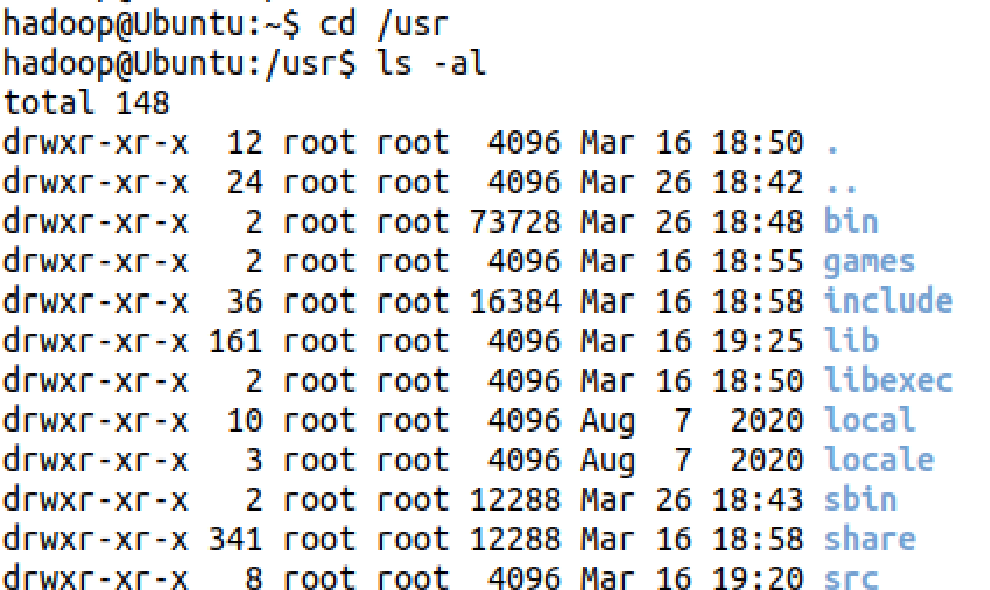

**mkdir**

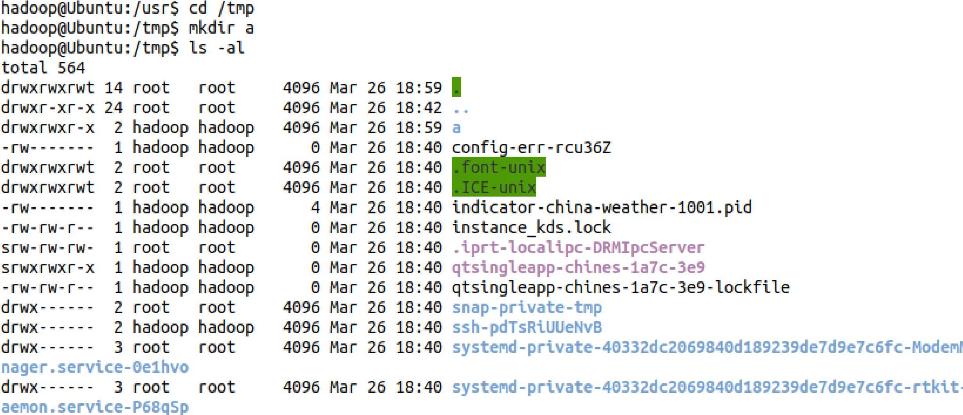

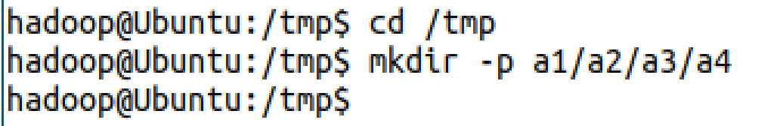

**rmdir**

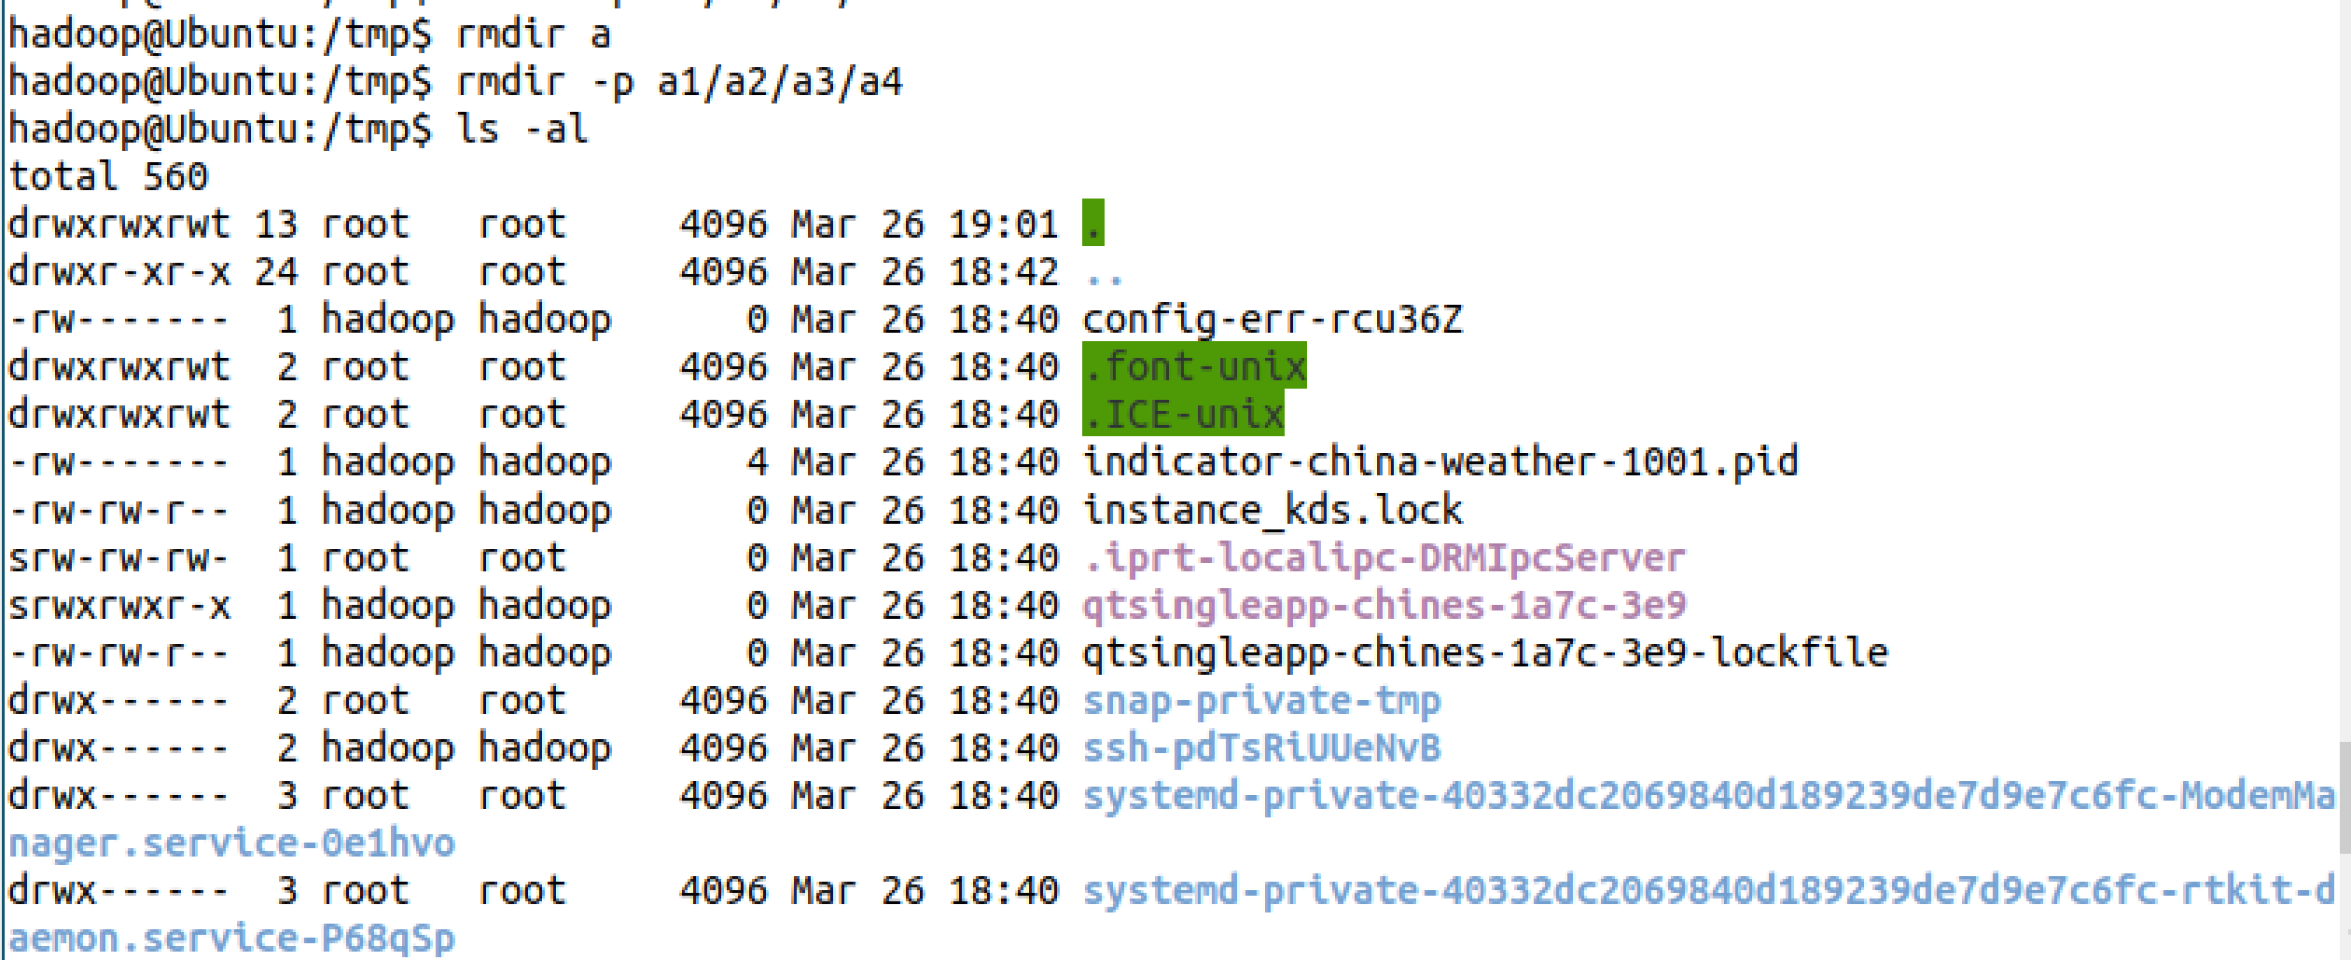

**cp命令**

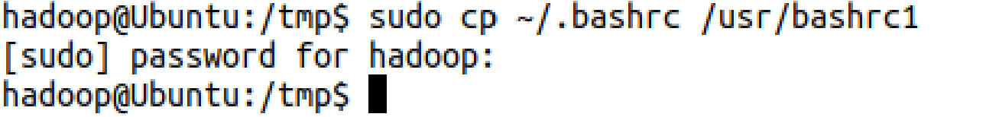

**mv**

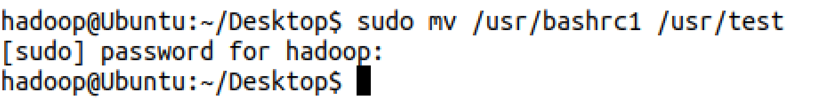



**rm**





**cat**

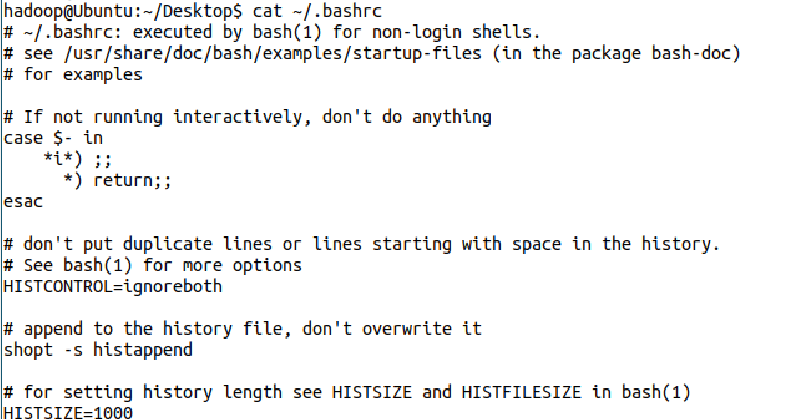

**tac**

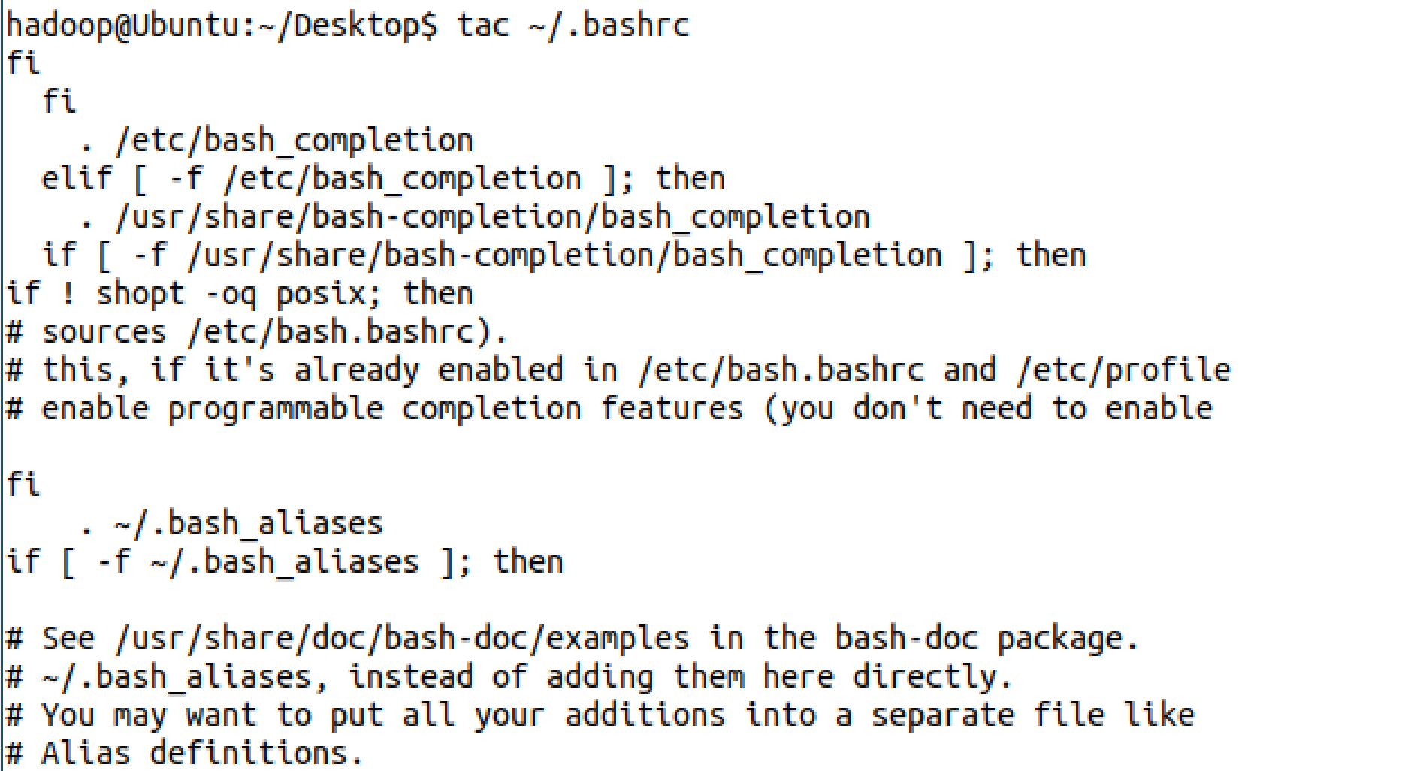

**more**

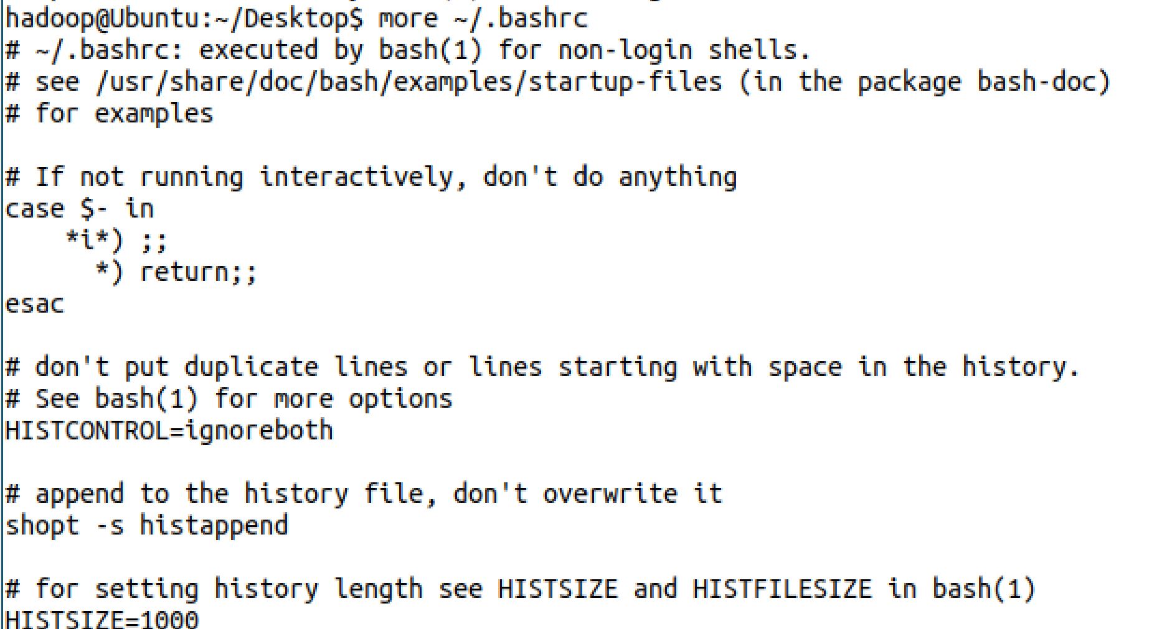

**head**

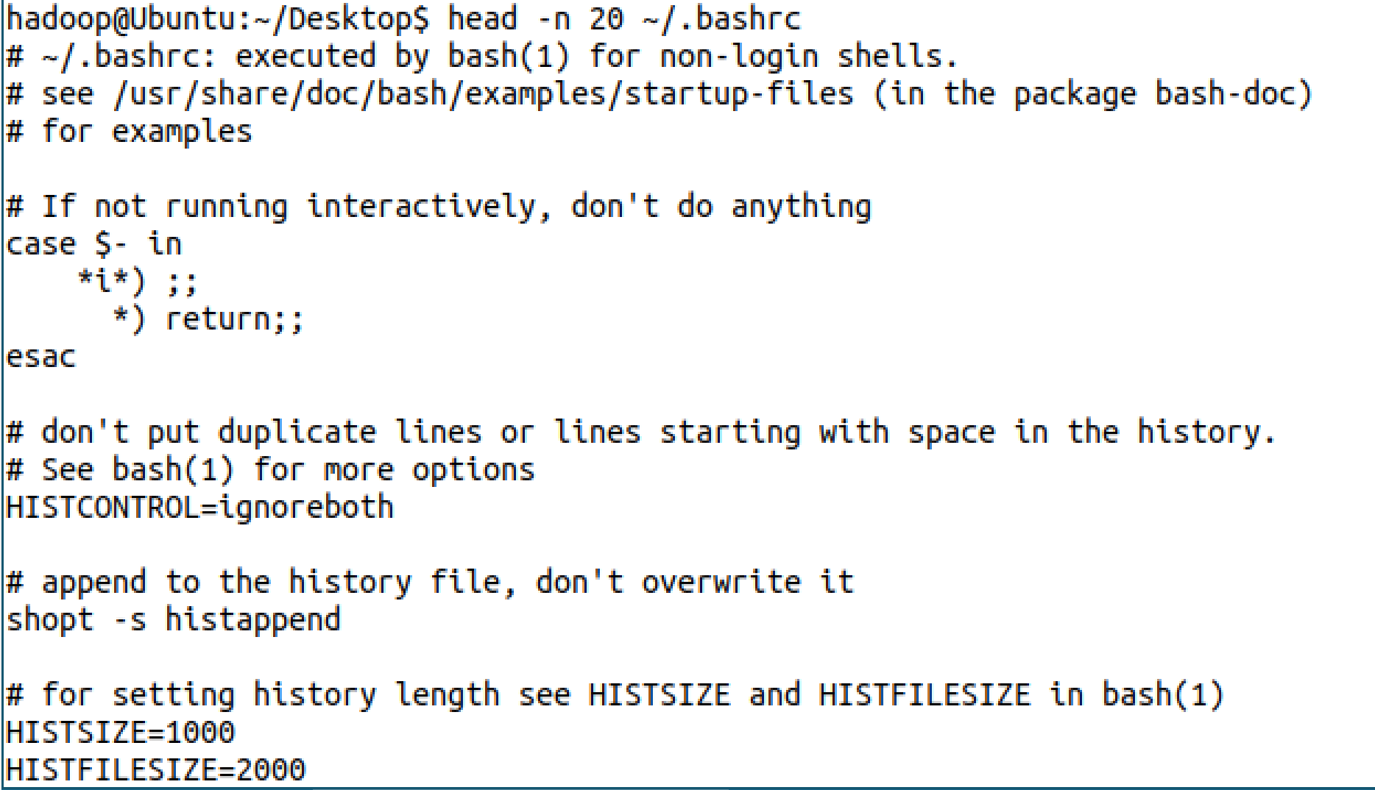

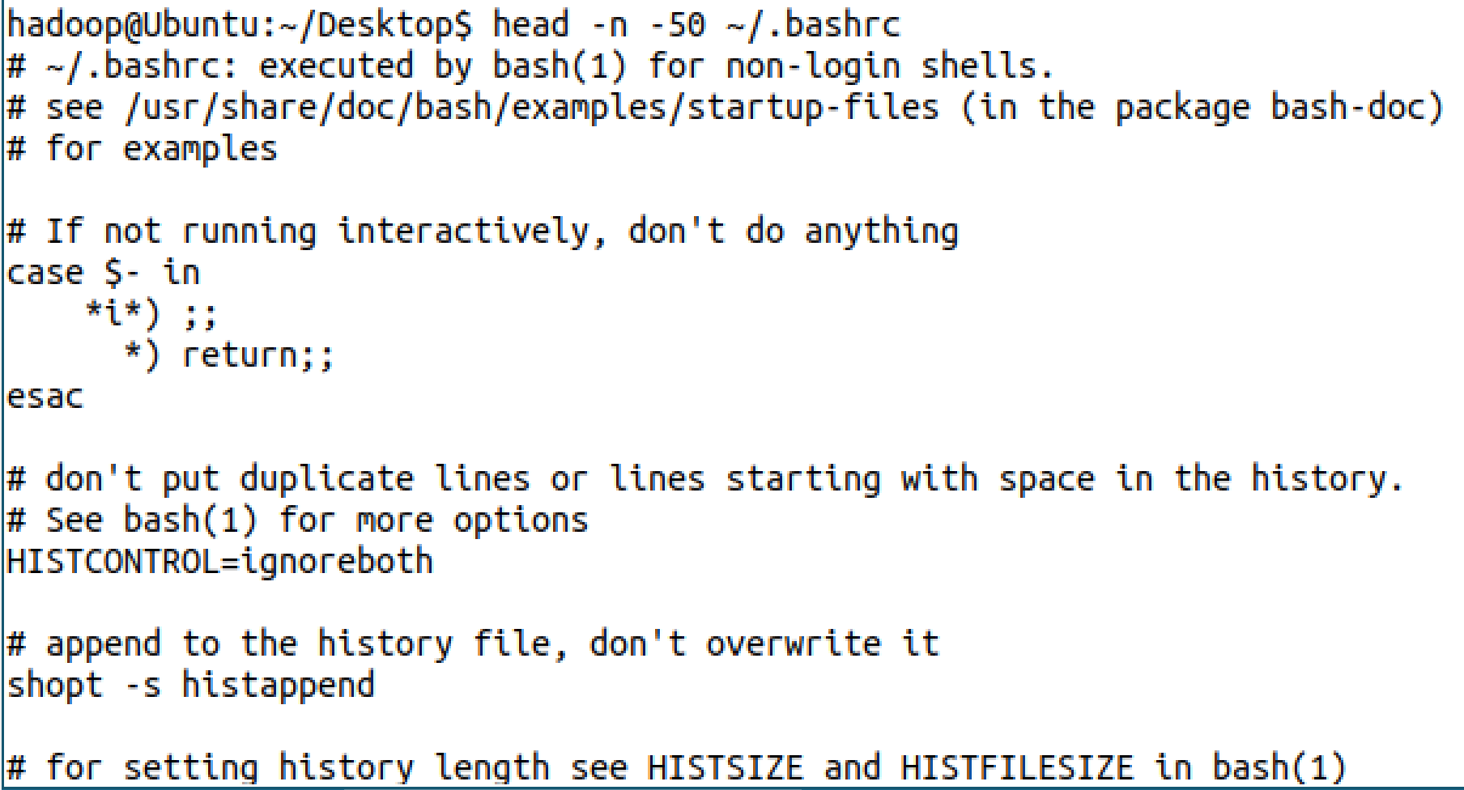

**tail**

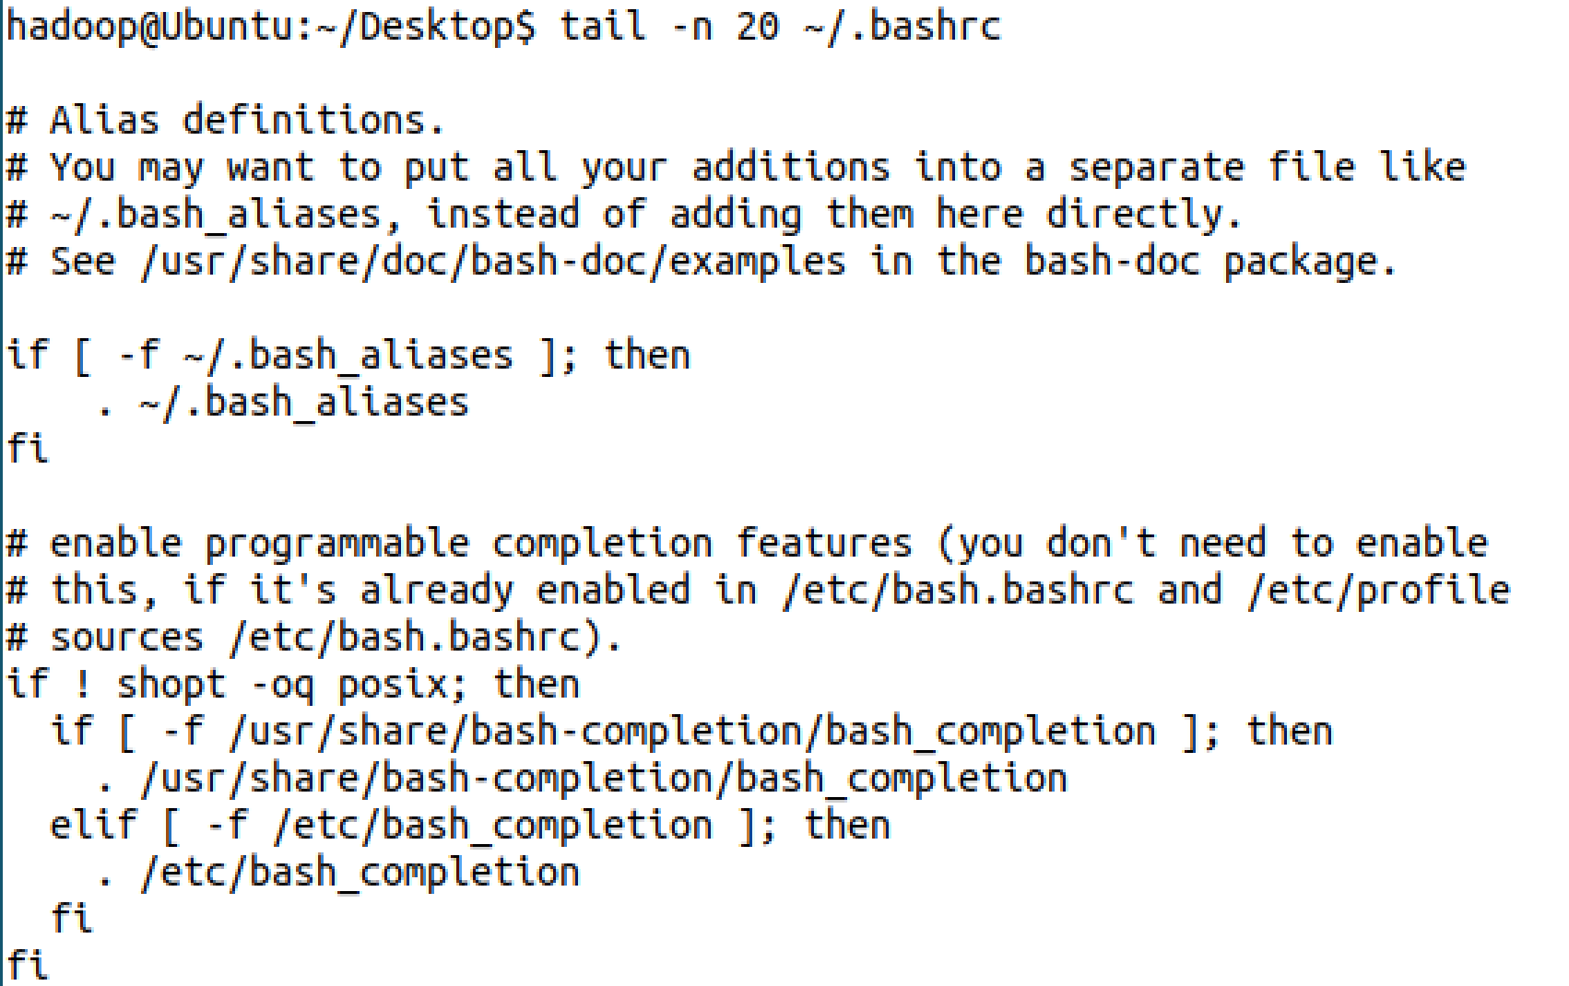

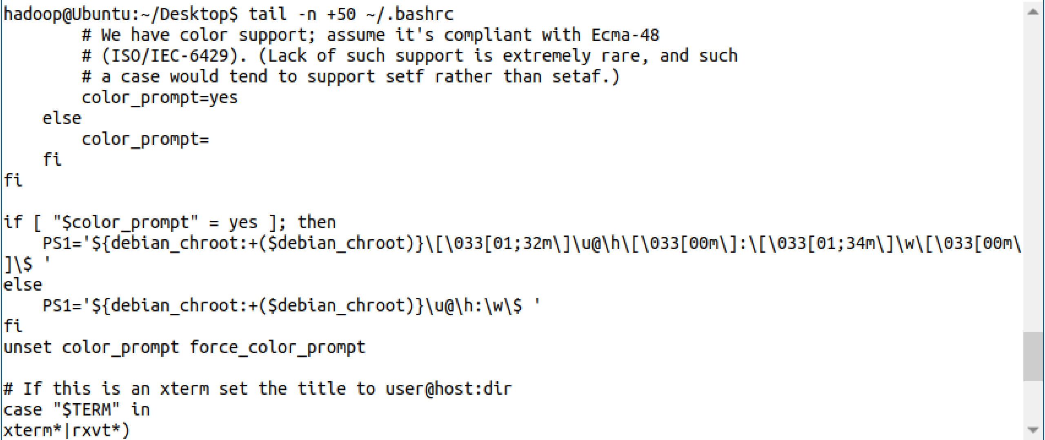

**touch**

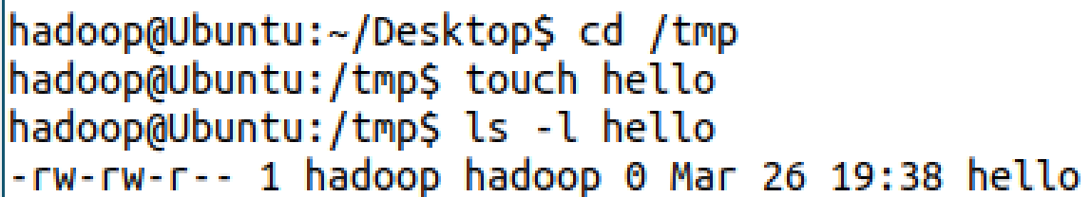



**chown**

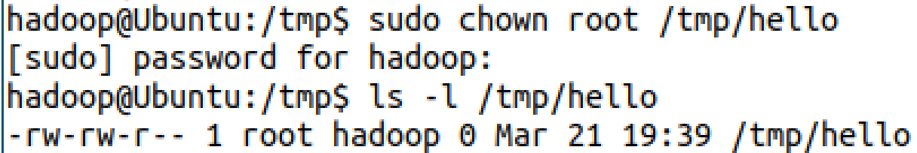

**find**



**tar**





**grep**

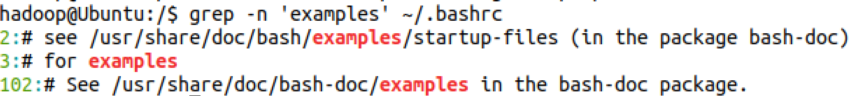

**Ssh登录**

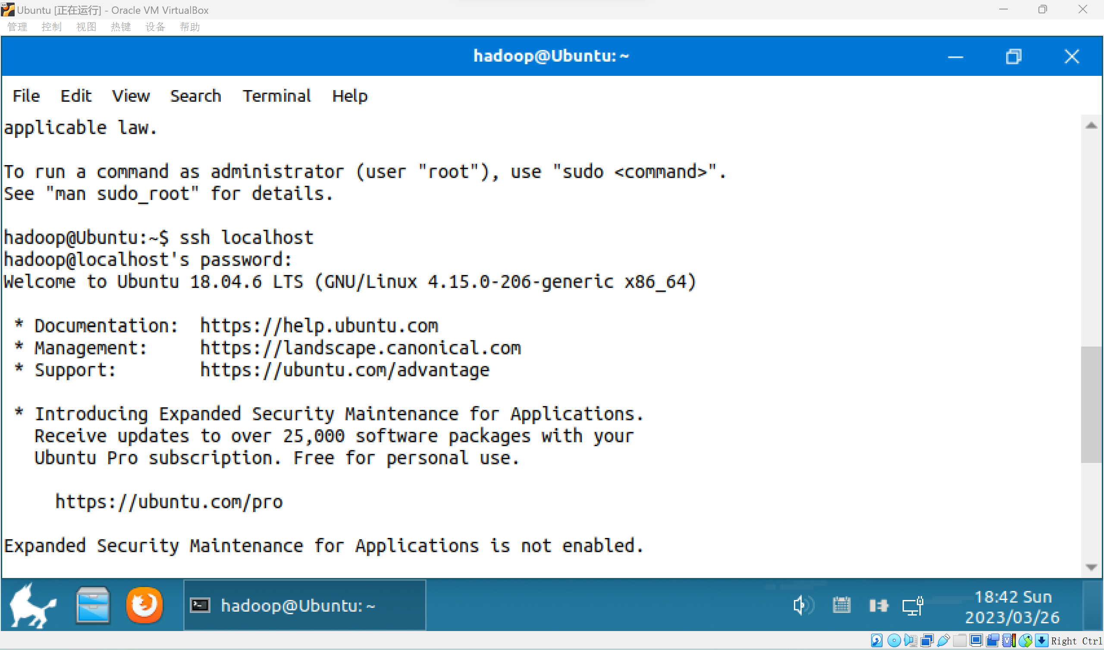

**Java的安装**

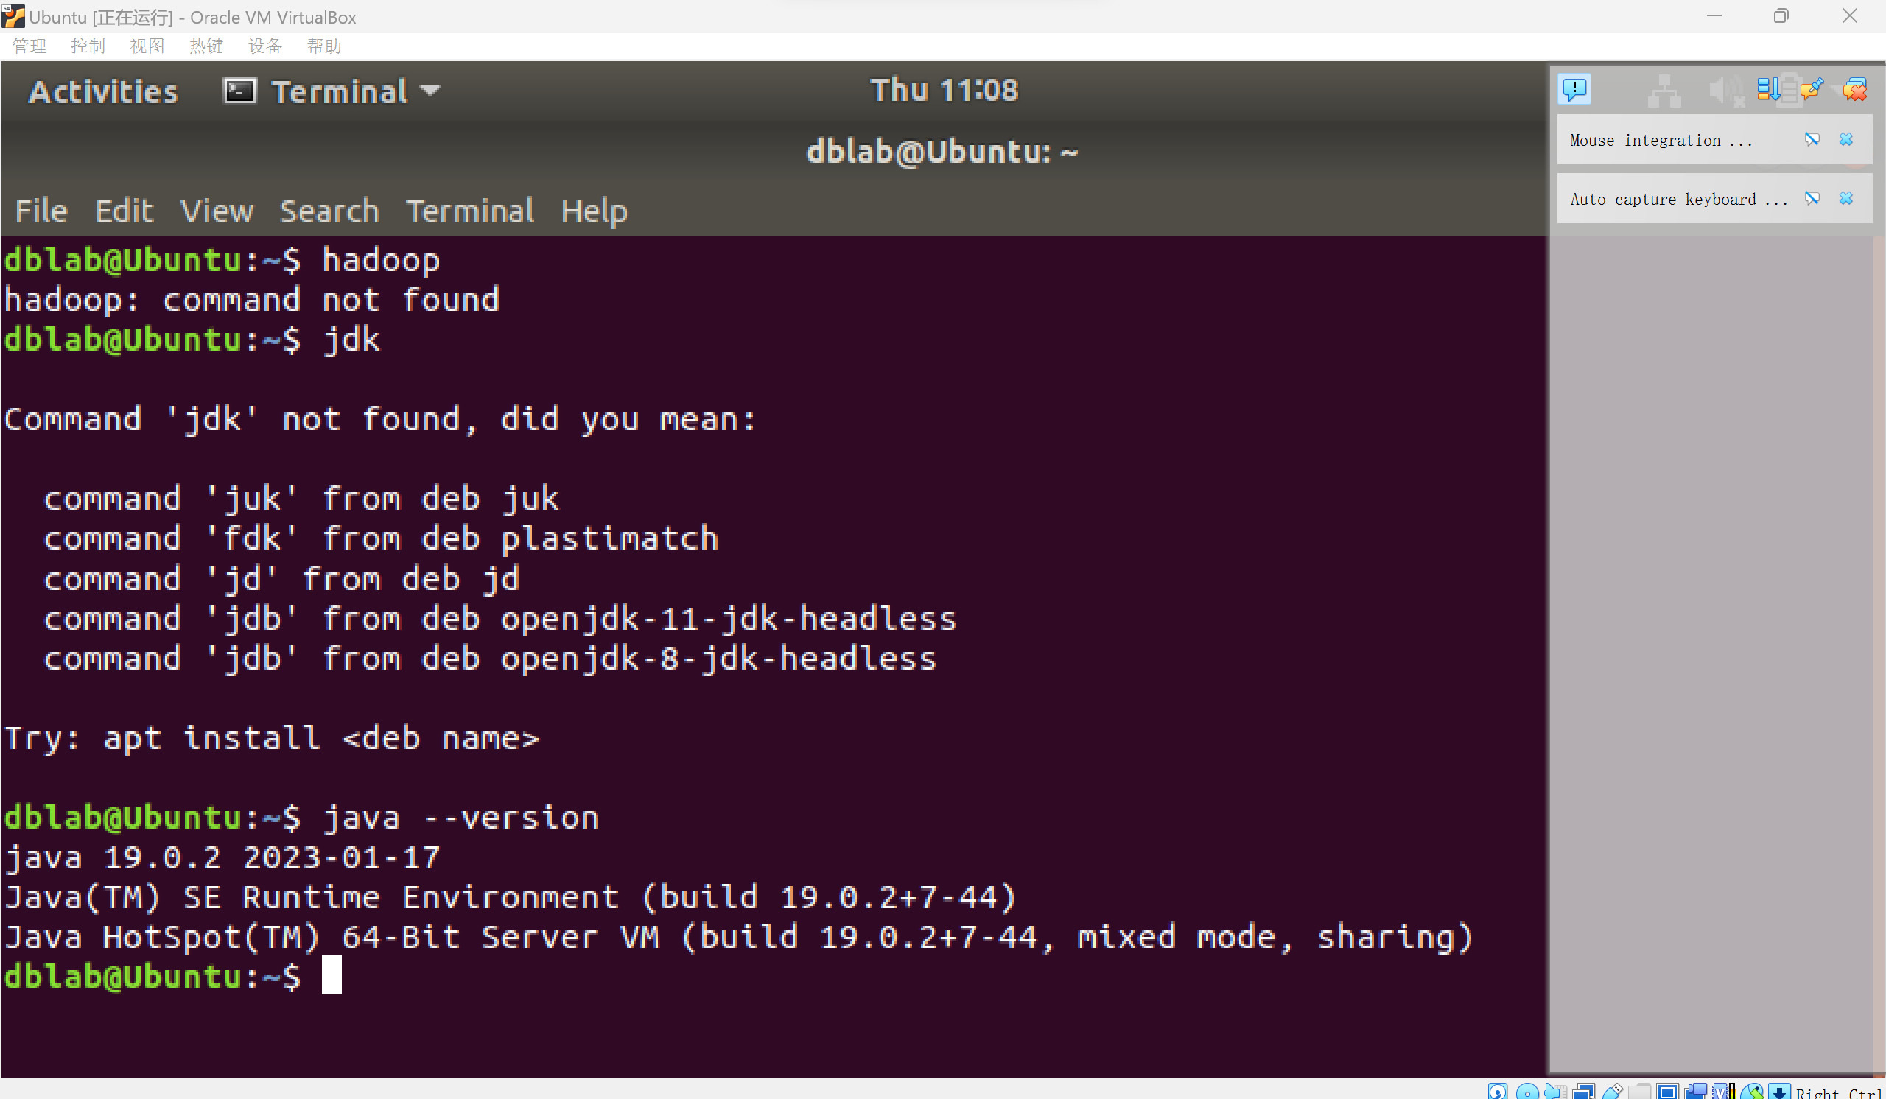

Hadoop的安装

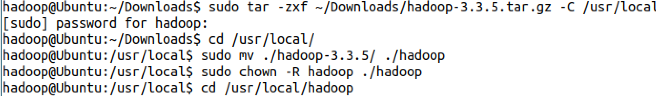

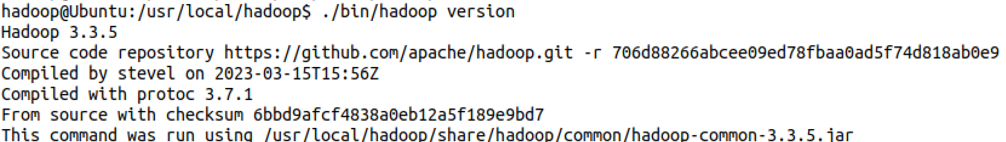

Hadoop安装成功。

伪分布式环境配置



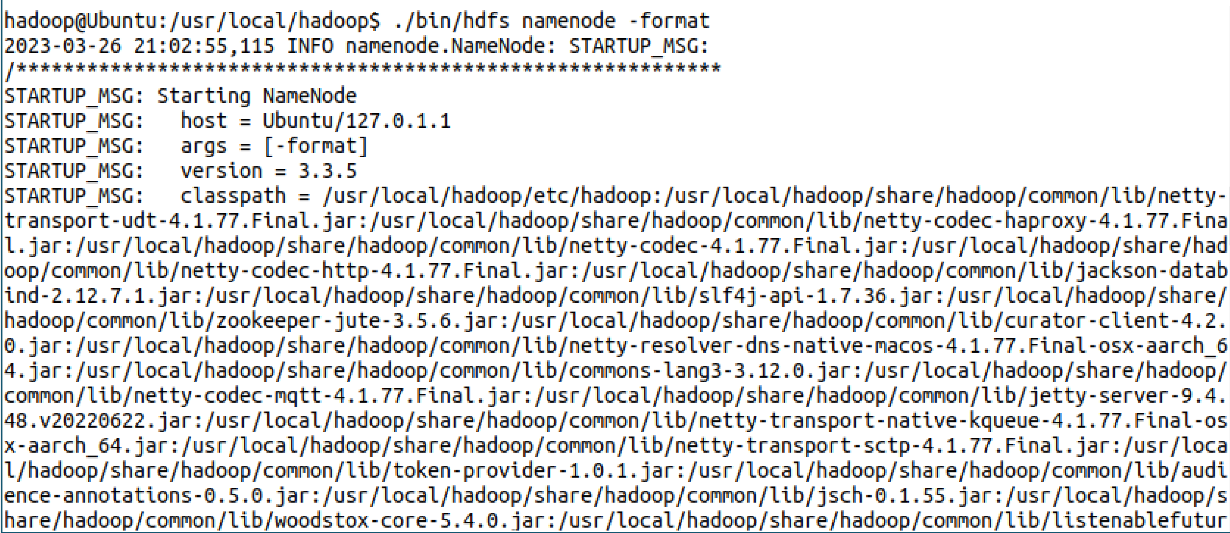

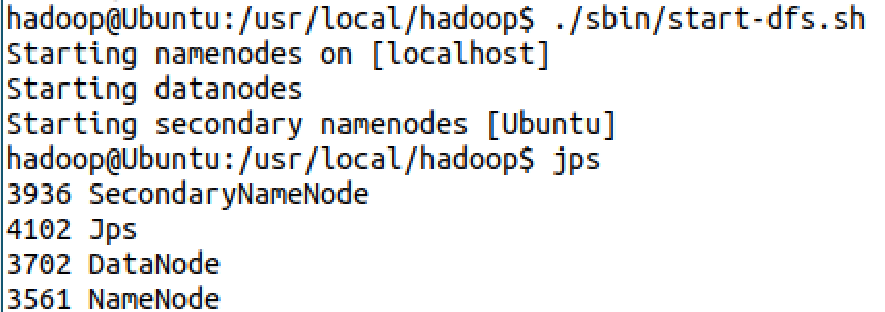

熟悉常用的hadoop操作



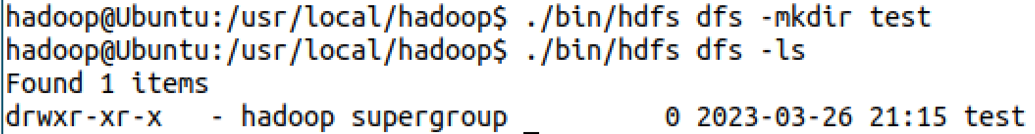

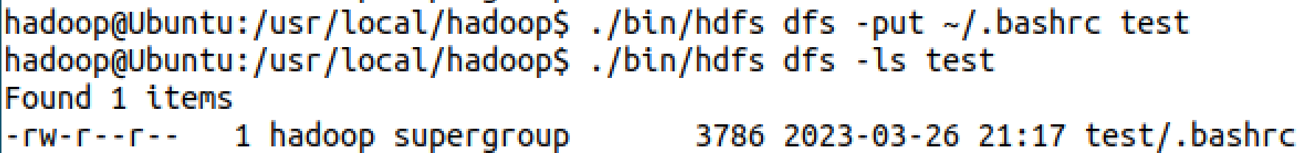



1. **思考讨论题或体会或对改进实验的建议**

可以使用docker简化操作。

1. **实验源代码**

cd /usr/local/Hadoop

cd /usr

ls -al

cd /tmp

mkdir a

ls -al

cd /tmp

rmdir -p a1/a2/a3/a4

ls -al

cd /tmp

mkdir test

sudo cp -r /tmp/test /usr

# 实验二 **熟悉常用的HDFS操作**

|  |  |  |  |  |
| --- | --- | --- | --- | --- |
| **地 点：** | B10楼 | 303房； | **实验台号：** |  |
| **实验日期与时间：** | 2023/3/16 | | **评 分：** |  |
| **预习检查纪录：** |  | | **实验教师：** | 焦青松 |

1. **实验目的**

**（1）.理解HDFS在Hadoop体系结构的角色。**

**(2).熟练使用HDFS操作常用的Shell命令**

**(3).熟悉HDFS操作常用的Java API。**

1. **实验平台**

(1).操作系统:Linux

(2).Hadoop版本:3.3.5

(3).JDK版本:19.3.0

(4).Java IDE:eclipse

1. **实验步骤（包括实验结果/截图）**



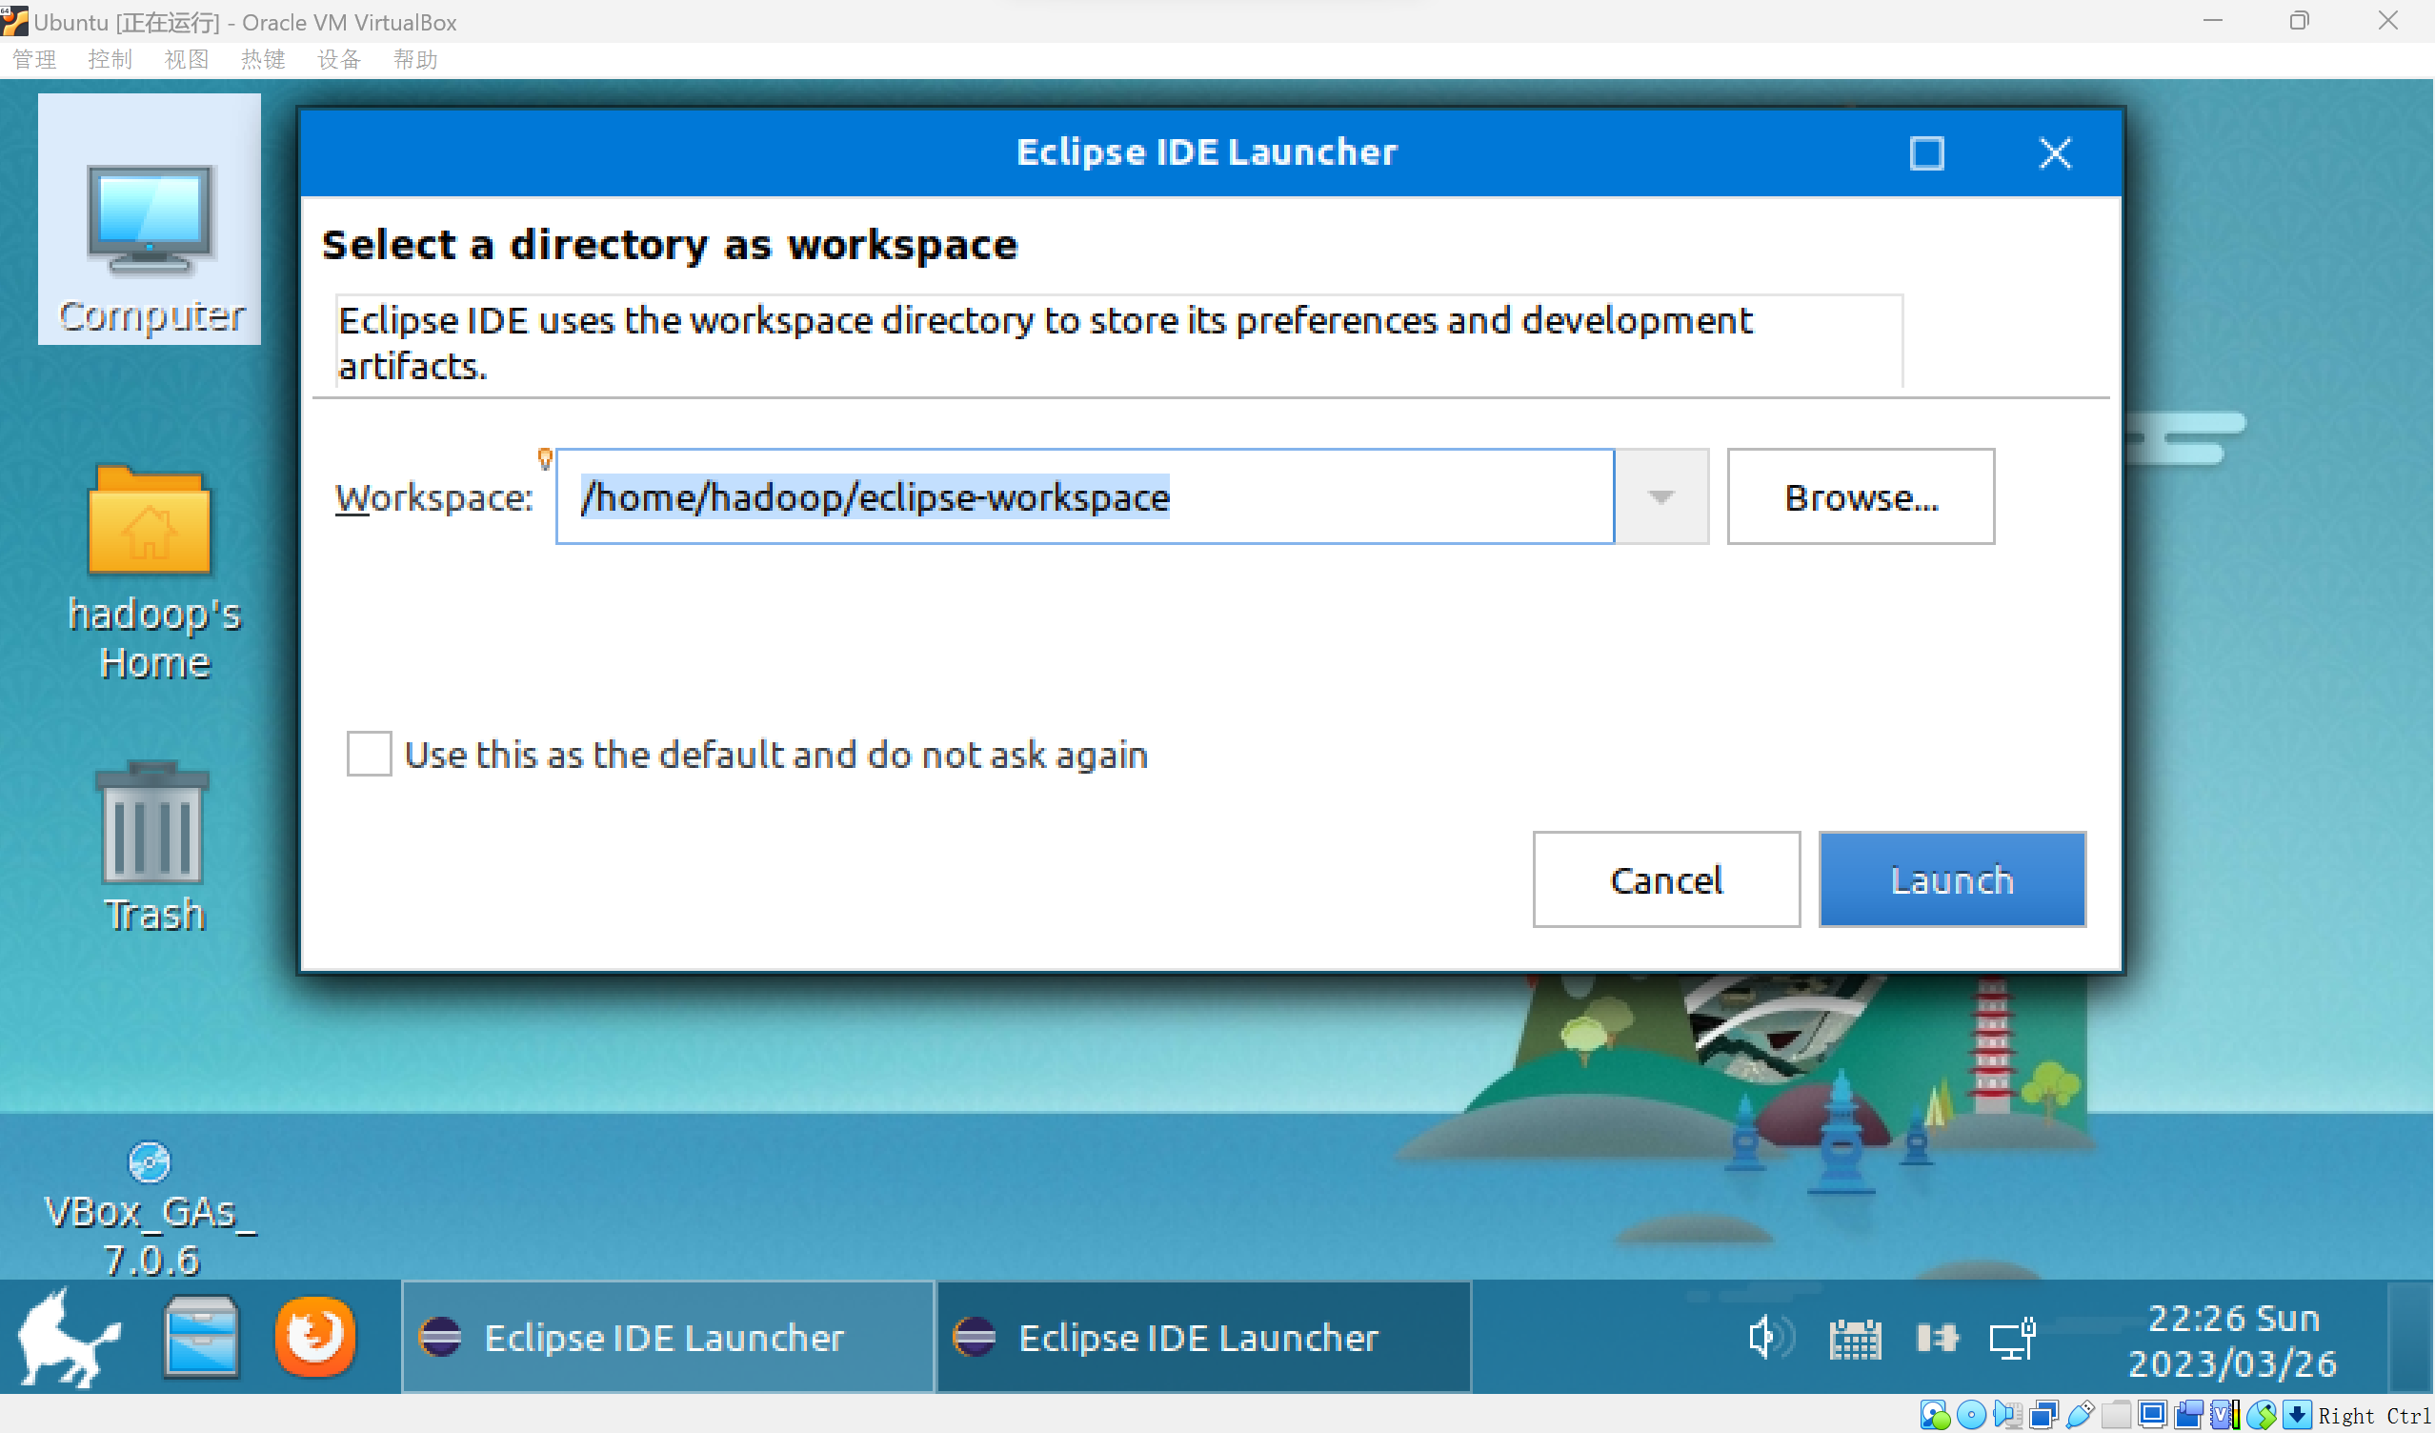

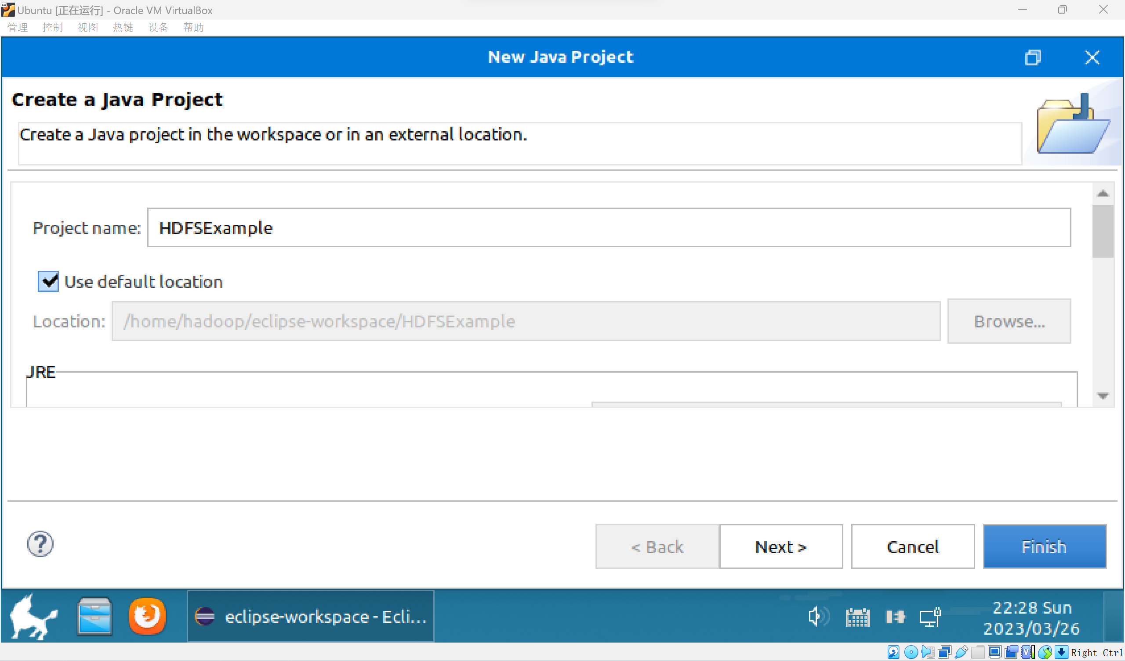

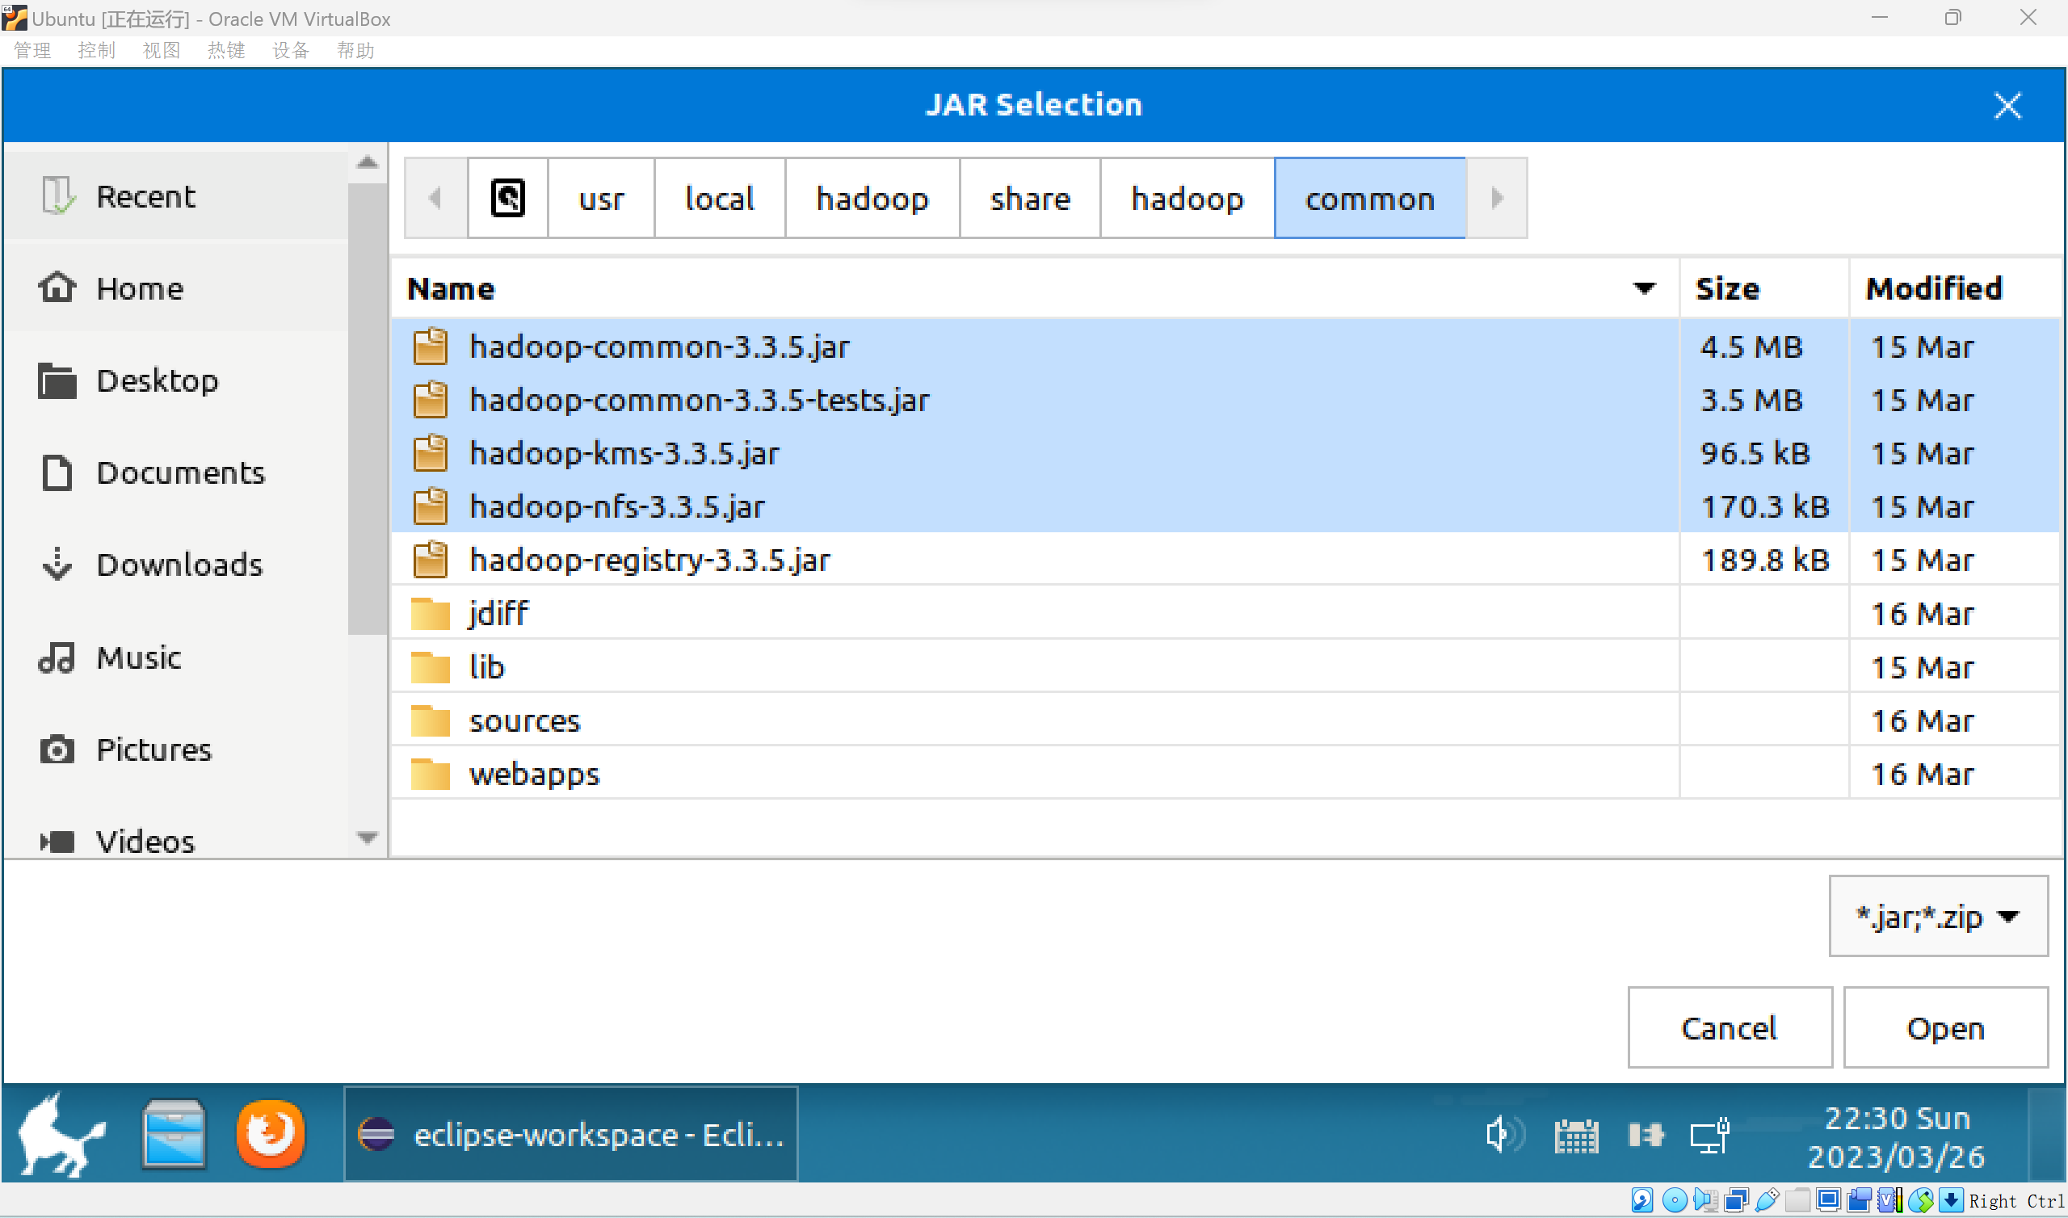

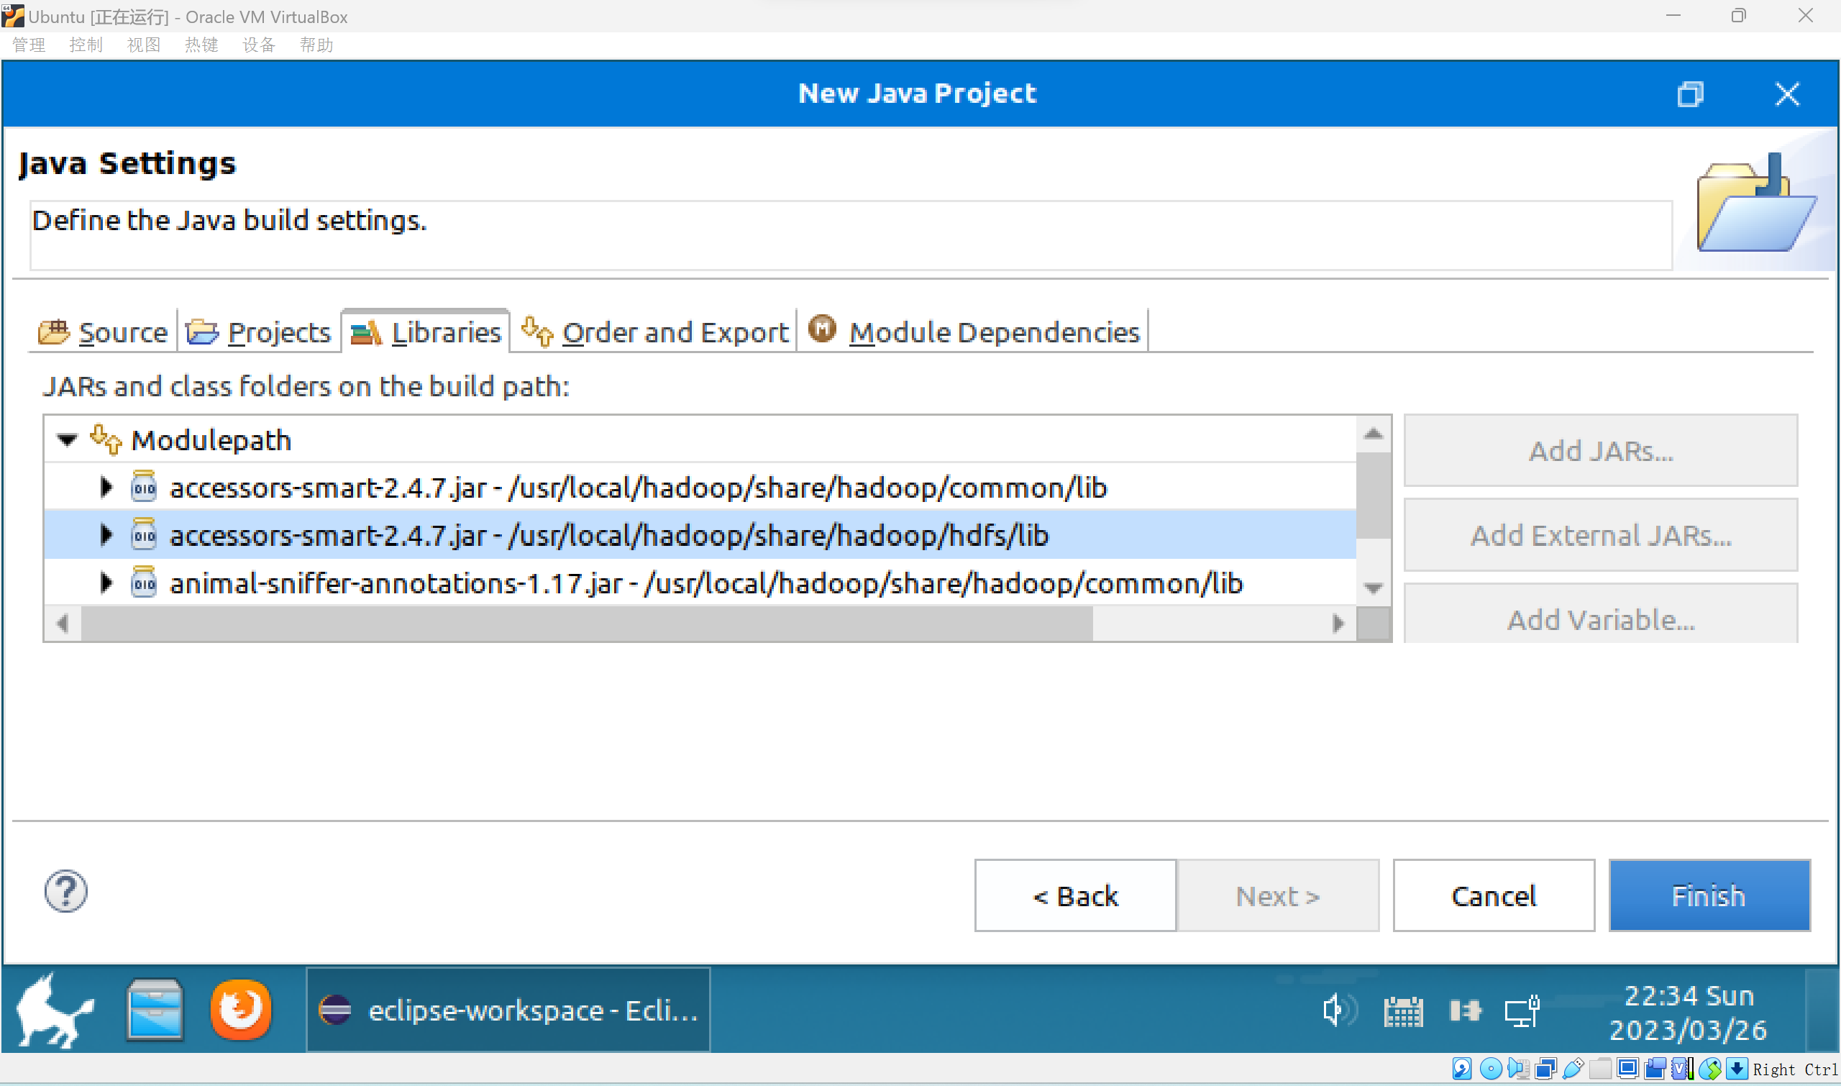

**所有jar包安装完毕。**

**新建类**

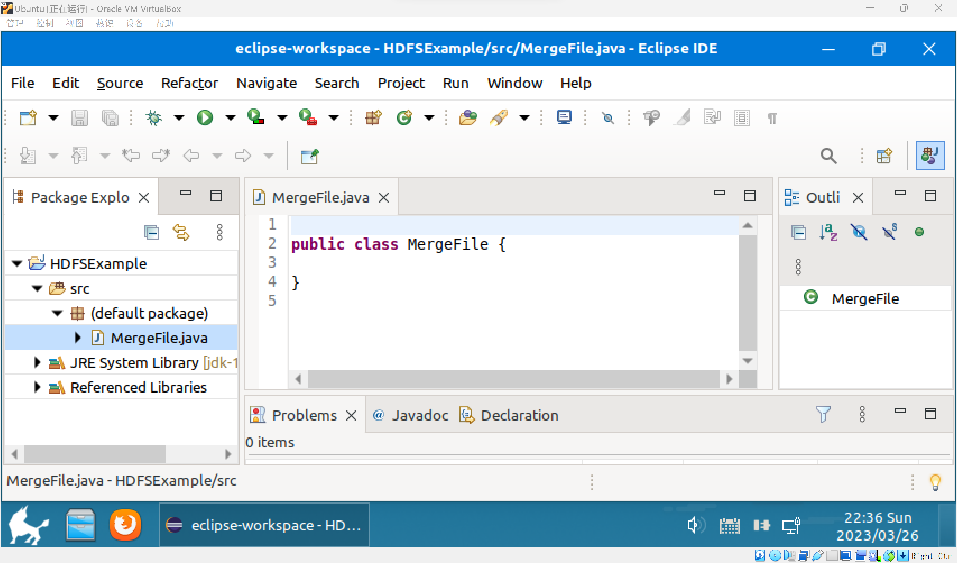

**无报错的创建类**

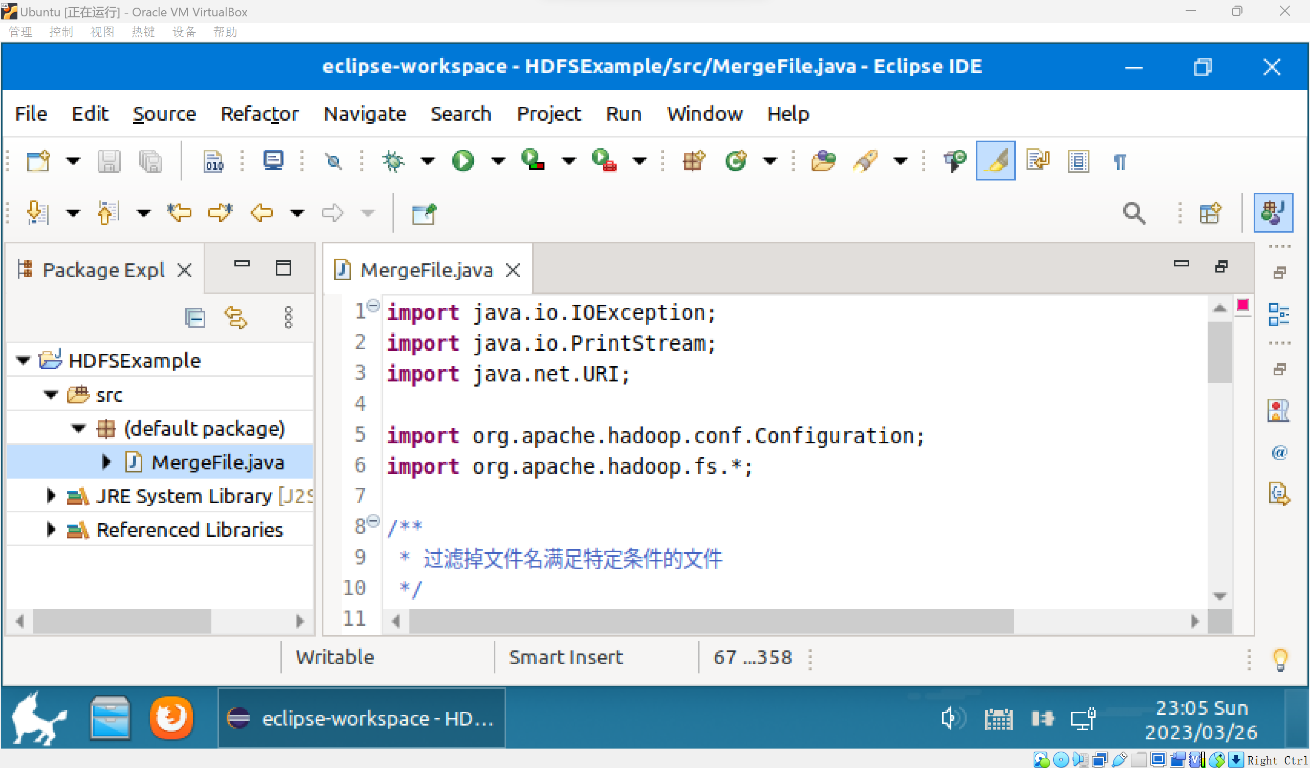

**创建五个需要的文件**

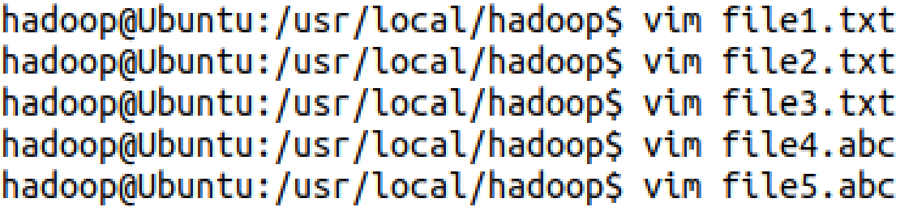

**将5个文件移入hdfs的user/hadoop处**

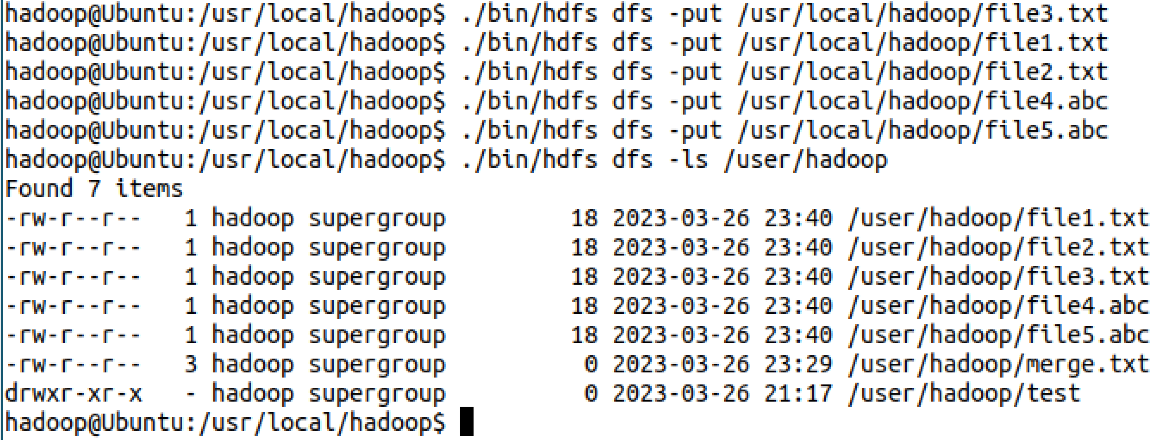

**在运行代码之前必须删除test文件夹，否则不能运行。**

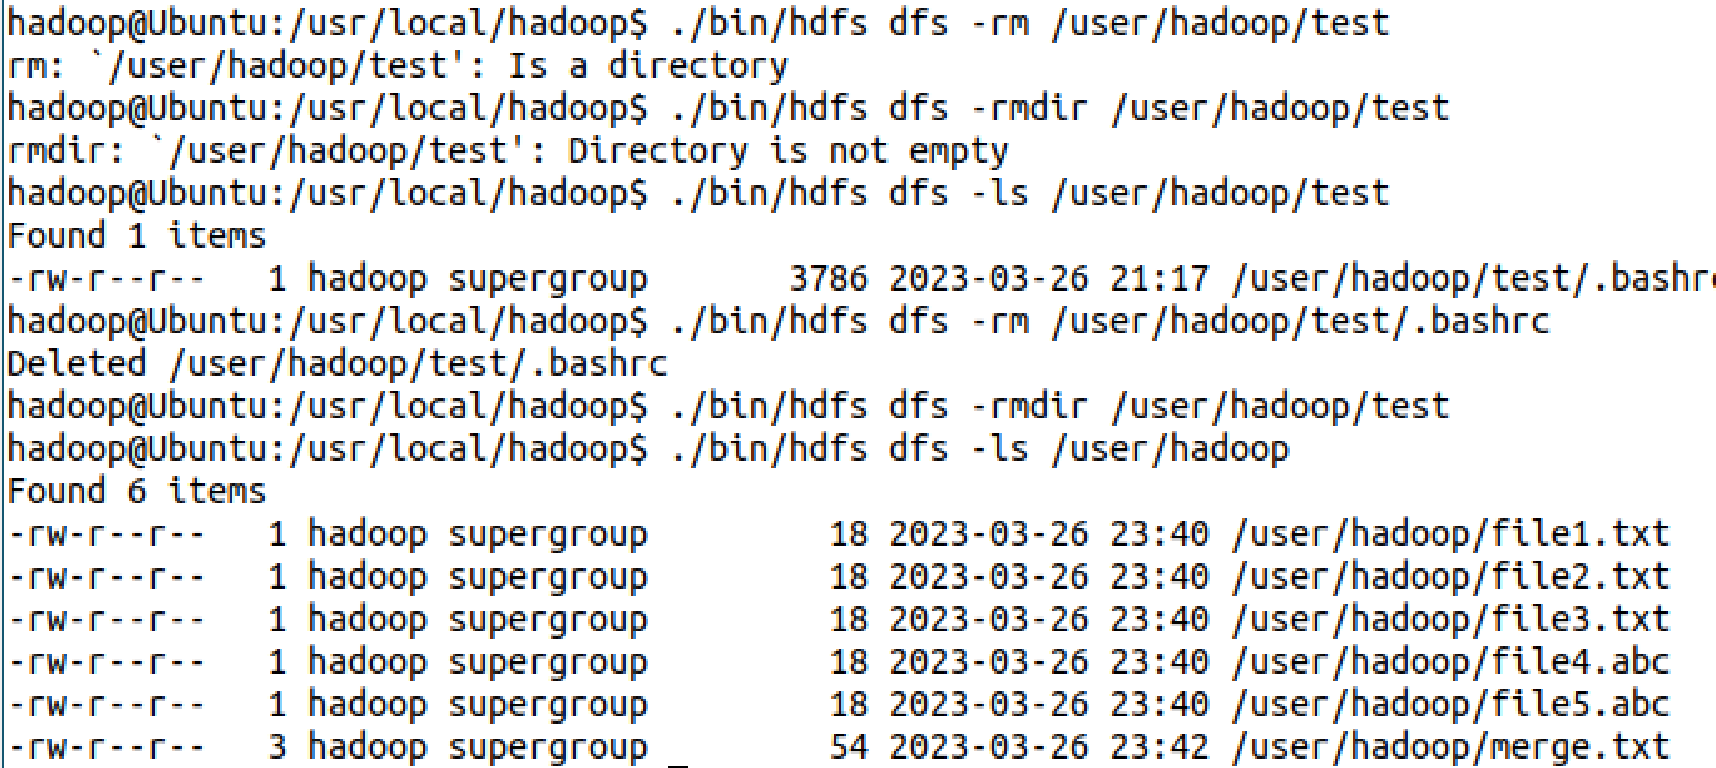

**运行成功**

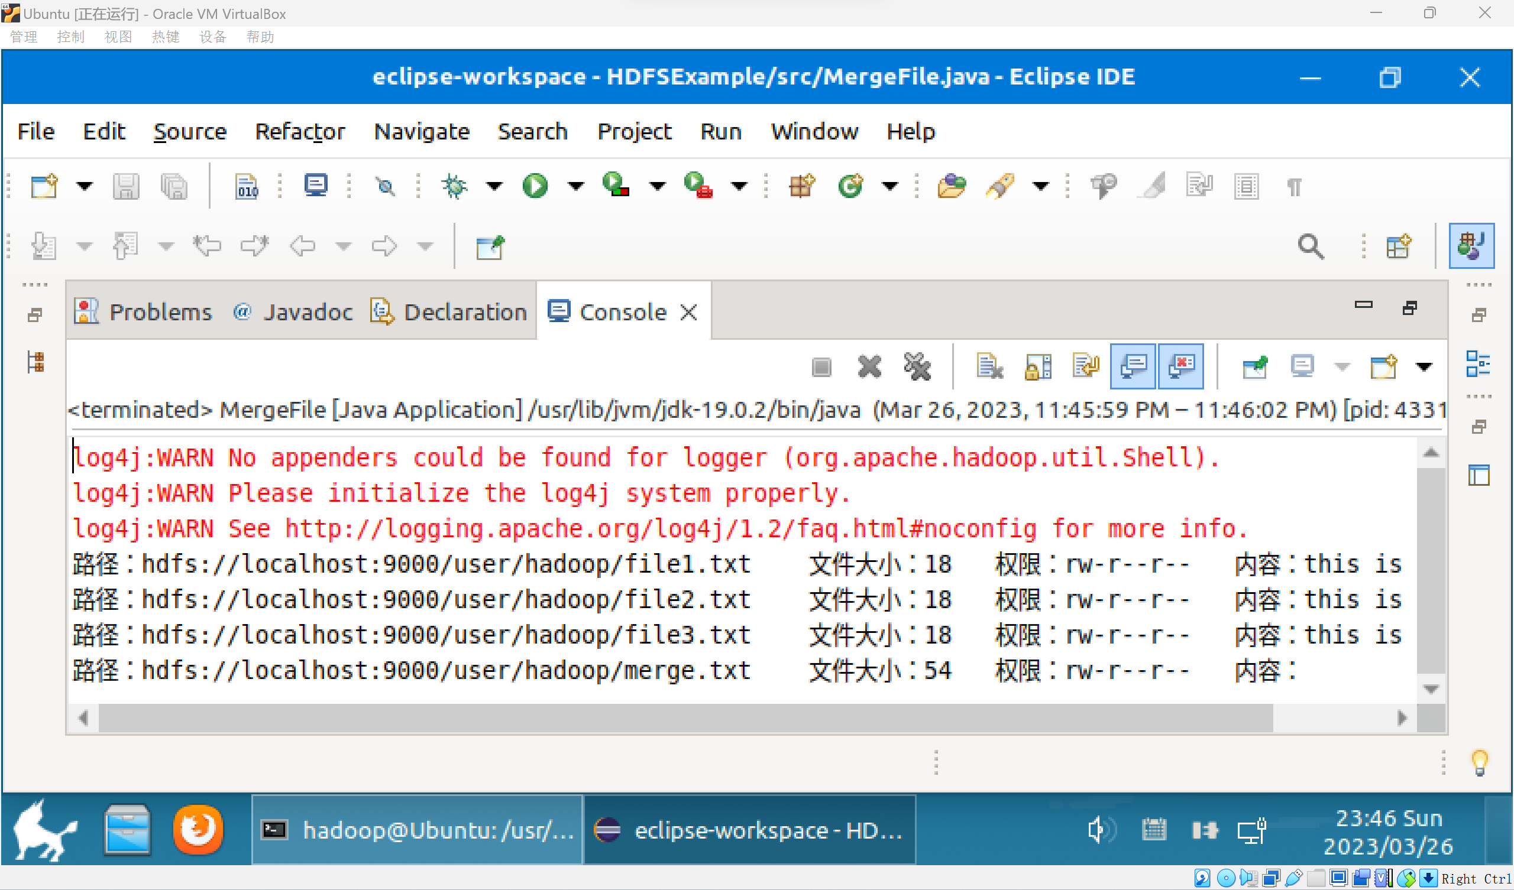

**模型部署**

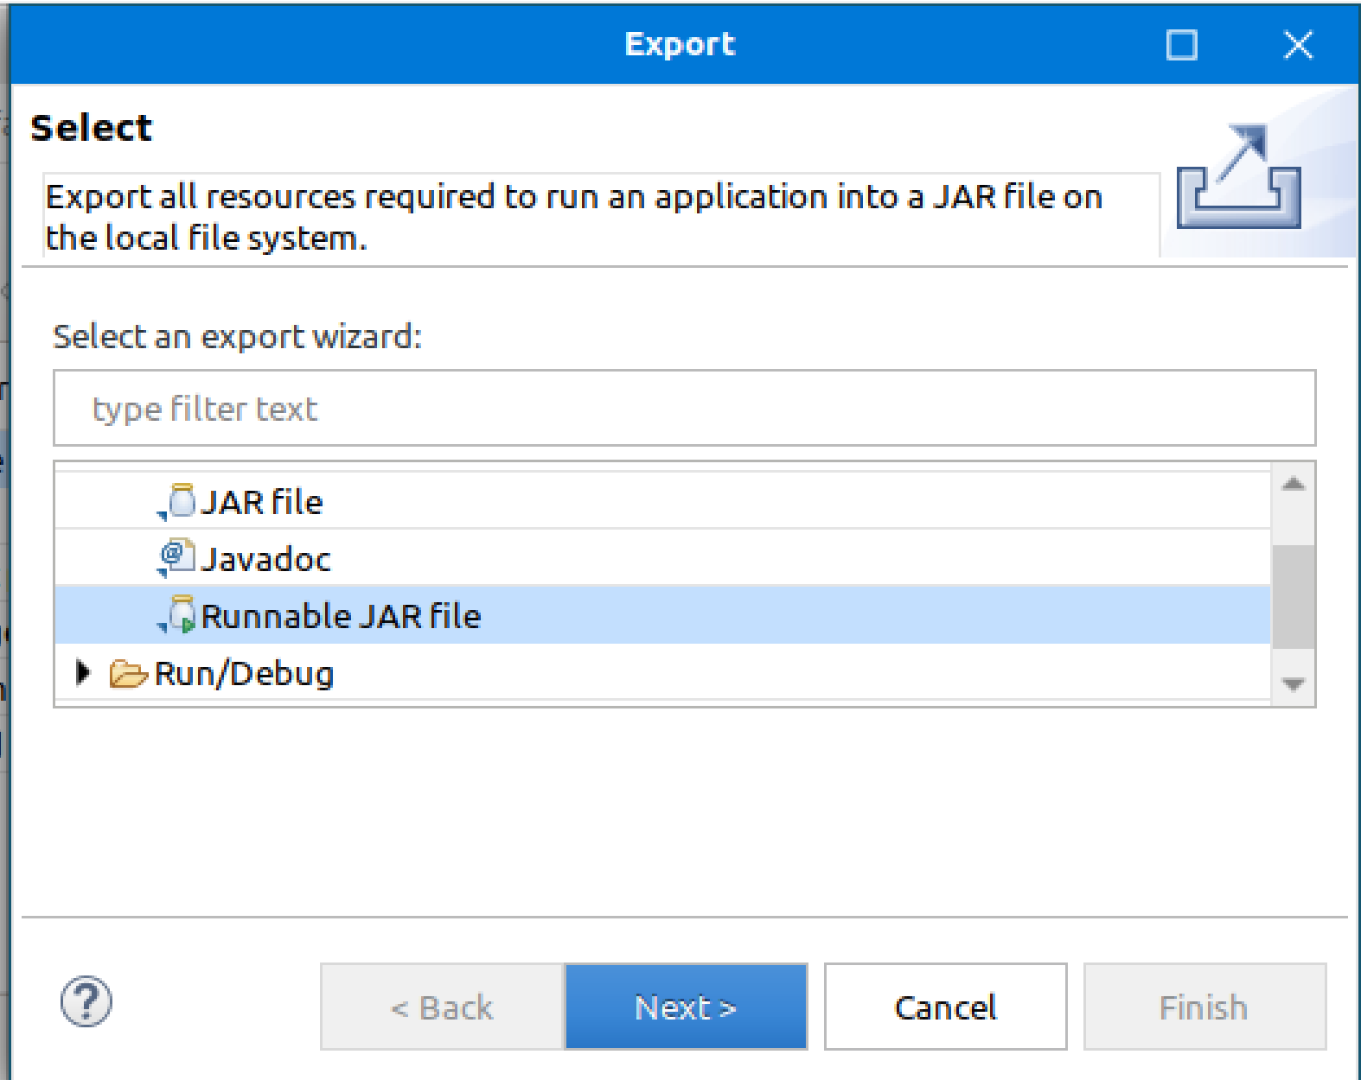

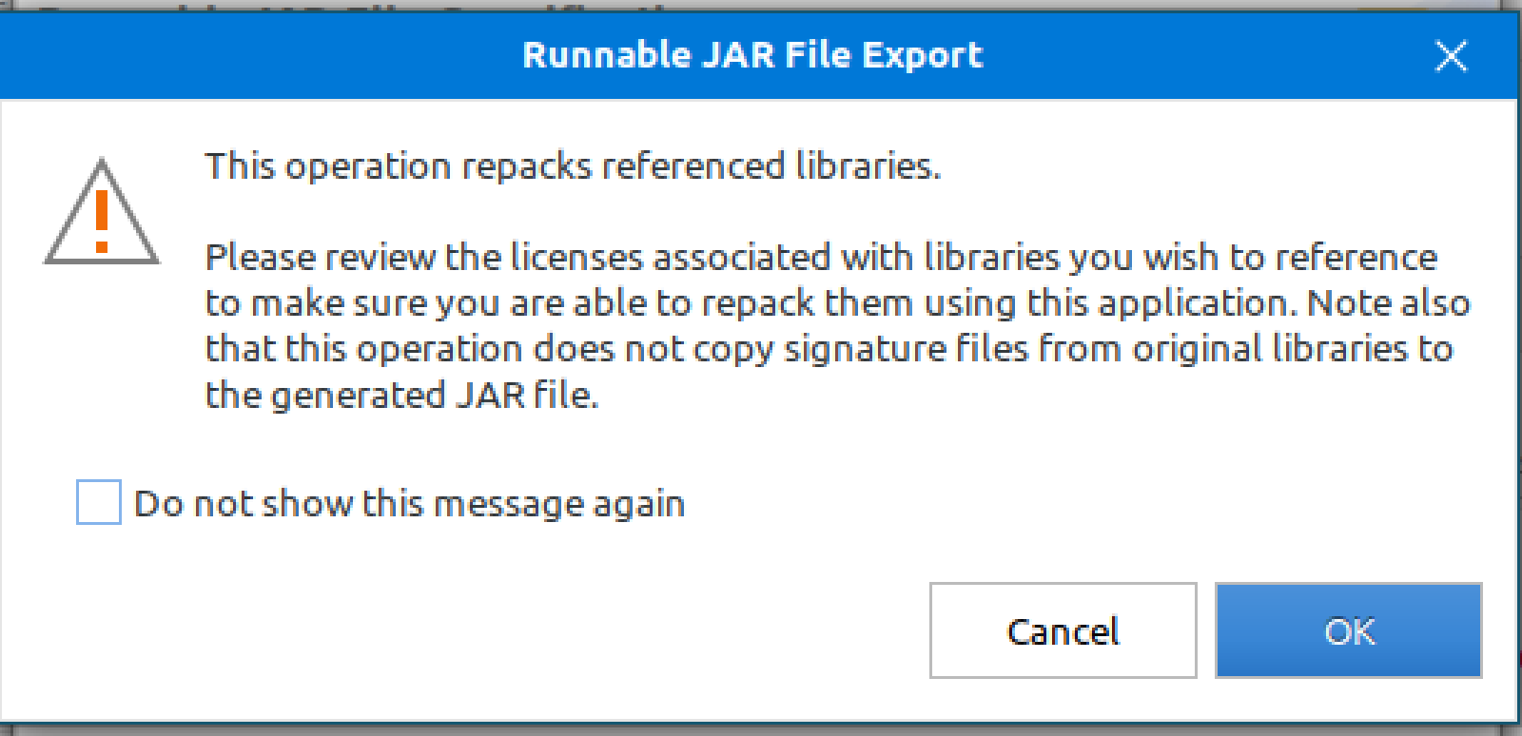

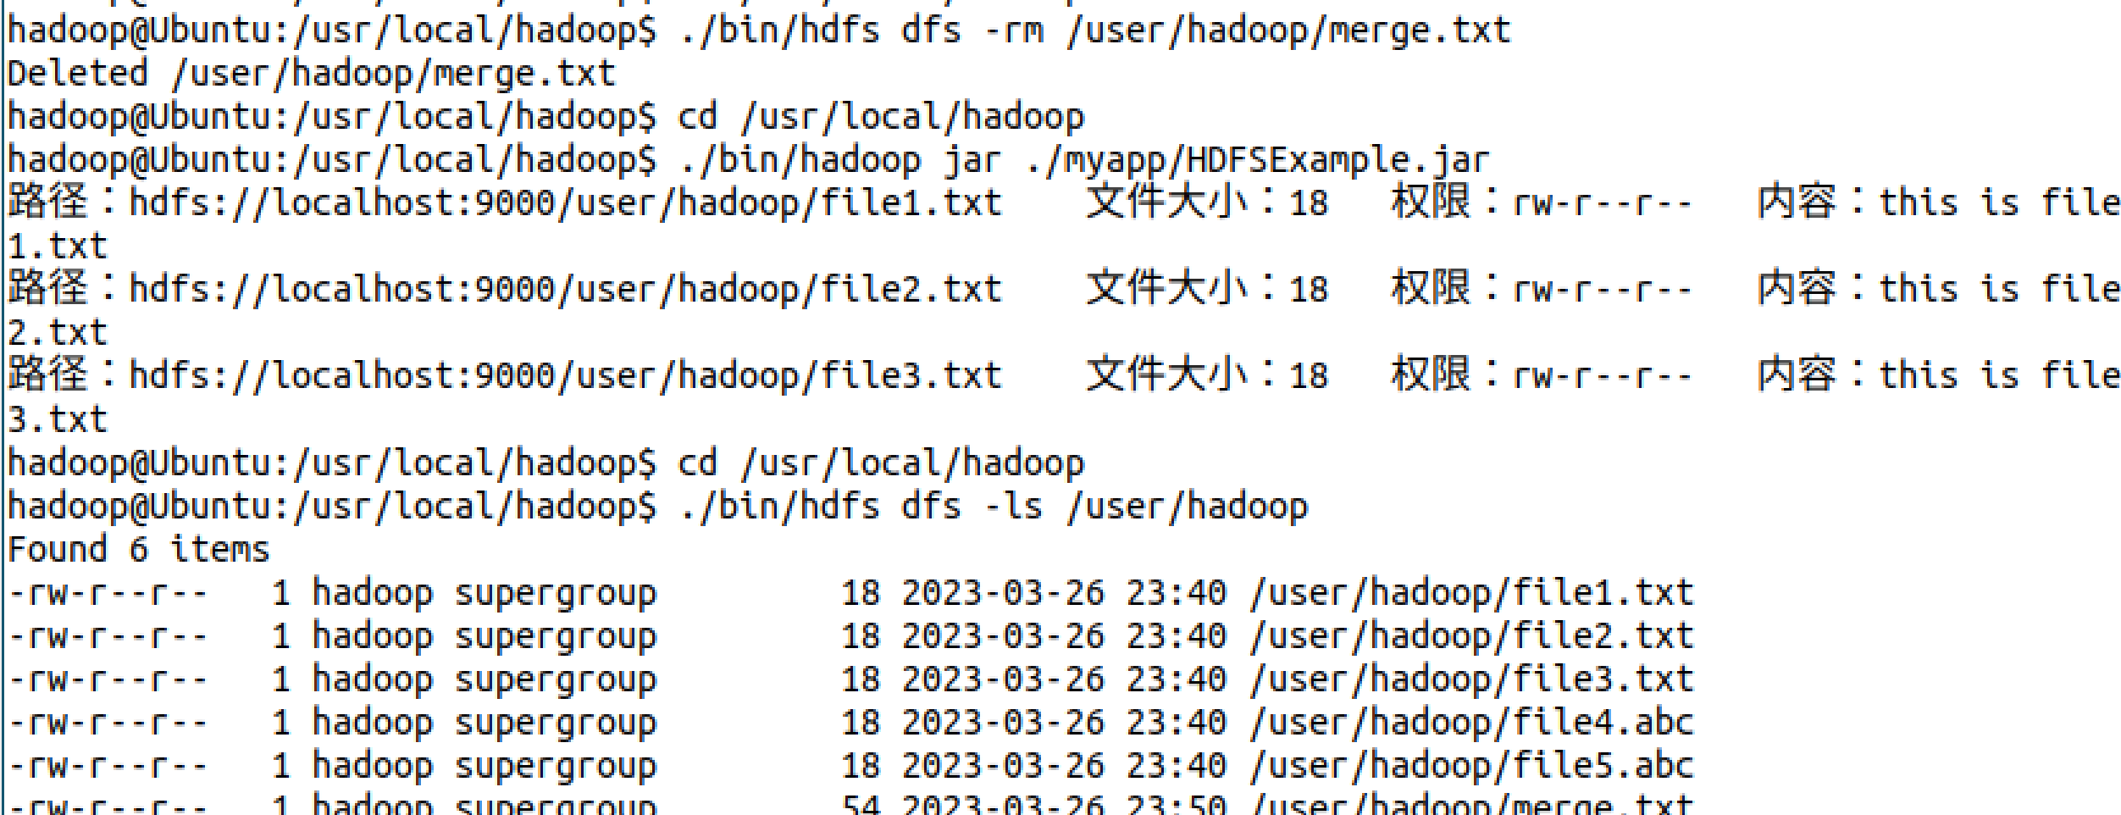

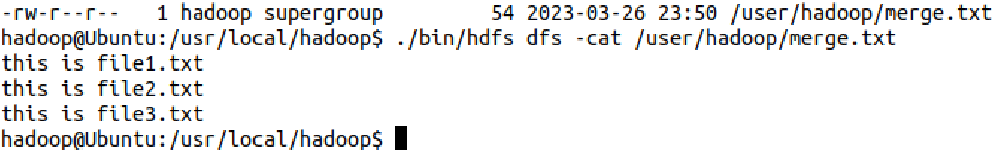

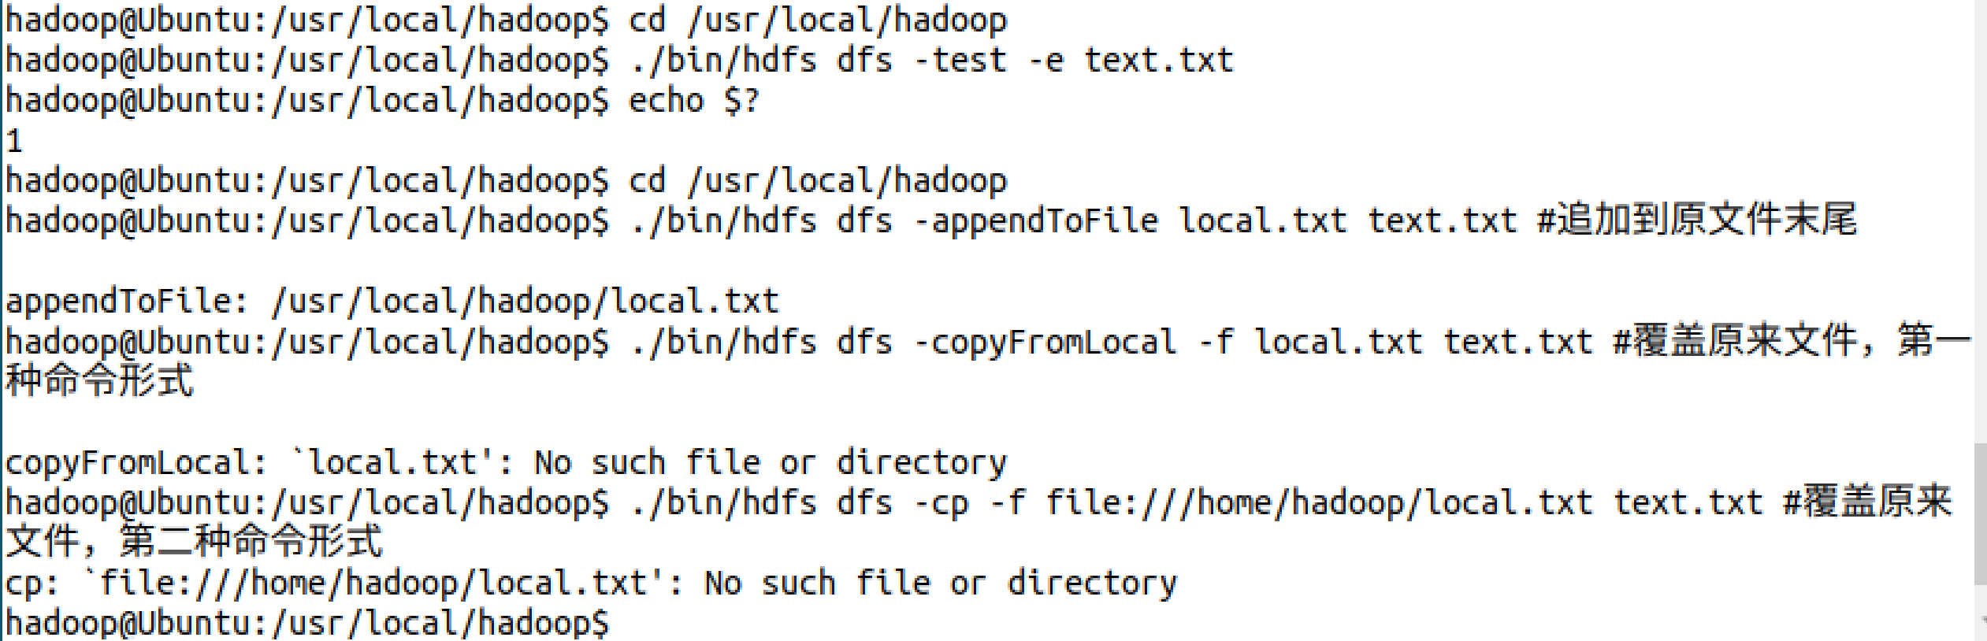

1. **思考讨论题或体会或对改进实验的建议**

可以使用Intellj IDEA作为项目IDE。

1. **实验源代码**

**import org.apache.hadoop.conf.Configuration;**

**import org.apache.hadoop.fs.*;**

**import java.io.*;**

**public class HDFSApi {**

**/\*\***

**\* 判断路径是否存在**

**\*/**

**public static boolean test(Configuration conf, String path) throws IOException {**

**FileSystem fs = FileSystem.get(conf);**

**return fs.exists(new Path(path));**

**}**

**/\*\***

**\* 复制文件到指定路径**

**\* 若路径已存在，则进行覆盖**

**\*/**

**public static void copyFromLocalFile(Configuration conf, String localFilePath, String remoteFilePath) throws IOException {**

**FileSystem fs = FileSystem.get(conf);**

**Path localPath = new Path(localFilePath);**

**Path remotePath = new Path(remoteFilePath);**

**/* fs.copyFromLocalFile 第一个参数表示是否删除源文件，第二个参数表示是否覆盖 */**

**fs.copyFromLocalFile(false, true, localPath, remotePath);**

**fs.close();**

**}**

**/\*\***

**\* 追加文件内容**

**\*/**

**public static void appendToFile(Configuration conf, String localFilePath, String remoteFilePath) throws IOException {**

**FileSystem fs = FileSystem.get(conf);**

**Path remotePath = new Path(remoteFilePath);**

**/* 创建一个文件读入流 */**

**FileInputStream in = new FileInputStream(localFilePath);**

**/* 创建一个文件输出流，输出的内容将追加到文件末尾 */**

**FSDataOutputStream out = fs.append(remotePath);**

**/* 读写文件内容 */**

**byte[] data = new byte[1024];**

**int read = -1;**

**while ( (read = in.read(data)) > 0 ) {**

**out.write(data, 0, read);**

**}**

**out.close();**

**in.close();**

**fs.close();**

**}**

**/\*\***

**\* 主函数**

**\*/**

**public static void main(String[] args) {**

**Configuration conf = new Configuration();**

**conf.set("fs.default.name","hdfs://localhost:9000");**

**String localFilePath = "/home/hadoop/text.txt"; // 本地路径**

**String remoteFilePath = "/user/hadoop/text.txt"; // HDFS路径**

**String choice = "append"; // 若文件存在则追加到文件末尾**

**// String choice = "overwrite"; // 若文件存在则覆盖**

**try {**

**/* 判断文件是否存在 */**

**Boolean fileExists = false;**

**if (HDFSApi.test(conf, remoteFilePath)) {**

**fileExists = true;**

**System.out.println(remoteFilePath + " 已存在.");**

**} else {**

**System.out.println(remoteFilePath + " 不存在.");**

**}**

**/* 进行处理 */**

**if ( !fileExists) { // 文件不存在，则上传**

**HDFSApi.copyFromLocalFile(conf, localFilePath, remoteFilePath);**

**System.out.println(localFilePath + " 已上传至 " + remoteFilePath);**

**} else if ( choice.equals("overwrite") ) { // 选择覆盖**

**HDFSApi.copyFromLocalFile(conf, localFilePath, remoteFilePath);**

**System.out.println(localFilePath + " 已覆盖 " + remoteFilePath);**

**} else if ( choice.equals("append") ) { // 选择追加**

**HDFSApi.appendToFile(conf, localFilePath, remoteFilePath);**

**System.out.println(localFilePath + " 已追加至 " + remoteFilePath);**

**}**

**} catch (Exception e) {**

**e.printStackTrace();**

**}**

**}**

**}**

**cd /usr/local/hadoop**

**./bin/hdfs dfs -test -e text.txt**

**import org.apache.hadoop.conf.Configuration;**

**import org.apache.hadoop.fs.*;**

**import java.io.*;**

**public class HDFSApi {**

**/\*\***

**\* 下载文件到本地**

**\* 判断本地路径是否已存在，若已存在，则自动进行重命名**

**\*/**

**public static void copyToLocal(Configuration conf, String remoteFilePath, String localFilePath) throws IOException {**

**FileSystem fs = FileSystem.get(conf);**

**Path remotePath = new Path(remoteFilePath);**

**File f = new File(localFilePath);**

**/* 如果文件名存在，自动重命名(在文件名后面加上 _0, _1 ...) */**

**if (f.exists()) {**

**System.out.println(localFilePath + " 已存在.");**

**Integer i = 0;**

**while (true) {**

**f = new File(localFilePath + "_" + i.toString());**

**if (!f.exists()) {**

**localFilePath = localFilePath + "_" + i.toString();**

**break;**

**}**

**}**

**System.out.println("将重新命名为: " + localFilePath);**

**}**

**// 下载文件到本地**

**Path localPath = new Path(localFilePath);**

**fs.copyToLocalFile(remotePath, localPath);**

**fs.close();**

**}**

**/\*\***

**\* 主函数**

**\*/**

**public static void main(String[] args) {**

**Configuration conf = new Configuration();**

**conf.set("fs.default.name","hdfs://localhost:9000");**

**String localFilePath = "/home/hadoop/text.txt"; // 本地路径**

**String remoteFilePath = "/user/hadoop/text.txt"; // HDFS路径**

**try {**

**HDFSApi.copyToLocal(conf, remoteFilePath, localFilePath);**

**System.out.println("下载完成");**

**} catch (Exception e) {**

**e.printStackTrace();**

**}**

**}**

**}**

**import org.apache.hadoop.conf.Configuration;**

**import org.apache.hadoop.fs.*;**

**import java.io.*;**

**public class HDFSApi {**

**/\*\***

**\* 读取文件内容**

**\*/**

**public static void cat(Configuration conf, String remoteFilePath) throws IOException {**

**FileSystem fs = FileSystem.get(conf);**

**Path remotePath = new Path(remoteFilePath);**

**FSDataInputStream in = fs.open(remotePath);**

**BufferedReader d = new BufferedReader(new InputStreamReader(in));**

**String line = null;**

**while ( (line = d.readLine()) != null ) {**

**System.out.println(line);**

**}**

**d.close();**

**in.close();**

**fs.close();**

**}**

**/\*\***

**\* 主函数**

**\*/**

**public static void main(String[] args) {**

**Configuration conf = new Configuration();**

**conf.set("fs.default.name","hdfs://localhost:9000");**

**String remoteFilePath = "/user/hadoop/text.txt"; // HDFS路径**

**try {**

**System.out.println("读取文件: " + remoteFilePath);**

**HDFSApi.cat(conf, remoteFilePath);**

**System.out.println("\n读取完成");**

**} catch (Exception e) {**

**e.printStackTrace();**

**}**

**}**

**}**

**import org.apache.hadoop.conf.Configuration;**

**import org.apache.hadoop.fs.*;**

**import java.io.*;**

**import java.text.SimpleDateFormat;**

**public class HDFSApi {**

**/\*\***

**\* 显示指定文件的信息**

**\*/**

**public static void ls(Configuration conf, String remoteFilePath) throws IOException {**

**FileSystem fs = FileSystem.get(conf);**

**Path remotePath = new Path(remoteFilePath);**

**FileStatus[] fileStatuses = fs.listStatus(remotePath);**

**for (FileStatus s : fileStatuses) {**

**System.out.println("路径: " + s.getPath().toString());**

**System.out.println("权限: " + s.getPermission().toString());**

**System.out.println("大小: " + s.getLen());**

**/* 返回的是时间戳,转化为时间日期格式 */**

**Long timeStamp = s.getModificationTime();**

**SimpleDateFormat format = new SimpleDateFormat("yyyy-MM-dd HH:mm:ss");**

**String date = format.format(timeStamp);**

**System.out.println("时间: " + date);**

**}**

**fs.close();**

**}**

**/\*\***

**\* 主函数**

**\*/**

**public static void main(String[] args) {**

**Configuration conf = new Configuration();**

**conf.set("fs.default.name","hdfs://localhost:9000");**

**String remoteFilePath = "/user/hadoop/text.txt"; // HDFS路径**

**try {**

**System.out.println("读取文件信息: " + remoteFilePath);**

**HDFSApi.ls(conf, remoteFilePath);**

**System.out.println("\n读取完成");**

**} catch (Exception e) {**

**e.printStackTrace();**

**}**

**}**

**}**

**import org.apache.hadoop.conf.Configuration;**

**import org.apache.hadoop.fs.*;**

**import java.io.*;**

**import java.text.SimpleDateFormat;**

**public class HDFSApi {**

**/\*\***

**\* 显示指定文件夹下所有文件的信息（递归）**

**\*/**

**public static void lsDir(Configuration conf, String remoteDir) throws IOException {**

**FileSystem fs = FileSystem.get(conf);**

**Path dirPath = new Path(remoteDir);**

**/* 递归获取目录下的所有文件 */**

**RemoteIterator<LocatedFileStatus> remoteIterator = fs.listFiles(dirPath, true);**

**/* 输出每个文件的信息 */**

**while (remoteIterator.hasNext()) {**

**FileStatus s = remoteIterator.next();**

**System.out.println("路径: " + s.getPath().toString());**

**System.out.println("权限: " + s.getPermission().toString());**

**System.out.println("大小: " + s.getLen());**

**/* 返回的是时间戳,转化为时间日期格式 */**

**Long timeStamp = s.getModificationTime();**

**SimpleDateFormat format = new SimpleDateFormat("yyyy-MM-dd HH:mm:ss");**

**String date = format.format(timeStamp);**

**System.out.println("时间: " + date);**

**System.out.println();**

**}**

**fs.close();**

**}**

**/\*\***

**\* 主函数**

**\*/**

**public static void main(String[] args) {**

**Configuration conf = new Configuration();**

**conf.set("fs.default.name","hdfs://localhost:9000");**

**String remoteDir = "/user/hadoop"; // HDFS路径**

**try {**

**System.out.println("(递归)读取目录下所有文件的信息: " + remoteDir);**

**HDFSApi.lsDir(conf, remoteDir);**

**System.out.println("读取完成");**

**} catch (Exception e) {**

**e.printStackTrace();**

**}**

**}**

**}**

**import org.apache.hadoop.conf.Configuration;**

**import org.apache.hadoop.fs.*;**

**import java.io.*;**

**public class HDFSApi {**

**/\*\***

**\* 判断路径是否存在**

**\*/**

**public static boolean test(Configuration conf, String path) throws IOException {**

**FileSystem fs = FileSystem.get(conf);**

**return fs.exists(new Path(path));**

**}**

**/\*\***

**\* 创建目录**

**\*/**

**public static boolean mkdir(Configuration conf, String remoteDir) throws IOException {**

**FileSystem fs = FileSystem.get(conf);**

**Path dirPath = new Path(remoteDir);**

**boolean result = fs.mkdirs(dirPath);**

**fs.close();**

**return result;**

**}**

**/\*\***

**\* 创建文件**

**\*/**

**public static void touchz(Configuration conf, String remoteFilePath) throws IOException {**

**FileSystem fs = FileSystem.get(conf);**

**Path remotePath = new Path(remoteFilePath);**

**FSDataOutputStream outputStream = fs.create(remotePath);**

**outputStream.close();**

**fs.close();**

**}**

**/\*\***

**\* 删除文件**

**\*/**

**public static boolean rm(Configuration conf, String remoteFilePath) throws IOException {**

**FileSystem fs = FileSystem.get(conf);**

**Path remotePath = new Path(remoteFilePath);**

**boolean result = fs.delete(remotePath, false);**

**fs.close();**

**return result;**

**}**

**/\*\***

**\* 主函数**

**\*/**

**public static void main(String[] args) {**

**Configuration conf = new Configuration();**

**conf.set("fs.default.name","hdfs://localhost:9000");**

**String remoteFilePath = "/user/hadoop/input/text.txt"; // HDFS路径**

**String remoteDir = "/user/hadoop/input"; // HDFS路径对应的目录**

**try {**

**/* 判断路径是否存在，存在则删除，否则进行创建 */**

**if ( HDFSApi.test(conf, remoteFilePath) ) {**

**HDFSApi.rm(conf, remoteFilePath); // 删除**

**System.out.println("删除路径: " + remoteFilePath);**

**} else {**

**if ( !HDFSApi.test(conf, remoteDir) ) { // 若目录不存在，则进行创建**

**HDFSApi.mkdir(conf, remoteDir);**

**System.out.println("创建文件夹: " + remoteDir);**

**}**

**HDFSApi.touchz(conf, remoteFilePath);**

**System.out.println("创建路径: " + remoteFilePath);**

**}**

**} catch (Exception e) {**

**e.printStackTrace();**

**}**

**}**

**}**

**import org.apache.hadoop.conf.Configuration;**

**import org.apache.hadoop.fs.*;**

**import java.io.*;**

**public class HDFSApi {**

**/\*\***

**\* 判断路径是否存在**

**\*/**

**public static boolean test(Configuration conf, String path) throws IOException {**

**FileSystem fs = FileSystem.get(conf);**

**return fs.exists(new Path(path));**

**}**

**/\*\***

**\* 判断目录是否为空**

**\* true: 空，false: 非空**

**\*/**

**public static boolean isDirEmpty(Configuration conf, String remoteDir) throws IOException {**

**FileSystem fs = FileSystem.get(conf);**

**Path dirPath = new Path(remoteDir);**

**RemoteIterator<LocatedFileStatus> remoteIterator = fs.listFiles(dirPath, true);**

**return !remoteIterator.hasNext();**

**}**

**/\*\***

**\* 创建目录**

**\*/**

**public static boolean mkdir(Configuration conf, String remoteDir) throws IOException {**

**FileSystem fs = FileSystem.get(conf);**

**Path dirPath = new Path(remoteDir);**

**boolean result = fs.mkdirs(dirPath);**

**fs.close();**

**return result;**

**}**

**/\*\***

**\* 删除目录**

**\*/**

**public static boolean rmDir(Configuration conf, String remoteDir) throws IOException {**

**FileSystem fs = FileSystem.get(conf);**

**Path dirPath = new Path(remoteDir);**

**/* 第二个参数表示是否递归删除所有文件 */**

**boolean result = fs.delete(dirPath, true);**

**fs.close();**

**return result;**

**}**

**/\*\***

**\* 主函数**

**\*/**

**public static void main(String[] args) {**

**Configuration conf = new Configuration();**

**conf.set("fs.default.name","hdfs://localhost:9000");**

**String remoteDir = "/user/hadoop/input"; // HDFS目录**

**Boolean forceDelete = false; // 是否强制删除**

**try {**

**/* 判断目录是否存在，不存在则创建，存在则删除 */**

**if ( !HDFSApi.test(conf, remoteDir) ) {**

**HDFSApi.mkdir(conf, remoteDir); // 创建目录**

**System.out.println("创建目录: " + remoteDir);**

**} else {**

**if ( HDFSApi.isDirEmpty(conf, remoteDir) || forceDelete ) { // 目录为空或强制删除**

**HDFSApi.rmDir(conf, remoteDir);**

**System.out.println("删除目录: " + remoteDir);**

**} else { // 目录不为空**

**System.out.println("目录不为空，不删除: " + remoteDir);**

**}**

**}**

**} catch (Exception e) {**

**e.printStackTrace();**

**}**

**}**

**}**

**import org.apache.hadoop.conf.Configuration;**

**import org.apache.hadoop.fs.*;**

**import java.io.*;**

**public class HDFSApi {**

**/\*\***

**\* 判断路径是否存在**

**\*/**

**public static boolean test(Configuration conf, String path) throws IOException {**

**FileSystem fs = FileSystem.get(conf);**

**return fs.exists(new Path(path));**

**}**

**/\*\***

**\* 追加文本内容**

**\*/**

**public static void appendContentToFile(Configuration conf, String content, String remoteFilePath) throws IOException {**

**FileSystem fs = FileSystem.get(conf);**

**Path remotePath = new Path(remoteFilePath);**

**/* 创建一个文件输出流，输出的内容将追加到文件末尾 */**

**FSDataOutputStream out = fs.append(remotePath);**

**out.write(content.getBytes());**

**out.close();**

**fs.close();**

**}**

**/\*\***

**\* 追加文件内容**

**\*/**

**public static void appendToFile(Configuration conf, String localFilePath, String remoteFilePath) throws IOException {**

**FileSystem fs = FileSystem.get(conf);**

**Path remotePath = new Path(remoteFilePath);**

**/* 创建一个文件读入流 */**

**FileInputStream in = new FileInputStream(localFilePath);**

**/* 创建一个文件输出流，输出的内容将追加到文件末尾 */**

**FSDataOutputStream out = fs.append(remotePath);**

**/* 读写文件内容 */**

**byte[] data = new byte[1024];**

**int read = -1;**

**while ( (read = in.read(data)) > 0 ) {**

**out.write(data, 0, read);**

**}**

**out.close();**

**in.close();**

**fs.close();**

**}**

**/\*\***

**\* 移动文件到本地**

**\* 移动后，删除源文件**

**\*/**

**public static void moveToLocalFile(Configuration conf, String remoteFilePath, String localFilePath) throws IOException {**

**FileSystem fs = FileSystem.get(conf);**

**Path remotePath = new Path(remoteFilePath);**

**Path localPath = new Path(localFilePath);**

**fs.moveToLocalFile(remotePath, localPath);**

**}**

**/\*\***

**\* 创建文件**

**\*/**

**public static void touchz(Configuration conf, String remoteFilePath) throws IOException {**

**FileSystem fs = FileSystem.get(conf);**

**Path remotePath = new Path(remoteFilePath);**

**FSDataOutputStream outputStream = fs.create(remotePath);**

**outputStream.close();**

**fs.close();**

**}**

**/\*\***

**\* 主函数**

**\*/**

**public static void main(String[] args) {**

**Configuration conf = new Configuration();**

**conf.set("fs.default.name","hdfs://localhost:9000");**

**String remoteFilePath = "/user/hadoop/text.txt"; // HDFS文件**

**String content = "新追加的内容\n";**

**String choice = "after"; //追加到文件末尾**

**// String choice = "before"; // 追加到文件开头**

**try {**

**/* 判断文件是否存在 */**

**if ( !HDFSApi.test(conf, remoteFilePath) ) {**

**System.out.println("文件不存在: " + remoteFilePath);**

**} else {**

**if ( choice.equals("after") ) { // 追加在文件末尾**

**HDFSApi.appendContentToFile(conf, content, remoteFilePath);**

**System.out.println("已追加内容到文件末尾" + remoteFilePath);**

**} else if ( choice.equals("before") ) { // 追加到文件开头**

**/* 没有相应的api可以直接操作，因此先把文件移动到本地*/**

**/*创建一个新的HDFS，再按顺序追加内容 */**

**String localTmpPath = "/user/hadoop/tmp.txt";**

**// 移动到本地**

**HDFSApi.moveToLocalFile(conf, remoteFilePath, localTmpPath);**

**// 创建一个新文件**

**HDFSApi.touchz(conf, remoteFilePath);**

**// 先写入新内容**

**HDFSApi.appendContentToFile(conf, content, remoteFilePath);**

**// 再写入原来内容**

**HDFSApi.appendToFile(conf, localTmpPath, remoteFilePath);**

**System.out.println("已追加内容到文件开头: " + remoteFilePath);**

**}**

**}**

**} catch (Exception e) {**

**e.printStackTrace();**

**}**

**}**

**}**

**import org.apache.hadoop.conf.Configuration;**

**import org.apache.hadoop.fs.*;**

**import java.io.*;**

**public class HDFSApi {**

**/\*\***

**\* 删除文件**

**\*/**

**public static boolean rm(Configuration conf, String remoteFilePath) throws IOException {**

**FileSystem fs = FileSystem.get(conf);**

**Path remotePath = new Path(remoteFilePath);**

**boolean result = fs.delete(remotePath, false);**

**fs.close();**

**return result;**

**}**

**/\*\***

**\* 主函数**

**\*/**

**public static void main(String[] args) {**

**Configuration conf = new Configuration();**

**conf.set("fs.default.name","hdfs://localhost:9000");**

**String remoteFilePath = "/user/hadoop/text.txt"; // HDFS文件**

**try {**

**if ( HDFSApi.rm(conf, remoteFilePath) ) {**

**System.out.println("文件删除: " + remoteFilePath);**

**} else {**

**System.out.println("操作失败（文件不存在或删除失败）");**

**}**

**} catch (Exception e) {**

**e.printStackTrace();**

**}**

**}**

**}**

**import org.apache.hadoop.conf.Configuration;**

**import org.apache.hadoop.fs.FSDataInputStream;**

**import org.apache.hadoop.fs.FileSystem;**

**import org.apache.hadoop.fs.Path;**

**import java.io.*;**

**public class MyFSDataInputStream extends FSDataInputStream {**

**public MyFSDataInputStream(InputStream in) {**

**super(in);**

**}**

**/\*\***

**\* 实现按行读取**

**\* 每次读入一个字符，遇到"\n"结束，返回一行内容**

**\*/**

**public static String readline(BufferedReader br) throws IOException {**

**char[] data = new char[1024];**

**int read = -1;**

**int off = 0;**

**// 循环执行时，br 每次会从上一次读取结束的位置继续读取**

**//因此该函数里，off 每次都从0开始**

**while ( (read = br.read(data, off, 1)) != -1 ) {**

**if (String.valueOf(data[off]).equals("\n") ) {**

**off += 1;**

**break;**

**}**

**off += 1;**

**}**

**if (off > 0) {**

**return String.valueOf(data);**

**} else {**

**return null;**

**}**

**}**

**/\*\***

**\* 读取文件内容**

**\*/**

**public static void cat(Configuration conf, String remoteFilePath) throws IOException {**

**FileSystem fs = FileSystem.get(conf);**

**Path remotePath = new Path(remoteFilePath);**

**FSDataInputStream in = fs.open(remotePath);**

**BufferedReader br = new BufferedReader(new InputStreamReader(in));**

**String line = null;**

**while ( (line = MyFSDataInputStream.readline(br)) != null ) {**

**System.out.println(line);**

**}**

**br.close();**

**in.close();**

**fs.close();**

**}**

**/\*\***

**\* 主函数**

**\*/**

**public static void main(String[] args) {**

**Configuration conf = new Configuration();**

**conf.set("fs.default.name","hdfs://localhost:9000");**

**String remoteFilePath = "/user/hadoop/text.txt"; // HDFS路径**

**try {**

**MyFSDataInputStream.cat(conf, remoteFilePath);**

**} catch (Exception e) {**

**e.printStackTrace();**

**}**

**}**

**}**

**import org.apache.hadoop.fs.*;**

**import org.apache.hadoop.io.IOUtils;**

**import java.io.*;**

**import java.net.URL;**

**public class HDFSApi {**

**static{**

**URL.setURLStreamHandlerFactory(new FsUrlStreamHandlerFactory());**

**}**

**/\*\***

**\* 主函数**

**\*/**

**public static void main(String[] args) throws Exception {**

**String remoteFilePath = "hdfs:///user/hadoop/text.txt"; // HDFS文件**

**InputStream in = null;**

**try{**

**/* 通过URL对象打开数据流，从中读取数据 */**

**in = new URL(remoteFilePath).openStream();**

**IOUtils.copyBytes(in,System.out,4096,false);**

**} finally{**

**IOUtils.closeStream(in);**

**}**

**}**

**}**

# 实验三 **熟悉常用的”HBase”操作**

|  |  |  |  |  |
| --- | --- | --- | --- | --- |
| **地 点：** | B10楼 | 303房； | **实验台号：** |  |
| **实验日期与时间：** | 2023/3/30 | | **评 分：** |  |
| **预习检查纪录：** |  | | **实验教师：** | 焦青松 |

1. **实验目的**

**（1）.理解HBase在Hadoop体系结构的角色。**

**(2).熟练使用HBase操作常用的Shell命令**

**(3).熟悉HBase操作常用的Java API。**

1. **实验平台**

(1).操作系统:Linux

(2).Hadoop版本:3.3.5

(3).Hbase版本：3.0.0

(4).JDK版本:19.3.0

(5).Java IDE:eclipse

1. **实验步骤（包括实验结果/截图）**

**Hbase的安装**





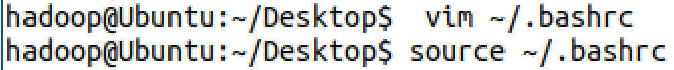

**查看版本**

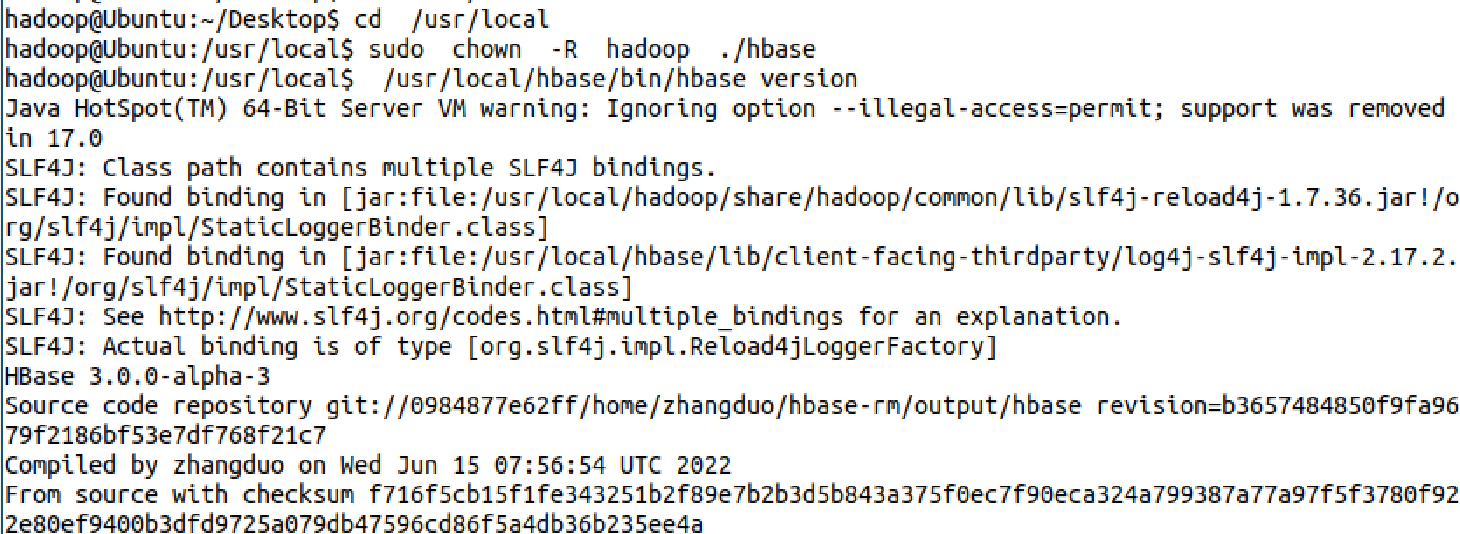

**单机模式配置**





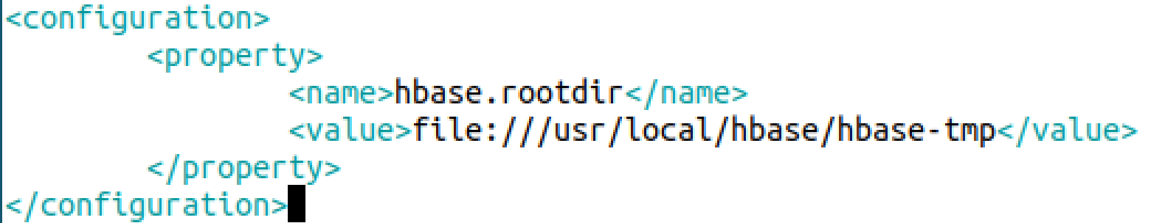

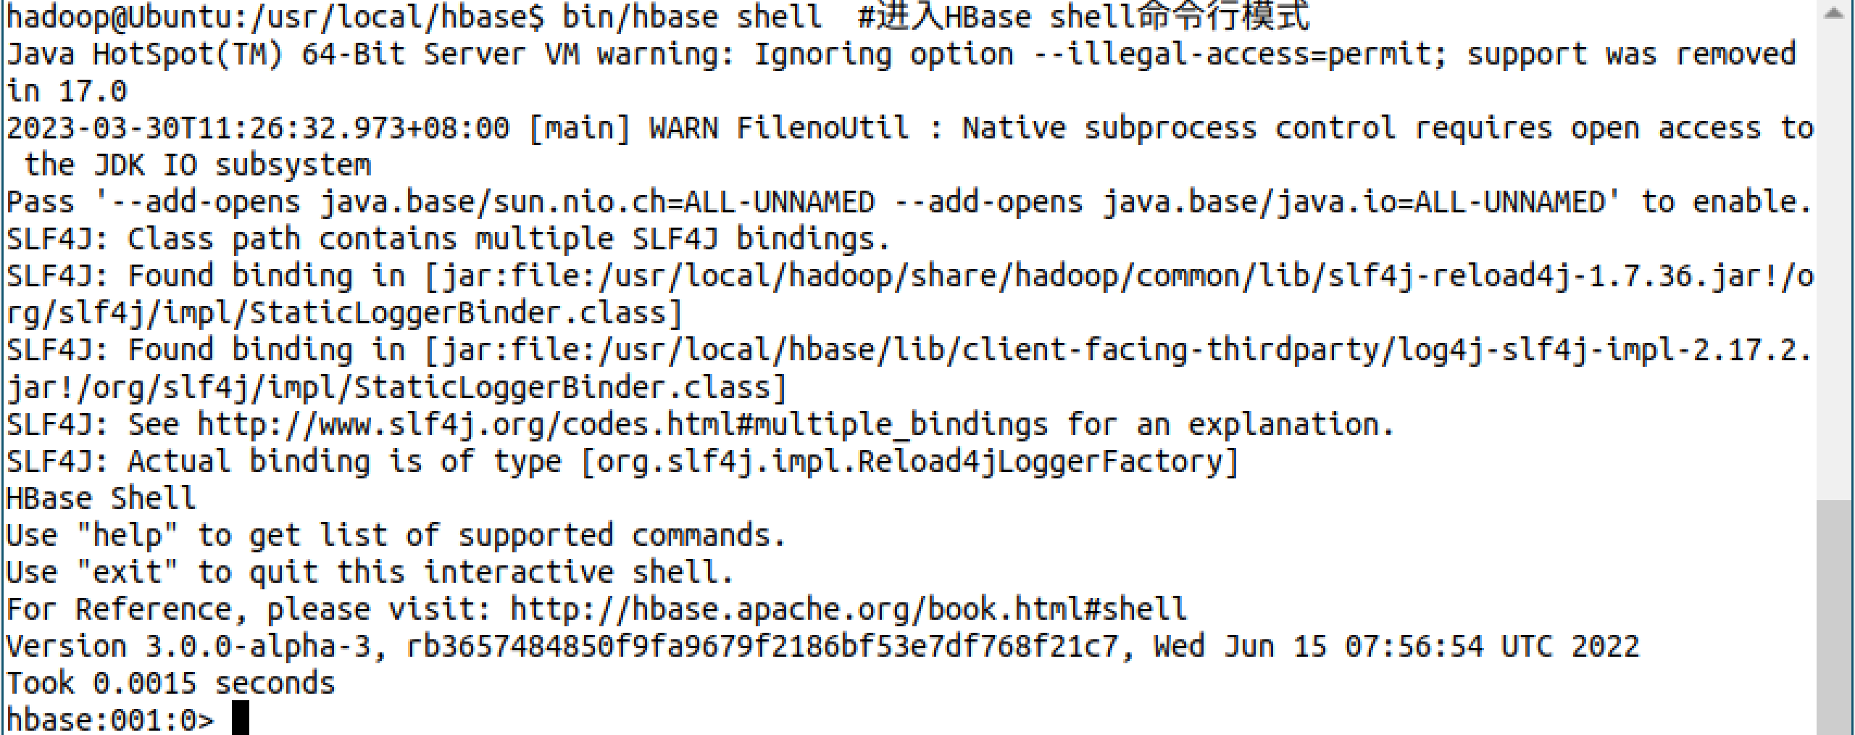

**Hbase配置成功**

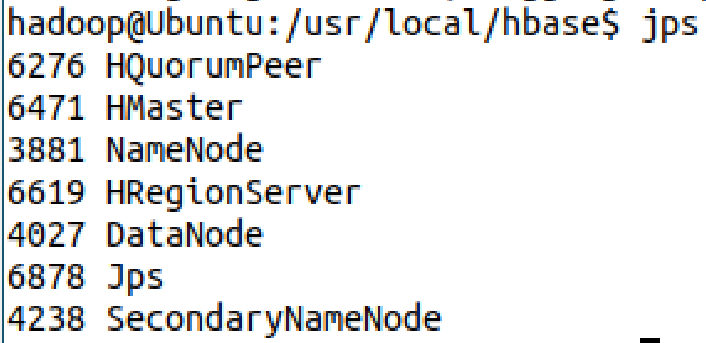

**Hbase创建表成功**

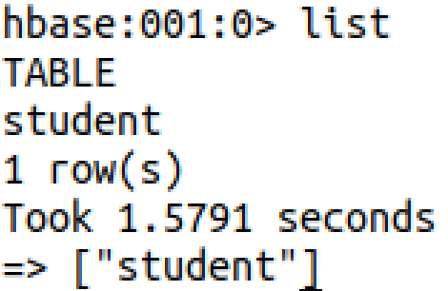

**添加数据**

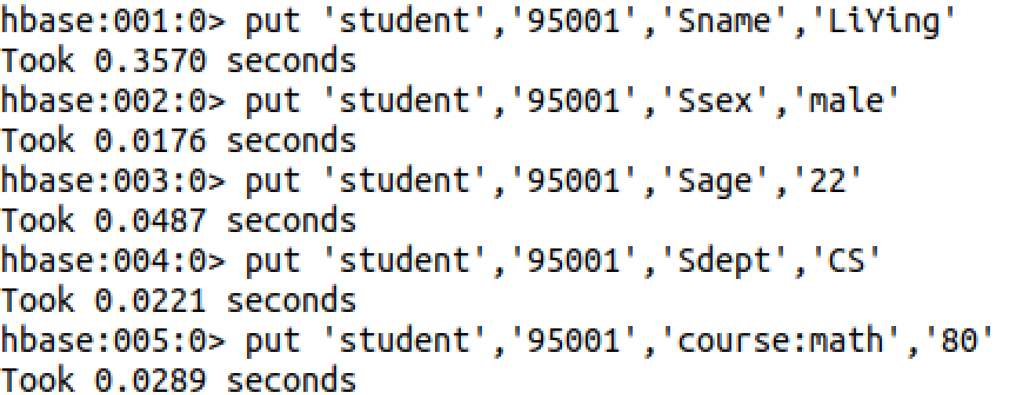

**查询数据**

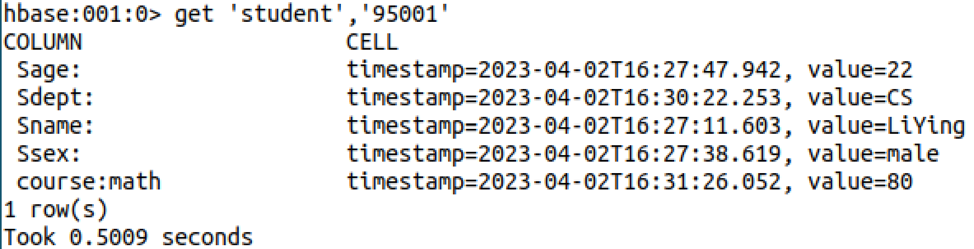

**编程实战**

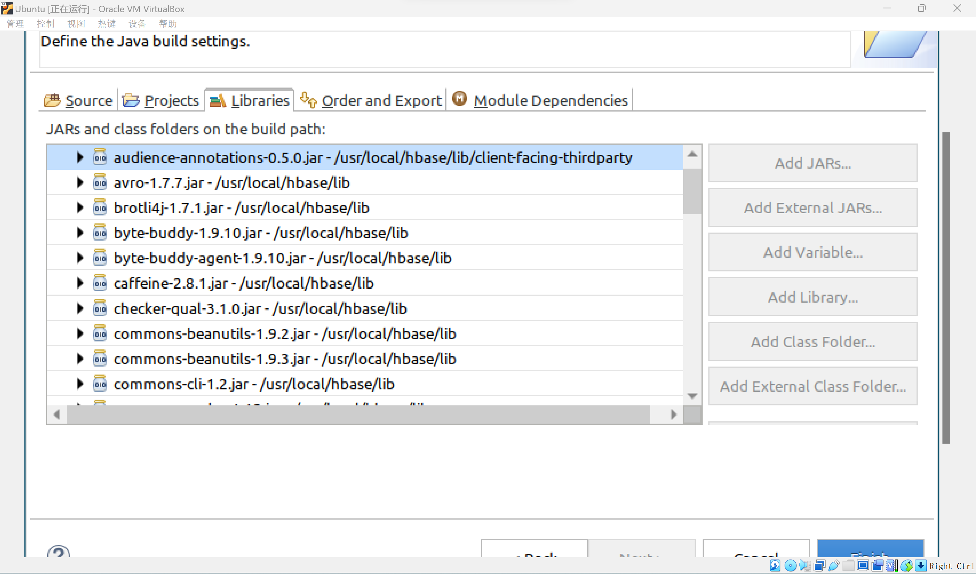

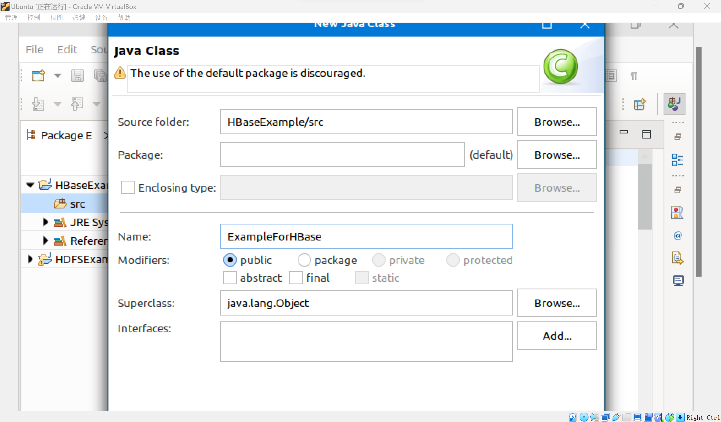

**运行结果为69**

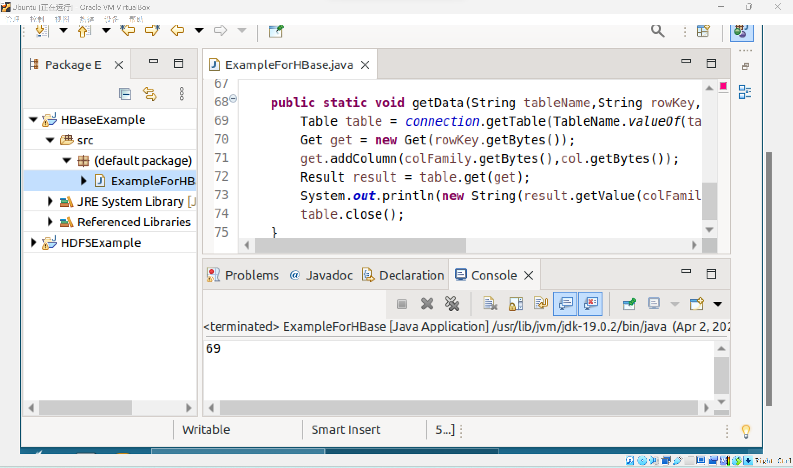

**编程实现功能**

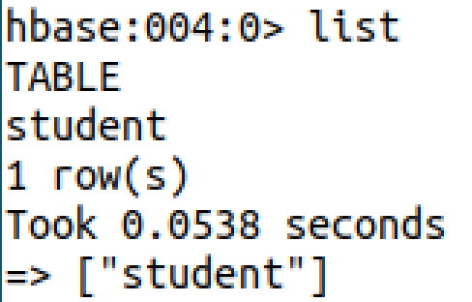

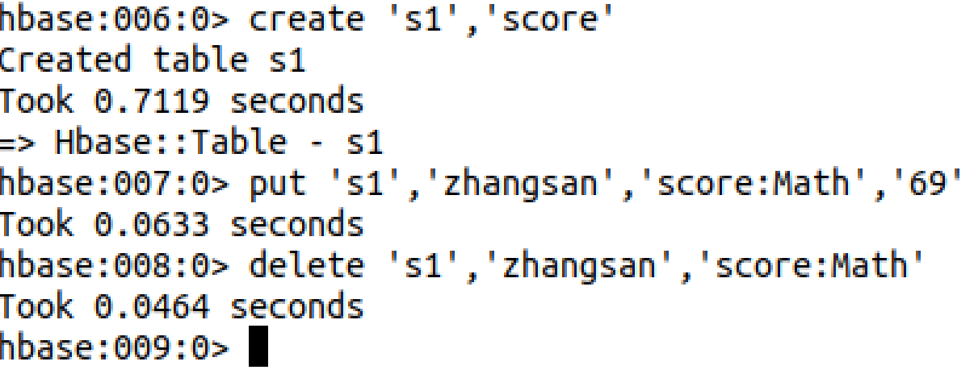

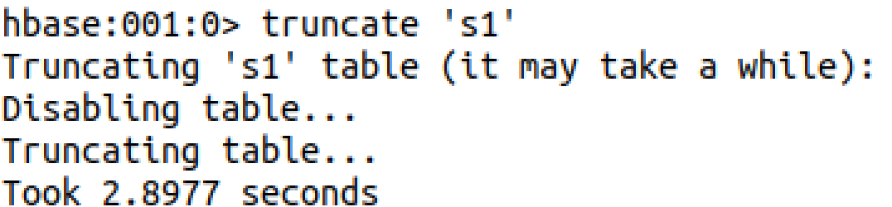

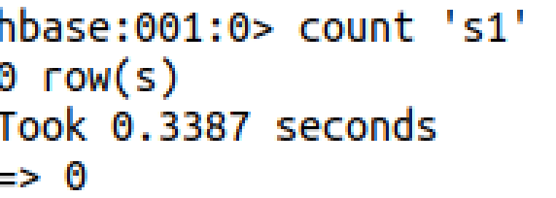

**Hbase数据库操作**

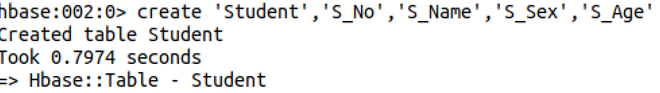

1. **思考讨论题或体会或对改进实验的建议**

可以使用Intellj IDEA作为项目IDE。

1. **实验源代码**

vim /usr/local/hbase/conf/hbase-env.sh

vim /usr/local/hbase/conf/hbase-site.xml

<configuration>

<property>

<name>hbase.rootdir</name>

<value>file:///usr/local/hbase/hbase-tmp</value>

</property>

</configuration>

cd /usr/local/hbase

bin/start-hbase.sh #启动HBase

bin/hbase shell #进入HBase shell命令行模式

cd /usr/local/hadoop

./sbin/start-dfs.sh

cd /usr/local/hbase

./bin/start-hbase.sh

./bin/hbase shell

hbase>create 'student','Sname','Ssex','Sage','Sdept','course'

import org.apache.hadoop.conf.Configuration;

import org.apache.hadoop.hbase.*;

import org.apache.hadoop.hbase.client.*;

import org.apache.hadoop.hbase.util.Bytes;

import java.io.IOException;

public class ExampleForHBase {

public static Configuration configuration;

public static Connection connection;

public static Admin admin;

public static void main(String[] args)throws IOException{

init();

createTable("student",new String[]{"score"});

insertData("student","zhangsan","score","English","69");

insertData("student","zhangsan","score","Math","86");

insertData("student","zhangsan","score","Computer","77");

getData("student", "zhangsan", "score","English");

close();

}

public static void init(){

configuration = HBaseConfiguration.create();

configuration.set("hbase.rootdir","hdfs://localhost:9000/hbase");

try{

connection = ConnectionFactory.createConnection(configuration);

admin = connection.getAdmin();

}catch (IOException e){

e.printStackTrace();

}

}

public static void close(){

try{

if(admin != null){

admin.close();

}

if(null != connection){

connection.close();

}

}catch (IOException e){

e.printStackTrace();

}

}

public static void createTable(String myTableName,String[] colFamily) throws IOException {

TableName tableName = TableName.valueOf(myTableName);

if(admin.tableExists(tableName)){

System.out.println("talbe is exists!");

}else {

TableDescriptorBuilder tableDescriptor = TableDescriptorBuilder.newBuilder(tableName);

for(String str:colFamily){

ColumnFamilyDescriptor family =

ColumnFamilyDescriptorBuilder.newBuilder(Bytes.toBytes(str)).build();

tableDescriptor.setColumnFamily(family);

}

admin.createTable(tableDescriptor.build());

}

}

public static void insertData(String tableName,String rowKey,String colFamily,String col,String val) throws IOException {

Table table = connection.getTable(TableName.valueOf(tableName));

Put put = new Put(rowKey.getBytes());

put.addColumn(colFamily.getBytes(),col.getBytes(), val.getBytes());

table.put(put);

table.close();

}

public static void getData(String tableName,String rowKey,String colFamily, String col)throws IOException{

Table table = connection.getTable(TableName.valueOf(tableName));

Get get = new Get(rowKey.getBytes());

get.addColumn(colFamily.getBytes(),col.getBytes());

Result result = table.get(get);

System.out.println(new String(result.getValue(colFamily.getBytes(),col==null?null:col.getBytes())));

table.close();

}

}

public static void listTables() throws IOException {

init();//建立连接

List<TableDescriptor> tableDescriptors = admin.listTableDescriptors();

for(TableDescriptor tableDescriptor : tableDescriptors){

TableName tableName = tableDescriptor.getTableName();

System.out.println("Table:" + tableName);

}

close();//关闭连接

}

//在终端打印出指定的表的所有记录数据

public static void getData(String tableName)throws IOException{

init();

Table table = connection.getTable(TableName.valueOf(tableName));

Scan scan = new Scan();

ResultScanner scanner = table.getScanner(scan);//获取行的遍历器

for (Result result:scanner){

printRecoder(result);

}

close();

}

//打印一条记录的详情

public static void printRecoder(Result result)throws IOException{

for(Cell cell:result.rawCells()){

System.out.print("行健: "+new String(Bytes.toString(cell.getRowArray(),cell.getRowOffset(), cell.getRowLength())));

System.out.print("列簇: "+new String( Bytes.toString(cell.getFamilyArray(),cell.getFamilyOffset(), cell.getFamilyLength()) ));

System.out.print(" 列: "+new String(Bytes.toString(cell.getQualifierArray(),cell.getQualifierOffset(), cell.getQualifierLength())));

System.out.print(" 值: "+new String(Bytes.toString(cell.getValueArray(),cell.getValueOffset(), cell.getValueLength())));

System.out.println("时间戳: "+cell.getTimestamp());

}

}

//向表添加数据

public static void insterRow(String tableName,String rowKey,String colFamily,String col,String val) throws IOException {

init();

Table table = connection.getTable(TableName.valueOf(tableName));

Put put = new Put(rowKey.getBytes());

put.addColumn(colFamily.getBytes(), col.getBytes(), val.getBytes());

table.put(put);

table.close();

close();

}

//删除数据

public static void deleRow(String tableName,String rowKey,String colFamily,String col) throws IOException {

init();

Table table = connection.getTable(TableName.valueOf(tableName));

Delete delete = new Delete(rowKey.getBytes());

//删除指定列族

delete.addFamily(Bytes.toBytes(colFamily));

//删除指定列

delete.addColumn(Bytes.toBytes(colFamily),Bytes.toBytes(col));

table.delete(delete);

table.close();

close();

}

//清空指定的表的所有记录数据

public static void clearRows(String tableName)throws IOException{

init();

TableName tablename = TableName.valueOf(tableName);

admin.disableTable(tablename);

admin.deleteTable(tablename);

TableDescriptorBuilder tableDescriptor = TableDescriptorBuilder.newBuilder(tablename);

admin.createTable(tableDescriptor.build());

close();

}

//统计表的行数

public static void countRows(String tableName)throws IOException{

init();

Table table = connection.getTable(TableName.valueOf(tableName));

Scan scan = new Scan();

ResultScanner scanner = table.getScanner(scan);

int num = 0;

for (Result result = scanner.next();result!=null;result=scanner.next()){

num++;

}

System.out.println("行数:"+ num);

scanner.close();

close();

}

public static void createTable(String tableName,String[] fields) throws IOException {

init();

TableName tablename = TableName.valueOf(tableName);

if(admin.tableExists(tablename)){

System.out.println("table is exists!");

admin.disableTable(tablename);

admin.deleteTable(tablename);//删除原来的表

}

TableDescriptorBuilder tableDescriptor = TableDescriptorBuilder.newBuilder(tablename);

for(String str : fields){

tableDescriptor.setColumnFamily(ColumnFamilyDescriptorBuilder.newBuilder(Bytes.toBytes(str)).build());

}

admin.createTable(tableDescriptor.build());

close();

}

public static void addRecord(String tableName,String row,String[] fields,String[] values) throws IOException {

init();

Table table = connection.getTable(TableName.valueOf(tableName));

for(int i = 0;i != fields.length;i++){

Put put = new Put(row.getBytes());

String[] cols = fields[i].split(":");

put.addColumn(cols[0].getBytes(), cols[1].getBytes(), values[i].getBytes());

table.put(put);

}

table.close();

close();

}

public static void scanColumn(String tableName,String column)throws IOException{

init();

Table table = connection.getTable(TableName.valueOf(tableName));

Scan scan = new Scan();

scan.addFamily(Bytes.toBytes(column));

ResultScanner scanner = table.getScanner(scan);

for (Result result = scanner.next(); result != null; result = scanner.next()){

showCell(result);

}

table.close();

close();

}

//格式化输出

public static void showCell(Result result){

Cell[] cells = result.rawCells();

for(Cell cell:cells){

System.out.println("RowName:"+new String(Bytes.toString(cell.getRowArray(),cell.getRowOffset(), cell.getRowLength()))+" ");

System.out.println("Timetamp:"+cell.getTimestamp()+" ");

System.out.println("column Family:"+new String(Bytes.toString(cell.getFamilyArray(),cell.getFamilyOffset(), cell.getFamilyLength()))+" ");

System.out.println("row Name:"+new String(Bytes.toString(cell.getQualifierArray(),cell.getQualifierOffset(), cell.getQualifierLength()))+" ");

System.out.println("value:"+new String(Bytes.toString(cell.getValueArray(),cell.getValueOffset(), cell.getValueLength()))+" ");

}

}

public static void scanColumn(String tableName,String column)throws IOException{

init();

Table table = connection.getTable(TableName.valueOf(tableName));

Scan scan = new Scan();

scan.addFamily(Bytes.toBytes(column));

ResultScanner scanner = table.getScanner(scan);

for (Result result = scanner.next(); result != null; result = scanner.next()){

showCell(result);

}

table.close();

close();

}

//格式化输出

public static void showCell(Result result){

Cell[] cells = result.rawCells();

for(Cell cell:cells){

System.out.println("RowName:"+new String(Bytes.toString(cell.getRowArray(),cell.getRowOffset(), cell.getRowLength()))+" ");

System.out.println("Timetamp:"+cell.getTimestamp()+" ");

System.out.println("column Family:"+new String(Bytes.toString(cell.getFamilyArray(),cell.getFamilyOffset(), cell.getFamilyLength()))+" ");

System.out.println("row Name:"+new String(Bytes.toString(cell.getQualifierArray(),cell.getQualifierOffset(), cell.getQualifierLength()))+" ");

System.out.println("value:"+new String(Bytes.toString(cell.getValueArray(),cell.getValueOffset(), cell.getValueLength()))+" ");

}

}

# 实验四 **NoSQL和关系数据库的操作比较**

|  |  |  |  |  |
| --- | --- | --- | --- | --- |
| **地 点：** | B10楼 | 303房； | **实验台号：** |  |
| **实验日期与时间：** | 2023/4/6 | | **评 分：** |  |
| **预习检查纪录：** |  | | **实验教师：** | 焦青松 |

1. **实验目的**

**（1）.理解4种数据库(MySQL,HBase,Redis,MongoDB)的概念和不同点。**

**(2).熟练使用4种数据库操作常用的Shell命令**

**(3).熟悉4种数据库操作常用的Java API。**

1. **实验平台**

(1).操作系统:Linux

(2).Hadoop版本:3.3.5

(3).Hbase版本：3.0.0

(4).JDK版本:19.3.0

(5).Java IDE:eclipse

(6).Redis版本:6.0.0

(7)MySQL版本:8.0

(8).MongoDB版本:6.0.5

1. **实验步骤（包括实验结果/截图）**

**Redis的安装**

**先下载.tar.gz。之后使用make命令进行编译。**

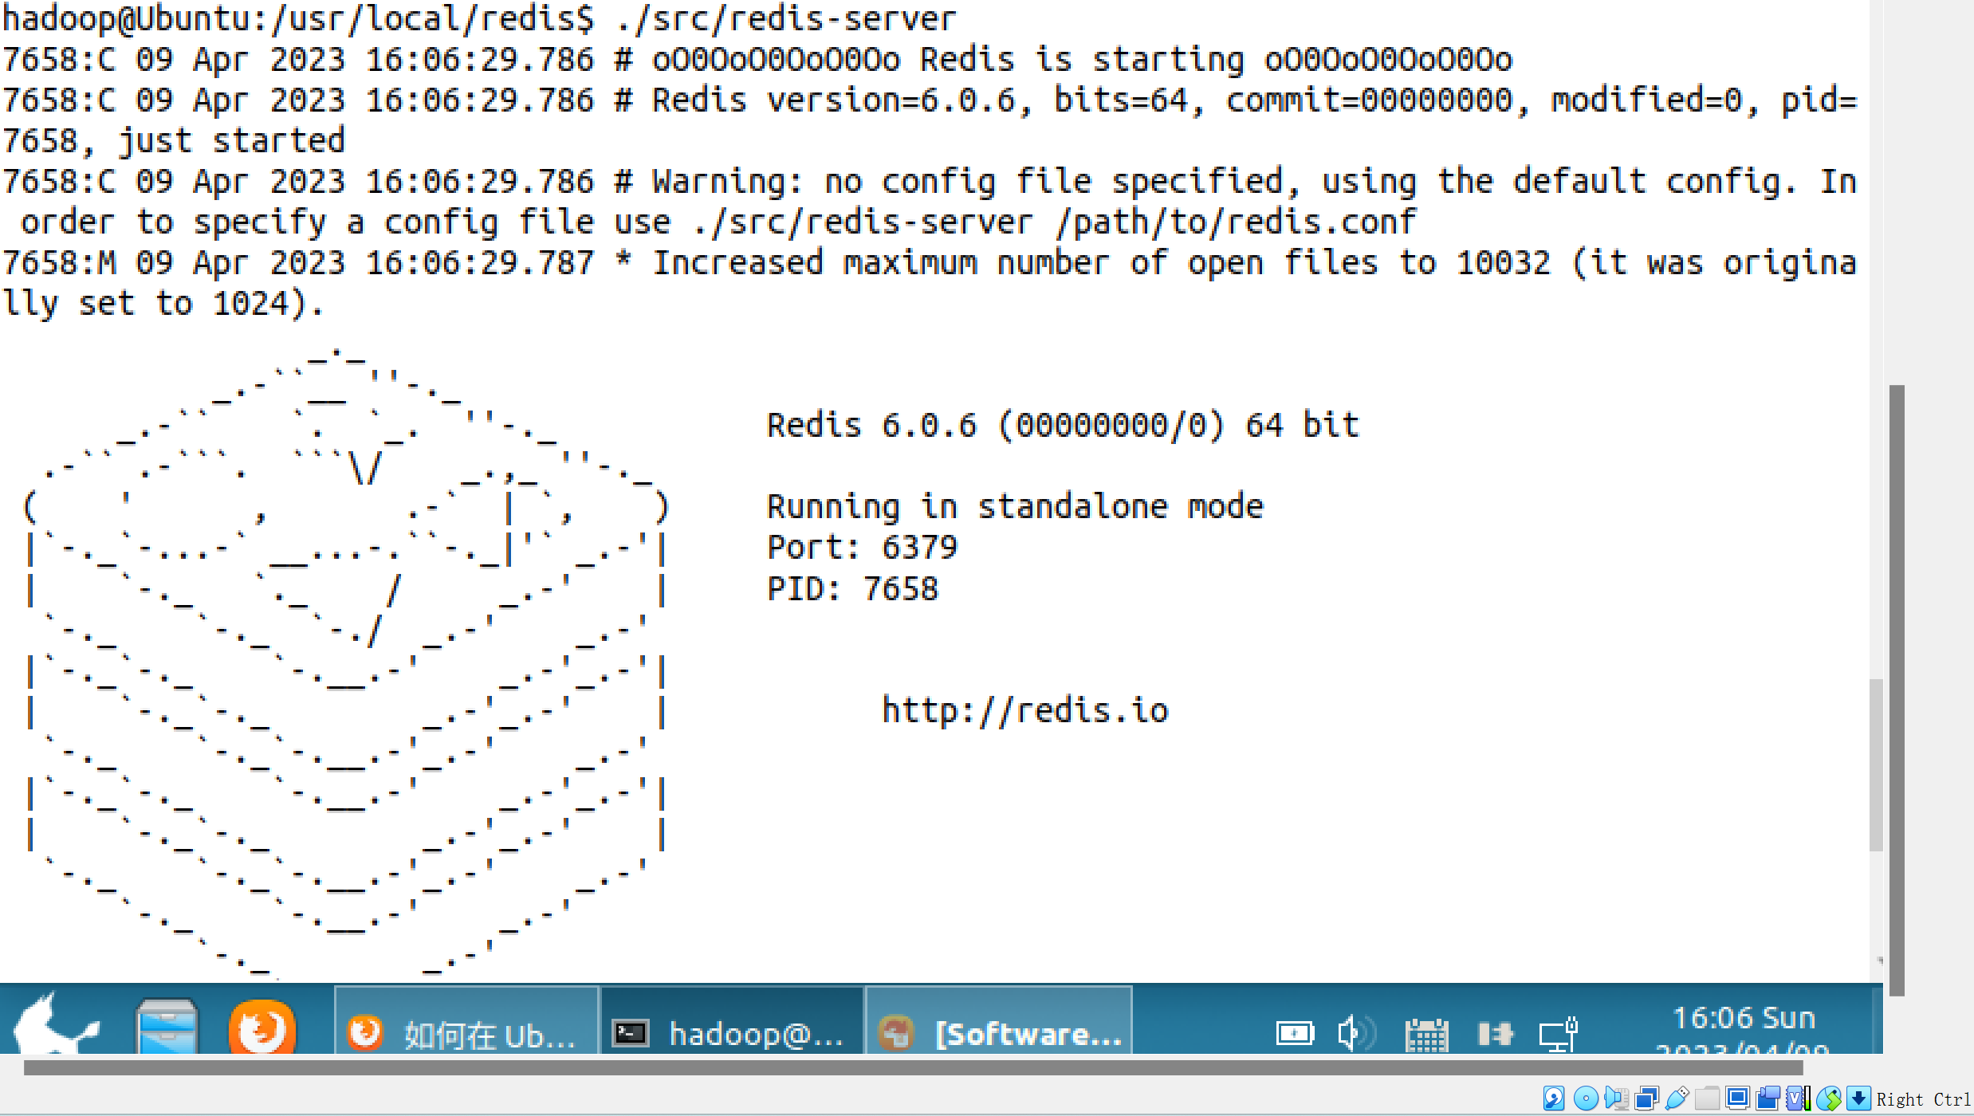

**Redis安装成功。**

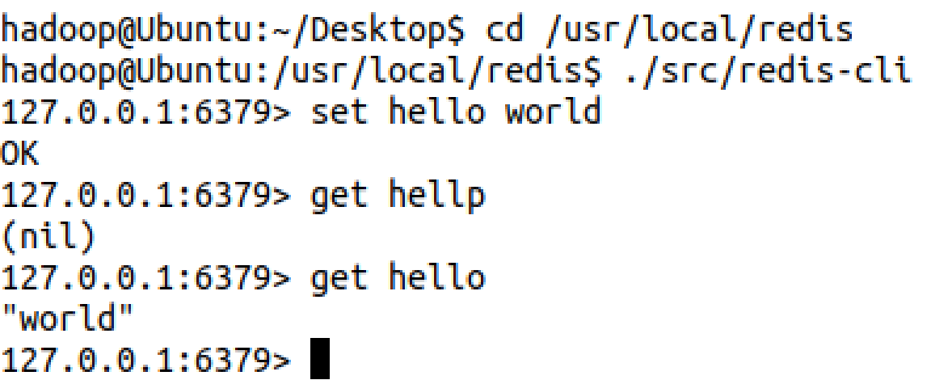

**客户端连上服务器。**

**MySQL的安装 这里直接使用了apt-get的方法的进行安装，很方便。**

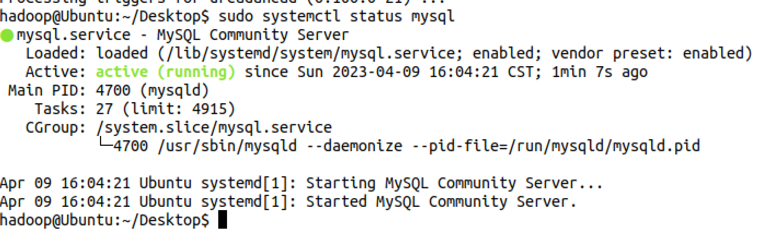

**Mysql安装成功。**

**MongoDB的安装**

**从他们官网上找方法安装。**

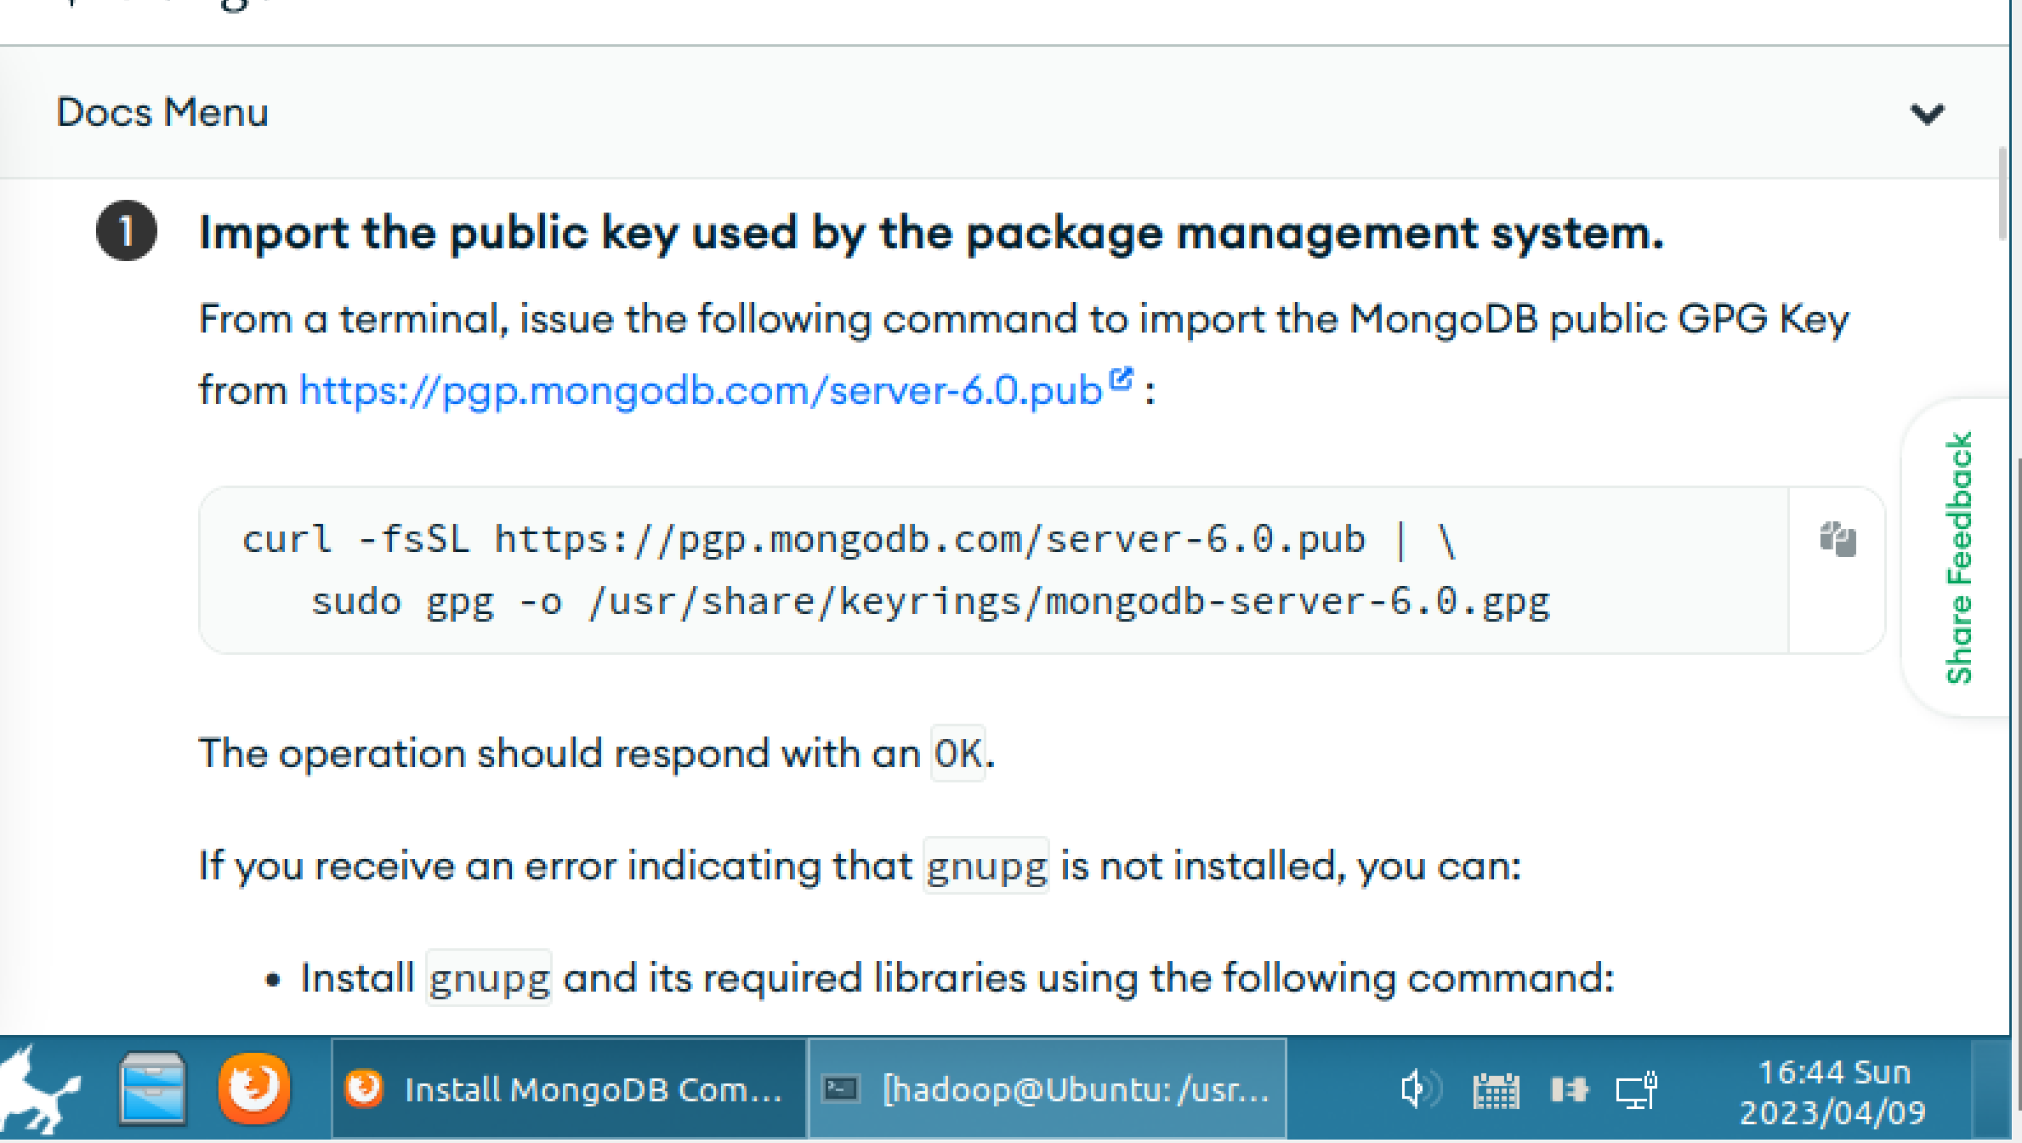

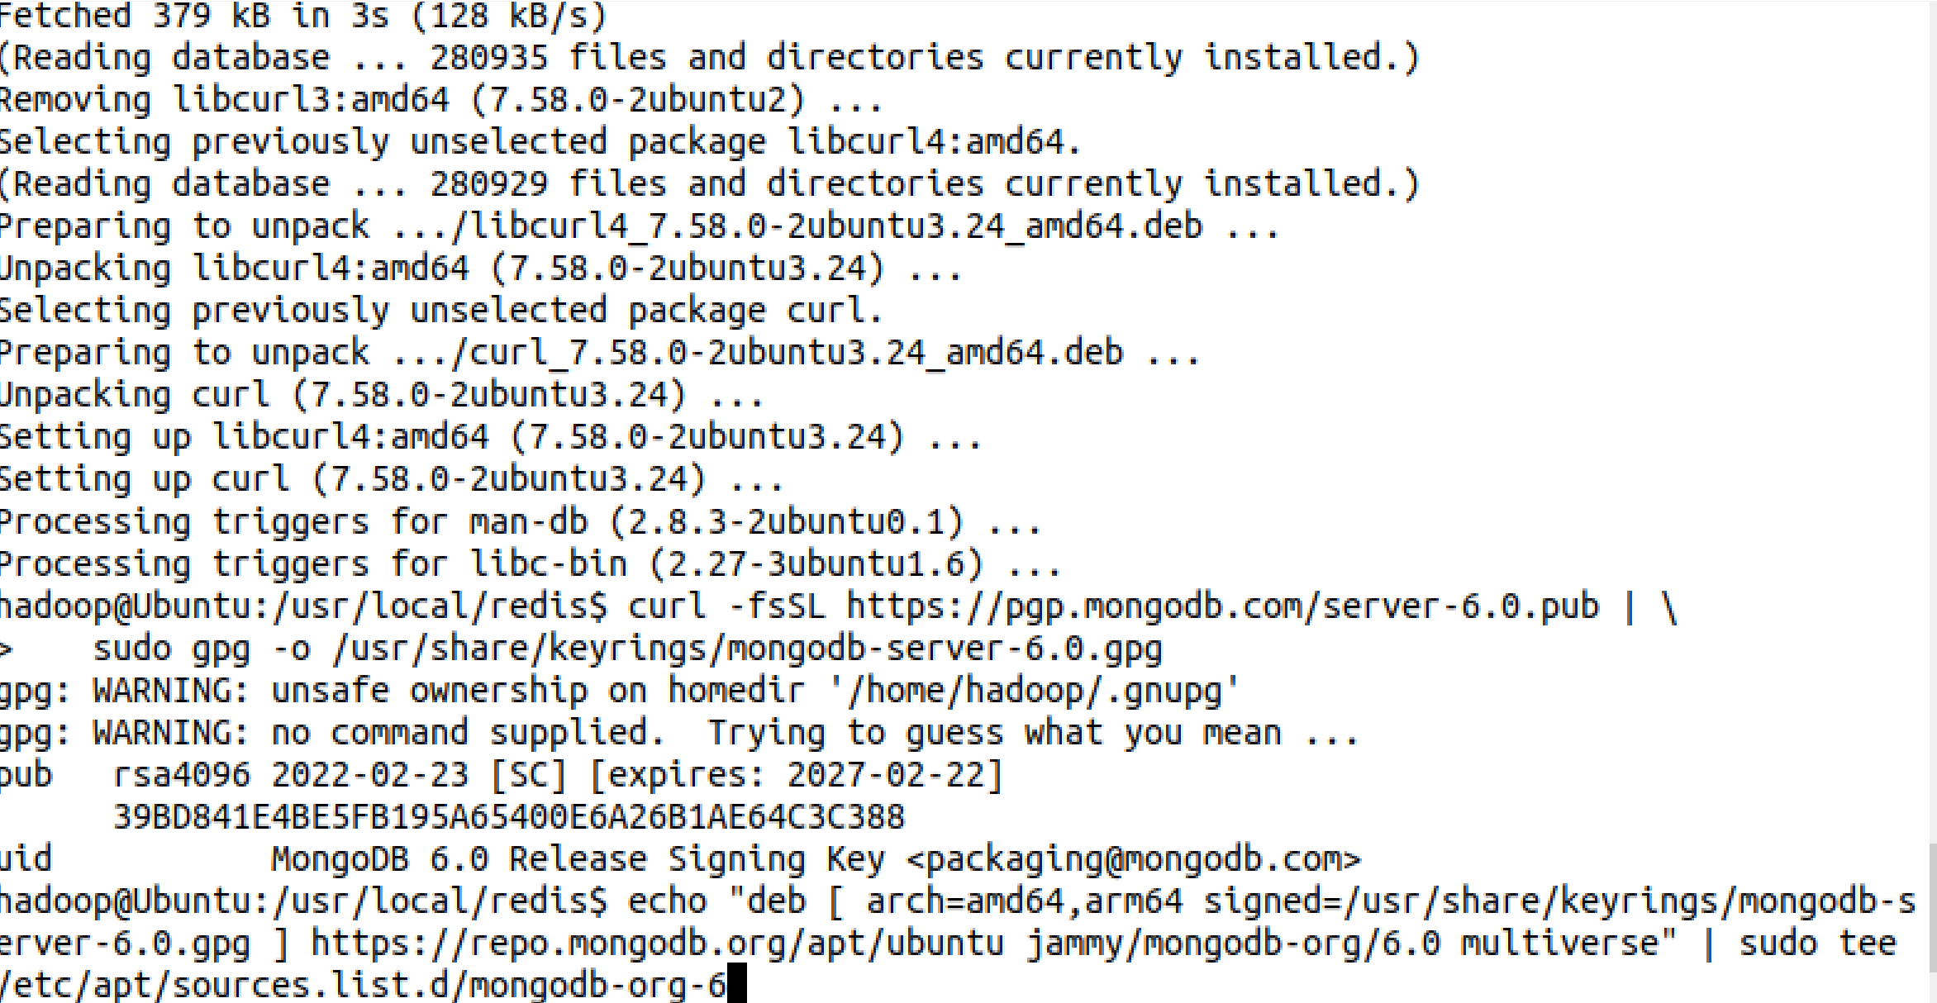

**更新源**

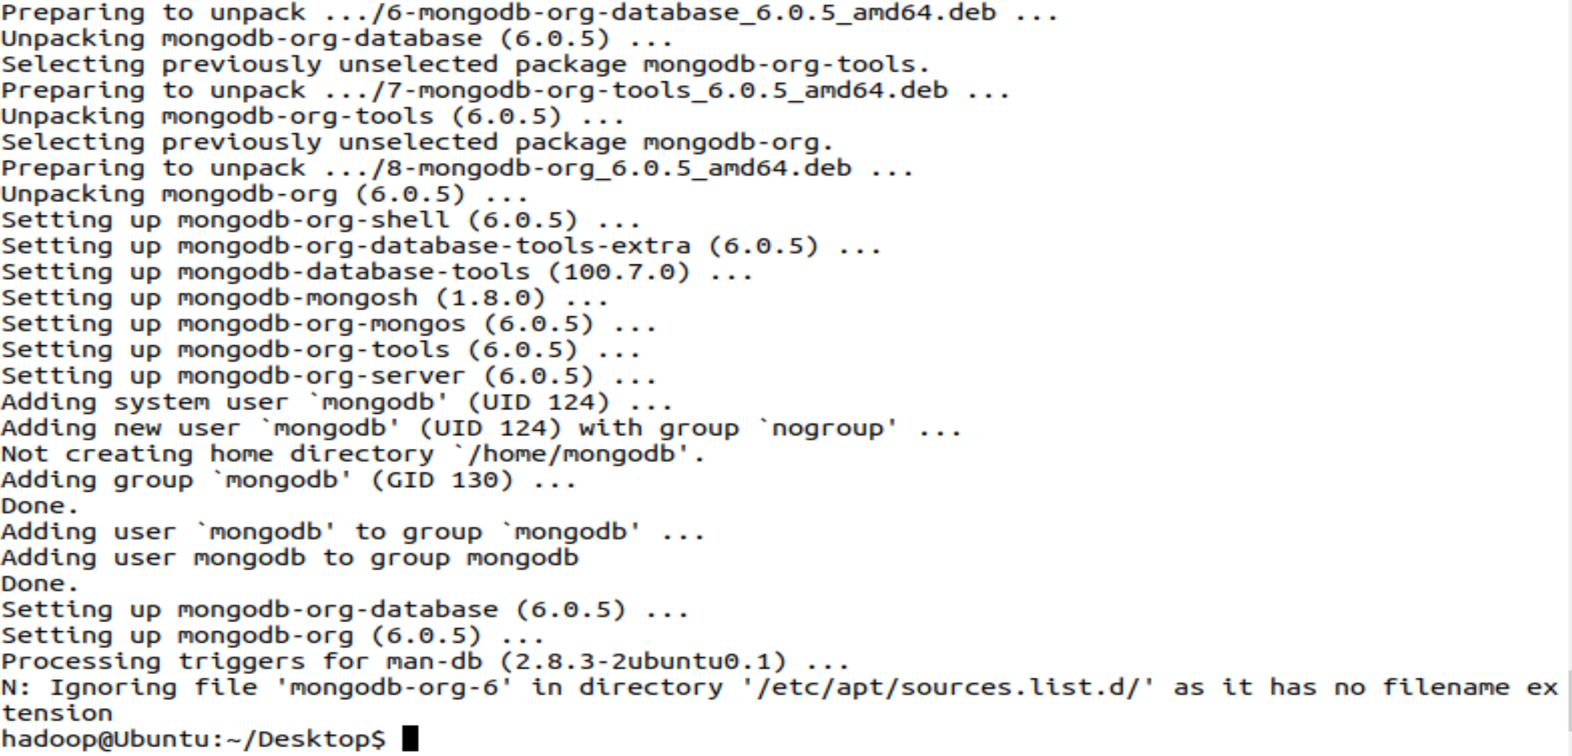

**在6.0版本mongoDB以后，需要安装mongodb-clients才能进行。**

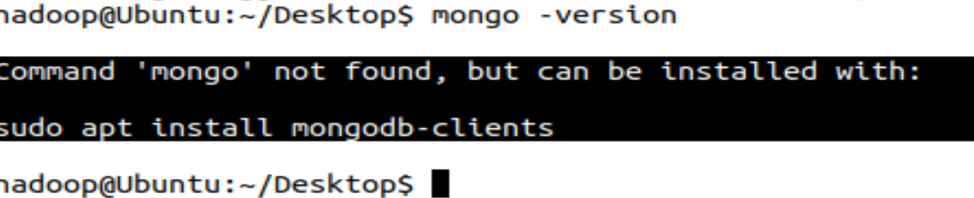

**启动成功**

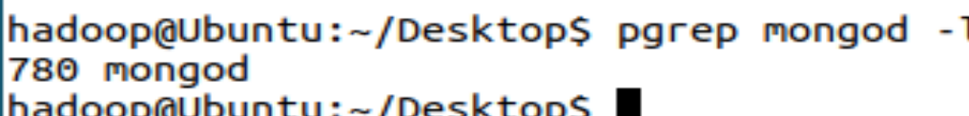

**Java API编程实例**

**先下载jar包，之后新建项目。**

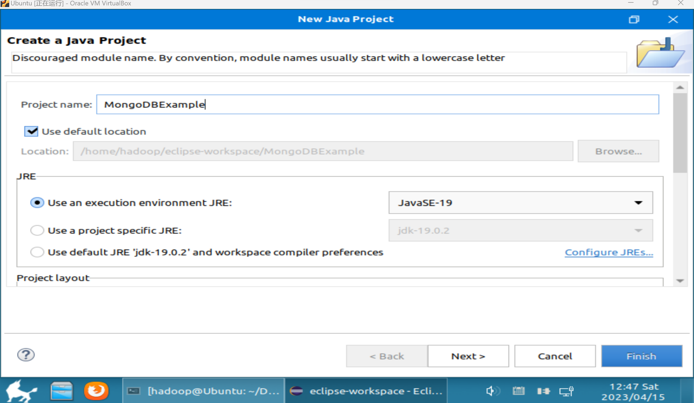

**添加jar包**

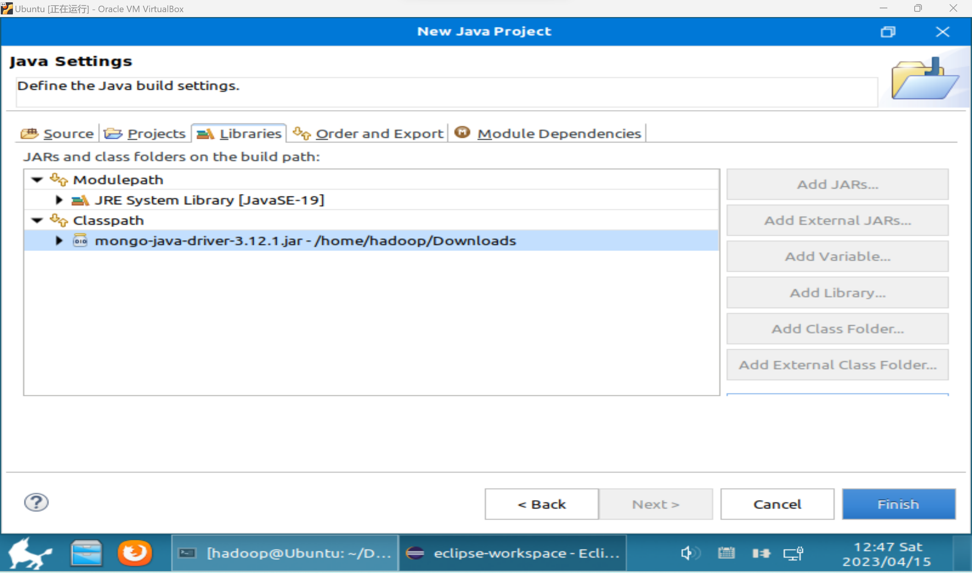

**Mysql数据库操作**

**登陆mysql**

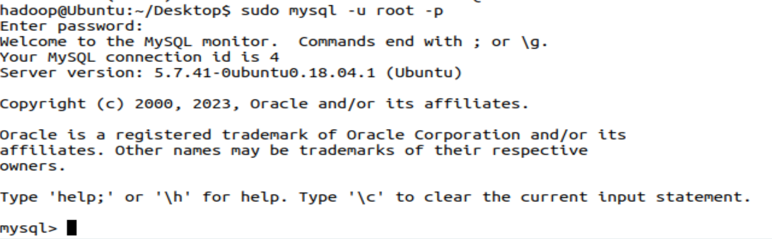

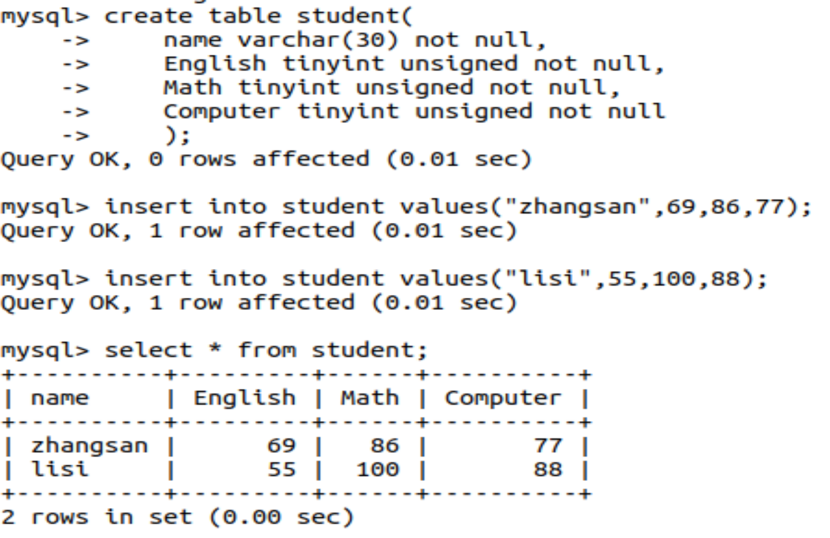

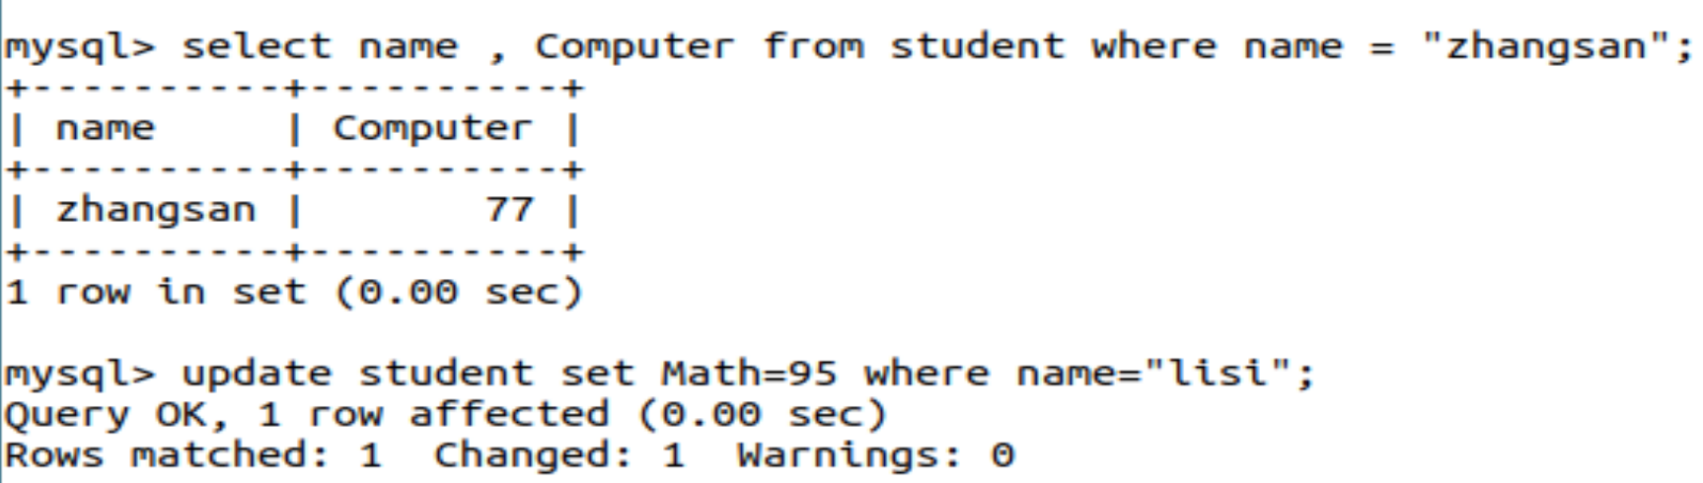

**使用java编程。**

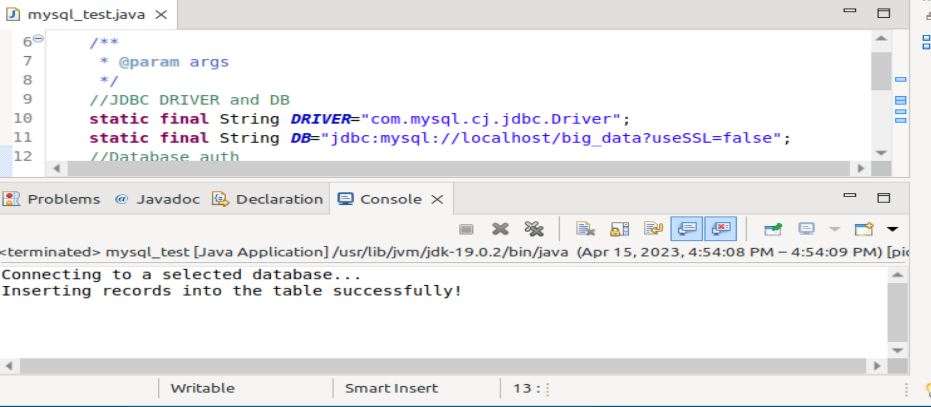

**Hbase操作**

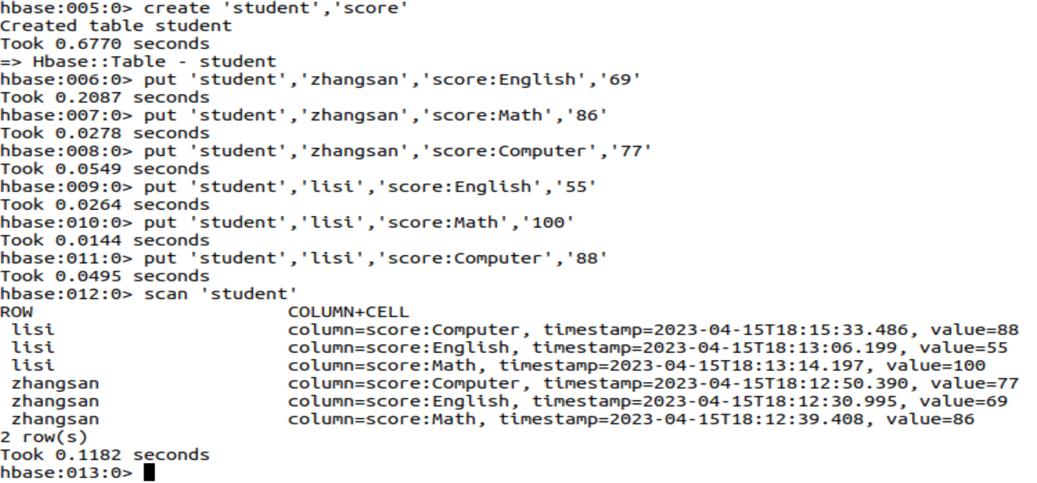

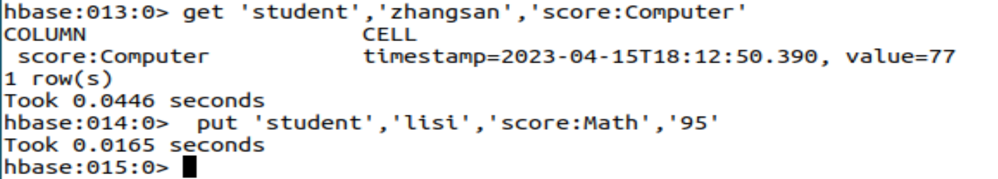

**添加数据**

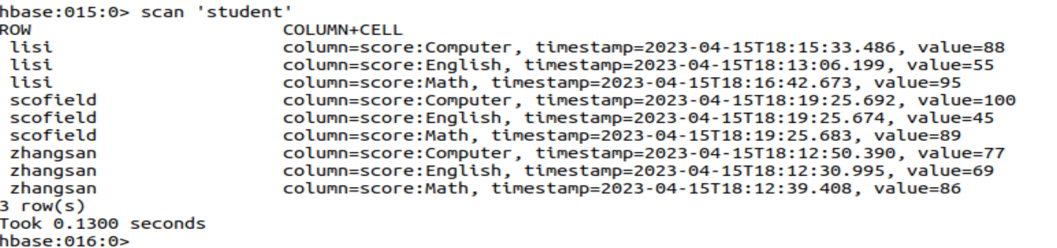

**使用java获取数据**

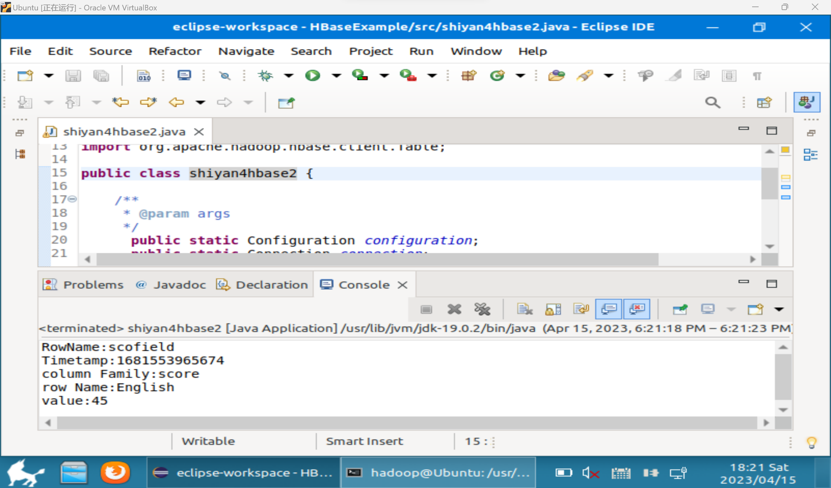

**Redis操作**

**使用shell操作**

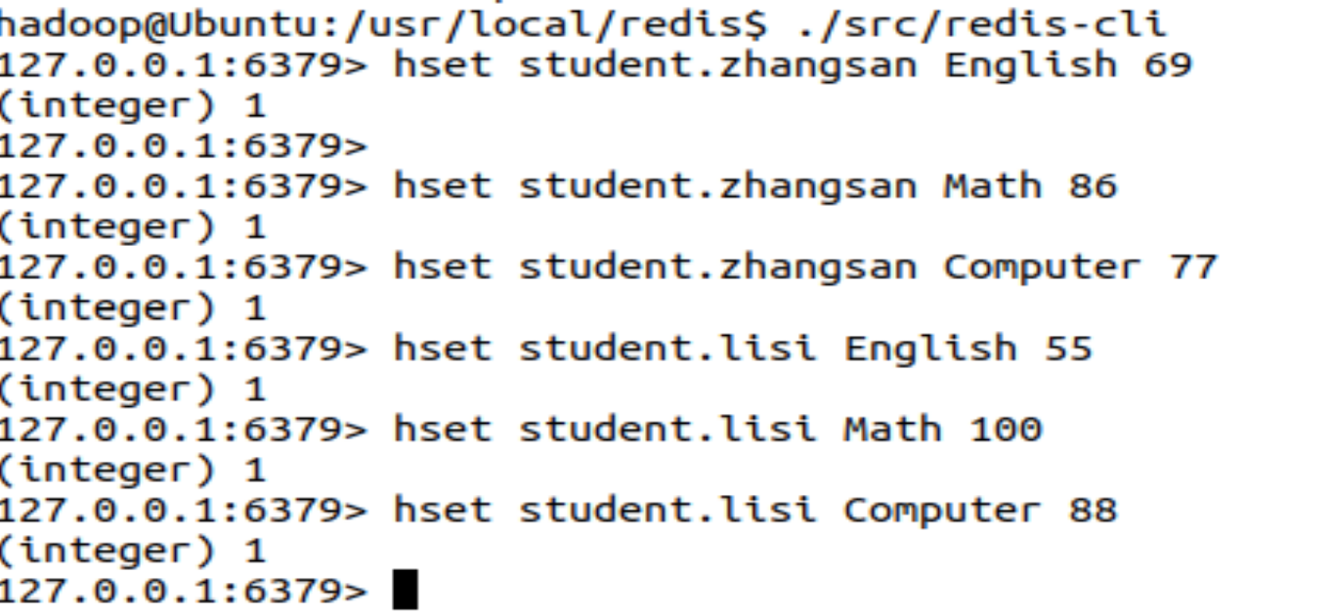

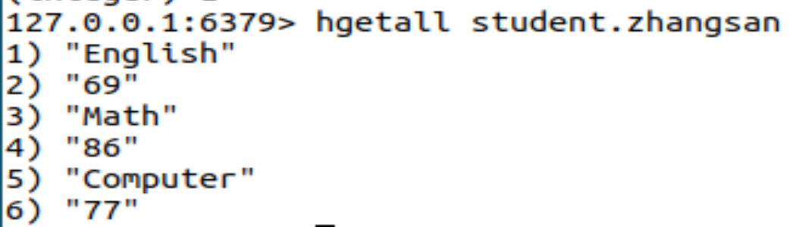

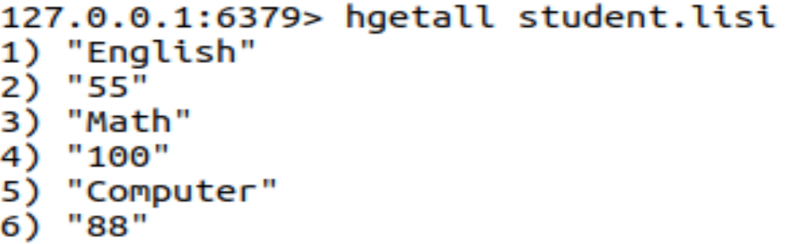





1. **思考讨论题或体会或对改进实验的建议**

**4种数据库的使用方法需要熟练掌握，nosql数据库和关系型数据库之间的区别与联系也值得探讨。**

1. **实验源代码**

**cd ~**

**sudo tar -zxvf ./下载/redis-5.0.5.tar.gz -C /usr/local**

**cd /usr/local**

**sudo mv ./redis-5.0.5 ./redis**

sudo apt install mysql-server

sudo apt update

sudo systemctl status mysql

curl -fsSL https://pgp.mongodb.com/server-6.0.pub | \

sudo gpg -o /usr/share/keyrings/mongodb-server-6.0.gpg

import java.util.ArrayList;

import java.util.List;

import org.bson.Document;

import com.mongodb.MongoClient;

import com.mongodb.client.MongoCollection;

import com.mongodb.client.MongoCursor;

import com.mongodb.client.MongoDatabase;

import com.mongodb.client.model.Filters;

public class TestMongoDB {

/**

* @param args

*/

public static void main(String[] args) {

// insert();//插入数据。执行插入时，可将其他三句函数调用语句注释，下同

find(); //查找数据

// update();//更新数据

// delete();//删除数据

}

/**

* 返回指定数据库中的指定集合

* @param dbname 数据库名

* @param collectionname 集合名

* @return

*/

//MongoDB无需预定义数据库和集合,在使用的时候会自动创建

public static MongoCollection<Document> getCollection(String dbname,String collectionname){

//实例化一个mongo客户端,服务器地址：localhost(本地)，端口号：27017

MongoClient mongoClient=new MongoClient("localhost",27017);

//实例化一个mongo数据库

MongoDatabase mongoDatabase = mongoClient.getDatabase(dbname);

//获取数据库中某个集合

MongoCollection<Document> collection = mongoDatabase.getCollection(collectionname);

return collection;

}

/**

* 插入数据

*/

public static void insert(){

try{

//连接MongoDB，指定连接数据库名，指定连接表名。

MongoCollection<Document> collection= getCollection("School","student"); //数据库名:School 集合名:student

//实例化一个文档,文档内容为{sname:'Mary',sage:25}，如果还有其他字段，可以继续追加append

Document doc1=new Document("sname","Mary").append("sage", 25);

//实例化一个文档,文档内容为{sname:'Bob',sage:20}

Document doc2=new Document("sname","Bob").append("sage", 20);

List<Document> documents = new ArrayList<Document>();

//将doc1、doc2加入到documents列表中

documents.add(doc1);

documents.add(doc2);

//将documents插入集合

collection.insertMany(documents);

System.out.println("插入成功");

}catch(Exception e){

System.err.println( e.getClass().getName() + ": " + e.getMessage() );

}

}

/**

* 查询数据

*/

public static void find(){

try{

MongoCollection<Document> collection = getCollection("School","student"); //数据库名:School 集合名:student

//通过游标遍历检索出的文档集合

// MongoCursor<Document> cursor= collection.find(new Document("sname","Mary")). projection(new Document("sname",1).append("sage",1).append("_id", 0)).iterator(); //find查询条件：sname='Mary'。projection筛选：显示sname和sage,不显示_id(_id默认会显示)

//查询所有数据

MongoCursor<Document> cursor= collection.find().iterator();

while(cursor.hasNext()){

System.out.println(cursor.next().toJson());

}

}catch(Exception e){

System.err.println( e.getClass().getName() + ": " + e.getMessage() );

}

}

/**

* 更新数据

*/

public static void update(){

try{

MongoCollection<Document> collection = getCollection("School","student"); //数据库名:School 集合名:student

//更新文档，将文档中sname='Mary'的文档修改为sage=22

collection.updateMany(Filters.eq("sname", "Mary"), new Document("$set",new Document("sage",22)));

System.out.println("更新成功！");

}catch(Exception e){

System.err.println( e.getClass().getName() + ": " + e.getMessage() );

}

}

/**

* 删除数据

*/

public static void delete(){

try{

MongoCollection<Document> collection = getCollection("School","student"); //数据库名:School 集合名:student

//删除符合条件的第一个文档

collection.deleteOne(Filters.eq("sname", "Bob"));

//删除所有符合条件的文档

//collection.deleteMany (Filters.eq("sname", "Bob"));

System.out.println("删除成功！");

}catch(Exception e){

System.err.println( e.getClass().getName() + ": " + e.getMessage() );

}

}

}

import java.io.IOException;

import org.apache.hadoop.conf.Configuration;

import org.apache.hadoop.hbase.HBaseConfiguration;

import org.apache.hadoop.hbase.TableName;

import org.apache.hadoop.hbase.client.Admin;

import org.apache.hadoop.hbase.client.Connection;

import org.apache.hadoop.hbase.client.ConnectionFactory;

import org.apache.hadoop.hbase.client.Put;

import org.apache.hadoop.hbase.client.Table;

public class hbase_insert {

/**

* @param args

*/

public static Configuration configuration;

public static Connection connection;

public static Admin admin;

public static void main(String[] args) {

// TODO Auto-generated method stub

configuration = HBaseConfiguration.create();

configuration.set("hbase.rootdir","hdfs://localhost:9000/hbase");

try{

connection = ConnectionFactory.createConnection(configuration);

admin = connection.getAdmin();

}catch (IOException e){

e.printStackTrace();

}

try {

insertRow("student","scofield","score","English","45");

insertRow("student","scofield","score","Math","89");

insertRow("student","scofield","score","Computer","100");

} catch (IOException e) {

// TODO Auto-generated catch block

e.printStackTrace();

}

close();

}

public static void insertRow(String tableName,String rowKey,String colFamily,

String col,String val) throws IOException {

Table table = connection.getTable(TableName.valueOf(tableName));

Put put = new Put(rowKey.getBytes());

put.addColumn(colFamily.getBytes(), col.getBytes(), val.getBytes());

table.put(put);

table.close();

}

public static void close(){

try{

if(admin != null){

admin.close();

}

if(null != connection){

connection.close();

}

}catch (IOException e){

e.printStackTrace();

}

}

}

**import java.io.IOException;**

**import org.apache.hadoop.conf.Configuration;**

**import org.apache.hadoop.hbase.Cell;**

**import org.apache.hadoop.hbase.CellUtil;**

**import org.apache.hadoop.hbase.HBaseConfiguration;**

**import org.apache.hadoop.hbase.TableName;**

**import org.apache.hadoop.hbase.client.Admin;**

**import org.apache.hadoop.hbase.client.Connection;**

**import org.apache.hadoop.hbase.client.ConnectionFactory;**

**import org.apache.hadoop.hbase.client.Get;**

**import org.apache.hadoop.hbase.client.Put;**

**import org.apache.hadoop.hbase.client.Result;**

**import org.apache.hadoop.hbase.client.Table;**

**public class hbase_query {**

**/\*\***

**\* @param args**

**\*/**

**public static Configuration configuration;**

**public static Connection connection;**

**public static Admin admin;**

**public static void main(String[] args) {**

**// TODO Auto-generated method stub**

**configuration = HBaseConfiguration.create();**

**configuration.set("hbase.rootdir","hdfs://localhost:9000/hbase");**

**try{**

**connection = ConnectionFactory.createConnection(configuration);**

**admin = connection.getAdmin();**

**}catch (IOException e){**

**e.printStackTrace();**

**}**

**try {**

**getData("student","scofield","score","English");**

**} catch (IOException e) {**

**// TODO Auto-generated catch block**

**e.printStackTrace();**

**}**

**close();**

**}**

**public static void getData(String tableName,String rowKey,String colFamily,**

**String col)throws IOException{**

**Table table = connection.getTable(TableName.valueOf(tableName));**

**Get get = new Get(rowKey.getBytes());**

**get.addColumn(colFamily.getBytes(),col.getBytes());**

**Result result = table.get(get);**

**showCell(result);**

**table.close();**

**}**

**public static void showCell(Result result){**

**Cell[] cells = result.rawCells();**

**for(Cell cell:cells){**

**System.out.println("RowName:"+new String(CellUtil.cloneRow(cell))+" ");**

**System.out.println("Timetamp:"+cell.getTimestamp()+" ");**

**System.out.println("column Family:"+new String(CellUtil.cloneFamily(cell))+" ");**

**System.out.println("row Name:"+new String(CellUtil.cloneQualifier(cell))+" ");**

**System.out.println("value:"+new String(CellUtil.cloneValue(cell))+" ");**

**}**

**}**

**public static void close(){**

**try{**

**if(admin != null){**

**admin.close();**

**}**

**if(null != connection){**

**connection.close();**

**}**

**}catch (IOException e){**

**e.printStackTrace();**

**}**

**}**

**}**

hset student.zhangsan English 69

hset student.zhangsan Math 86

hset student.zhangsan Computer 77

hset student.lisi English 55

hset student.lisi Math 100

hset student.lisi Computer 88

**import java.util.Map;**

**import redis.clients.jedis.Jedis;**

**public class jedis_test {**

**/\*\***

**\* @param args**

**\*/**

**public static void main(String[] args) {**

**// TODO Auto-generated method stub**

**Jedis jedis = new Jedis("localhost");**

**jedis.hset("student.scofield", "English","45");**

**jedis.hset("student.scofield", "Math","89");**

**jedis.hset("student.scofield", "Computer","100");**

**Map<String,String> value = jedis.hgetAll("student.scofield");**

**for(Map.Entry<String, String> entry:value.entrySet())**

**{**

**System.out.println(entry.getKey()+":"+entry.getValue());**

**}**

**}**

**}**

**import java.util.Map;**

**import redis.clients.jedis.Jedis;**

**public class jedis_query {**

**/\*\***

**\* @param args**

**\*/**

**public static void main(String[] args) {**

**// TODO Auto-generated method stub**

**Jedis jedis = new Jedis("localhost");**

**String value=jedis.hget("student.scofield", "English");**

**System.out.println("scofield's English score is: "+value);**

**}**

**}**

**import java.util.ArrayList;**

**import java.util.List;**

**import org.bson.Document;**

**import com.mongodb.MongoClient;**

**import com.mongodb.client.MongoCollection;**

**import com.mongodb.client.MongoDatabase;**

**public class mongo_insert {**

**/\*\***

**\* @param args**

**\*/**

**public static void main(String[] args) {**

**// TODO Auto-generated method stub**

**//实例化一个mongo客户端**

**MongoClient mongoClient=new MongoClient("localhost",27017);**

**//实例化一个mongo数据库**

**MongoDatabase mongoDatabase = mongoClient.getDatabase("student");**

**//获取数据库中某个集合**

**MongoCollection<Document> collection = mongoDatabase.getCollection("student");**

**//实例化一个文档,内嵌一个子文档**

**Document document=new Document("name","scofield").**

**append("score", new Document("English",45).**

**append("Math", 89).**

**append("Computer", 100));**

**List<Document> documents = new ArrayList<Document>();**

**documents.add(document);**

**//将文档插入集合中**

**collection.insertMany(documents);**

**System.out.println("文档插入成功");**

**}**

**import java.util.ArrayList;**

**import java.util.List;**

**import org.bson.Document;**

**import com.mongodb.MongoClient;**

**import com.mongodb.client.MongoCollection;**

**import com.mongodb.client.MongoCursor;**

**import com.mongodb.client.MongoDatabase;**

**import com.mongodb.client.model.Filters;**

**import static com.mongodb.client.model.Filters.eq;**

**public class mongo_query {**

**/\*\***

**\* @param args**

**\*/**

**public static void main(String[] args) {**

**// TODO Auto-generated method stub**

**//实例化一个mongo客户端**

**MongoClient mongoClient=new MongoClient("localhost",27017);**

**//实例化一个mongo数据库**

**MongoDatabase mongoDatabase = mongoClient.getDatabase("student");**

**//获取数据库中某个集合**

**MongoCollection<Document> collection = mongoDatabase.getCollection("student");**

**//进行数据查找,查询条件为name=scofield, 对获取的结果集只显示score这个域**

**MongoCursor<Document> cursor=collection.find( new Document("name","scofield")).**

**projection(new Document("score",1).append("_id", 0)).iterator();**

**while(cursor.hasNext())**

**System.out.println(cursor.next().toJson());**

**}**

**}**

# 实验五 **MapReduce初级编程实践**

|  |  |  |  |  |
| --- | --- | --- | --- | --- |
| **地 点：** | B10楼 | 303房； | **实验台号：** |  |
| **实验日期与时间：** | 2023/4/13 | | **评 分：** |  |
| **预习检查纪录：** |  | | **实验教师：** | 焦青松 |

1. **实验目的**

**（1）.通过实验掌握基本的MapReduce方法。**

**(2).掌握用MapReduce解决一些常用的数据处理问题，包括数据去重，数据排序和数据挖掘等。**

1. **实验平台**

(1).操作系统:Linux

(2).Hadoop版本:3.3.5

1. **实验步骤（包括实验结果/截图）**

**先建wordCount.java文件。之后进行编译打包。**



**打包**

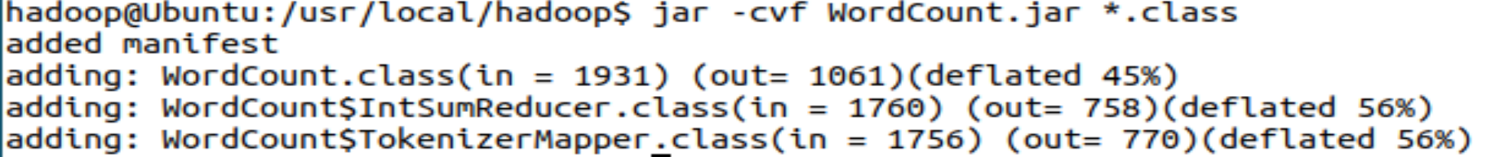

**运行程序**

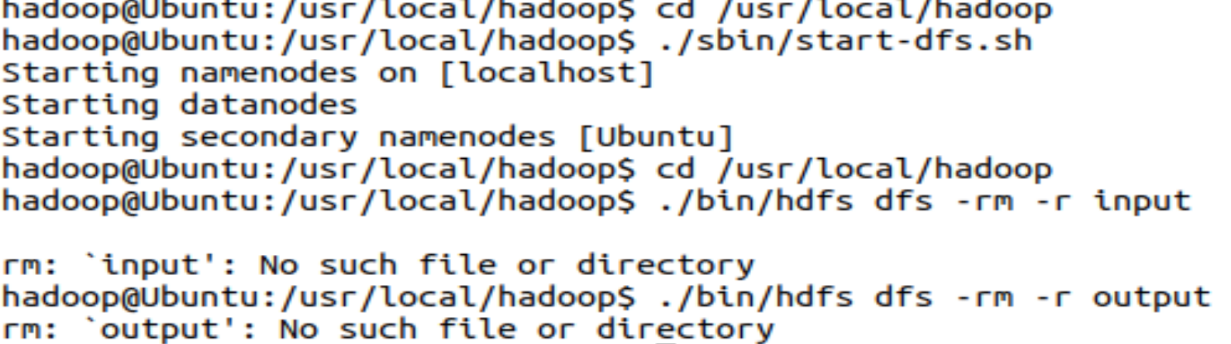



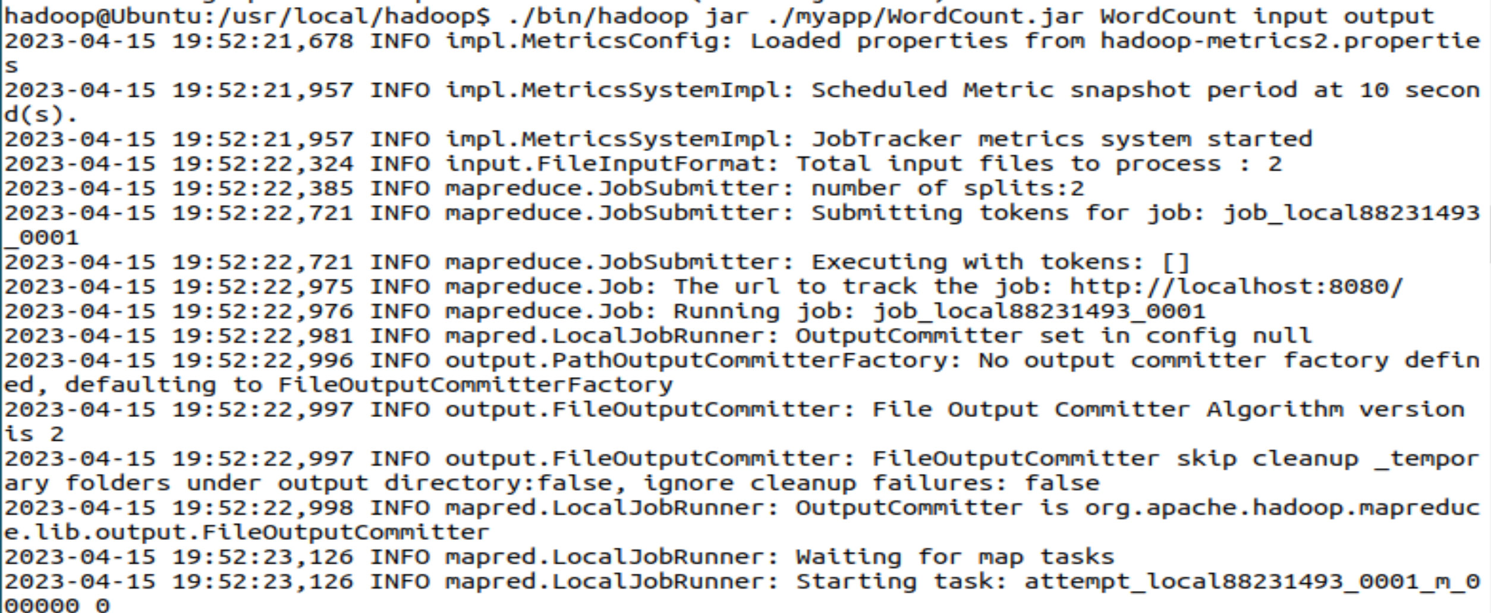

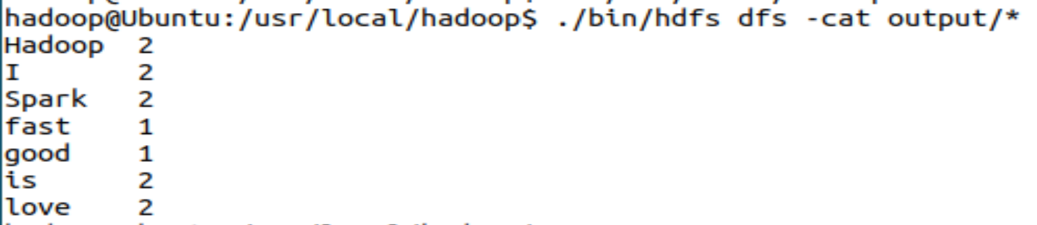

**程序完成！**

1. **思考讨论题或体会或对改进实验的建议**

1.MapReduce将输入的数据进行逻辑切片，一片对应一个Map任务

2.Map以并行的方式处理切片

3.框架对Map输出进行排序，然后发给Reduce

4.MapReduce的输入输出数据处于同一个文件系统（HDFS）

5.框架负责任务调度、任务监控、失败任务的重新执行

6.框架会对键和值进行序列化，因此键和值需要实现writable接口，框架会对键排序，因此必须实现writableComparable接口。

1. **实验源代码**

**public static void main(String[] args) throws Exception {**

**Configuration conf = new Configuration();**

**String[] otherArgs = (new GenericOptionsParser(conf, args)).getRemainingArgs();**

**if(otherArgs.length < 2) {**

**System.err.println("Usage: wordcount <in> [<in>...] <out>");**

**System.exit(2);**

**}**

**Job job = Job.getInstance(conf, "word count"); //设置环境参数**

**job.setJarByClass(WordCount.class); //设置整个程序的类名**

**job.setMapperClass(WordCount.TokenizerMapper.class); //添加Mapper类**

**job.setReducerClass(WordCount.IntSumReducer.class); //添加Reducer类**

**job.setOutputKeyClass(Text.class); //设置输出类型**

**job.setOutputValueClass(IntWritable.class); //设置输出类型**

**for(int i = 0; i < otherArgs.length - 1; ++i) {**

**FileInputFormat.addInputPath(job, new Path(otherArgs[i])); //设置输入文件**

**}**

**FileOutputFormat.setOutputPath(job, new Path(otherArgs[otherArgs.length - 1]));//设置输出文件**

**System.exit(job.waitForCompletion(true)?0:1);**

**}**

**import java.io.IOException;**

**import java.util.Iterator;**

**import java.util.StringTokenizer;**

**import org.apache.hadoop.conf.Configuration;**

**import org.apache.hadoop.fs.Path;**

**import org.apache.hadoop.io.IntWritable;**

**import org.apache.hadoop.io.Text;**

**import org.apache.hadoop.mapreduce.Job;**

**import org.apache.hadoop.mapreduce.Mapper;**

**import org.apache.hadoop.mapreduce.Reducer;**

**import org.apache.hadoop.mapreduce.lib.input.FileInputFormat;**

**import org.apache.hadoop.mapreduce.lib.output.FileOutputFormat;**

**import org.apache.hadoop.util.GenericOptionsParser;**

**public class WordCount {**

**public WordCount() {**

**}**

**public static void main(String[] args) throws Exception {**

**Configuration conf = new Configuration();**

**String[] otherArgs = (new GenericOptionsParser(conf, args)).getRemainingArgs();**

**if(otherArgs.length < 2) {**

**System.err.println("Usage: wordcount <in> [<in>...] <out>");**

**System.exit(2);**

**}**

**Job job = Job.getInstance(conf, "word count");**

**job.setJarByClass(WordCount.class);**

**job.setMapperClass(WordCount.TokenizerMapper.class);**

**job.setCombinerClass(WordCount.IntSumReducer.class);**

**job.setReducerClass(WordCount.IntSumReducer.class);**

**job.setOutputKeyClass(Text.class);**

**job.setOutputValueClass(IntWritable.class);**

**for(int i = 0; i < otherArgs.length - 1; ++i) {**

**FileInputFormat.addInputPath(job, new Path(otherArgs[i]));**

**}**

**FileOutputFormat.setOutputPath(job, new Path(otherArgs[otherArgs.length - 1]));**

**System.exit(job.waitForCompletion(true)?0:1);**

**}**

**public static class TokenizerMapper extends Mapper<Object, Text, Text, IntWritable> {**

**private static final IntWritable one = new IntWritable(1);**

**private Text word = new Text();**

**public TokenizerMapper() {**

**}**

**public void map(Object key, Text value, Mapper<Object, Text, Text, IntWritable>.Context context) throws IOException, InterruptedException {**

**StringTokenizer itr = new StringTokenizer(value.toString());**

**while(itr.hasMoreTokens()) {**

**this.word.set(itr.nextToken());**

**context.write(this.word, one);**

**}**

**}**

**}**

**public static class IntSumReducer extends Reducer<Text, IntWritable, Text, IntWritable> {**

**private IntWritable result = new IntWritable();**

**public IntSumReducer() {**

**}**

**public void reduce(Text key, Iterable<IntWritable> values, Reducer<Text, IntWritable, Text, IntWritable>.Context context) throws IOException, InterruptedException {**

**int sum = 0;**

**IntWritable val;**

**for(Iterator i$ = values.iterator(); i$.hasNext(); sum += val.get()) {**

**val = (IntWritable)i$.next();**

**}**

**this.result.set(sum);**

**context.write(key, this.result);**

**}**

**}**

**}**

# 实验六 **熟悉Hive的基本操作**

|  |  |  |  |  |
| --- | --- | --- | --- | --- |
| **地 点：** | B10楼 | 303房； | **实验台号：** |  |
| **实验日期与时间：** | 2023/4/20 | | **评 分：** |  |
| **预习检查纪录：** |  | | **实验教师：** | 焦青松 |

1. **实验目的**

**(1).理解Hive作为数据仓库在Hadoop体系中的角色**

**(2).熟练使用常用的HiveQL**

1. **实验平台**

(1).操作系统:Linux

(2).Hadoop版本:3.3.5

(3).Hive版本:3.1.3

(4).JDK版本:19.0.2

1. **实验步骤（包括实验结果/截图）**

**Hive的安装**

**解压缩**

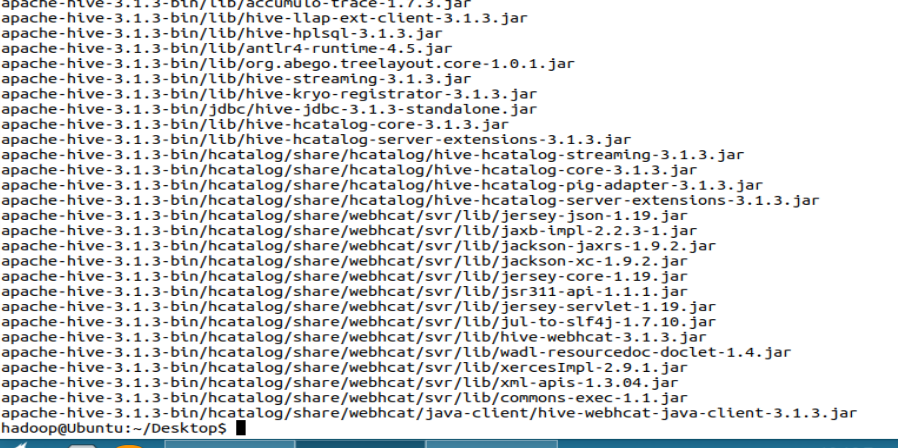

**授予权限**



**配置环境变量**

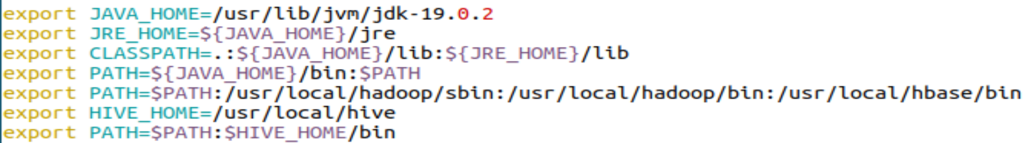



**修改配置文件**

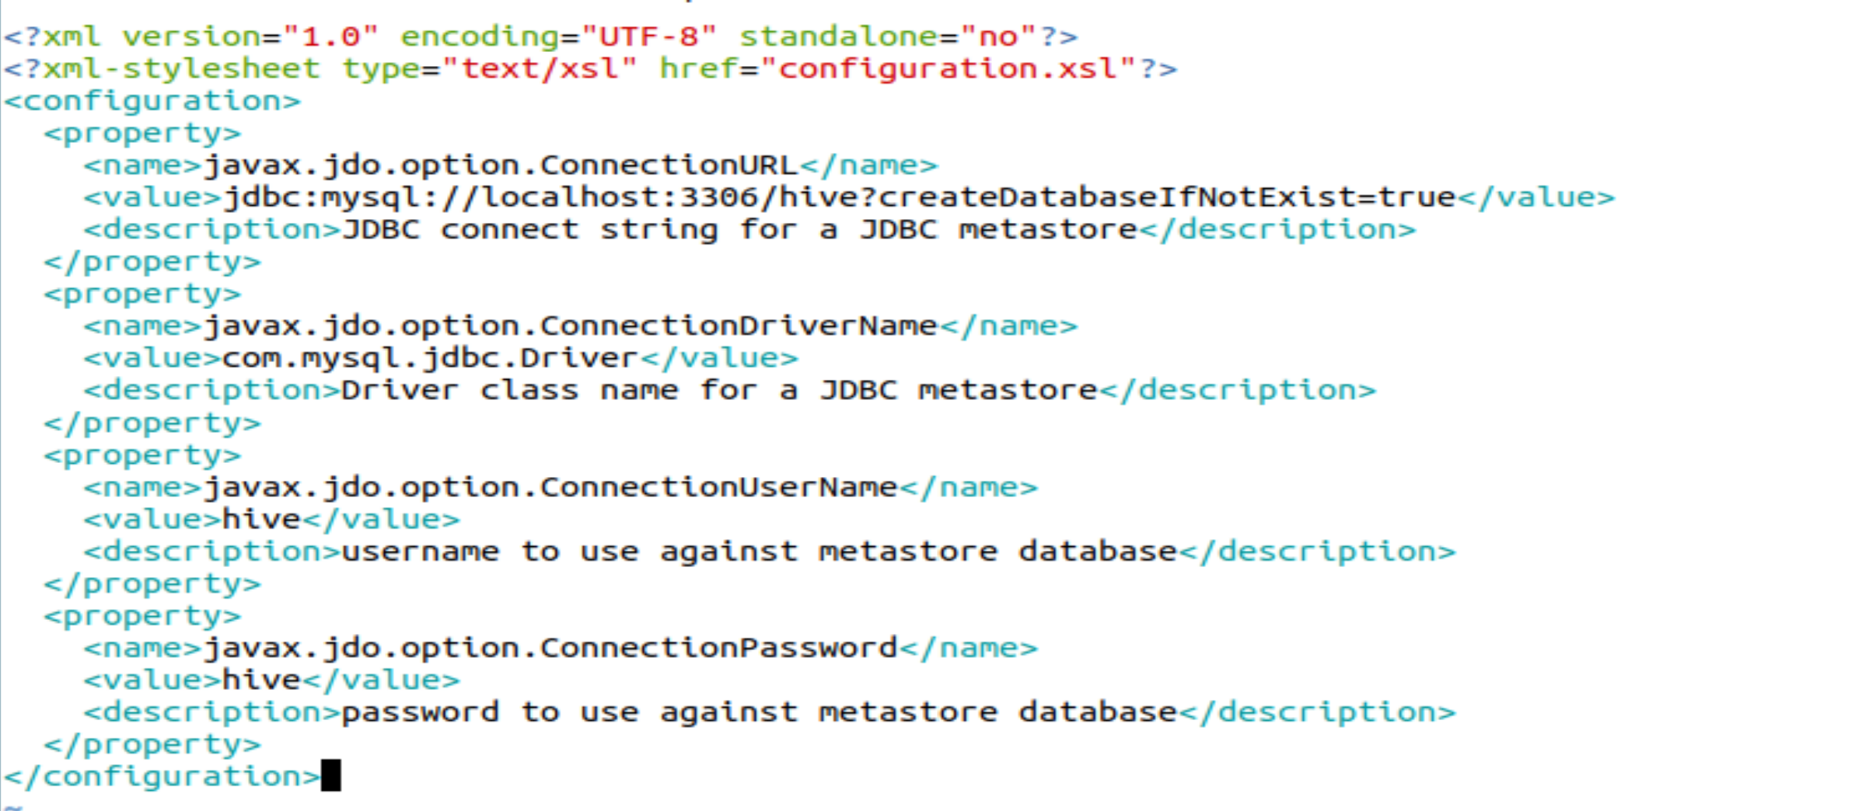

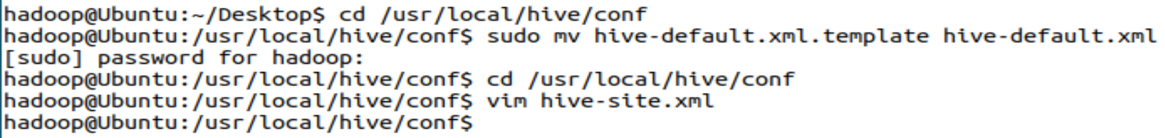

**配置mySQL**

**MySQL在实验4时已经安装，此处不必重新安装。**

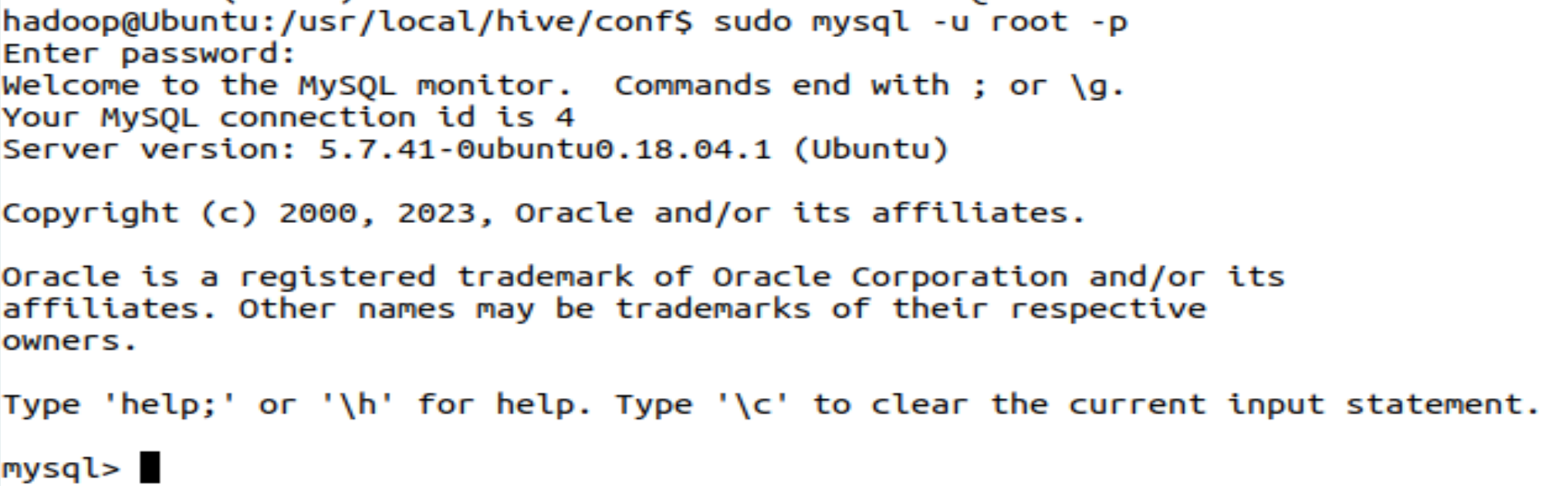

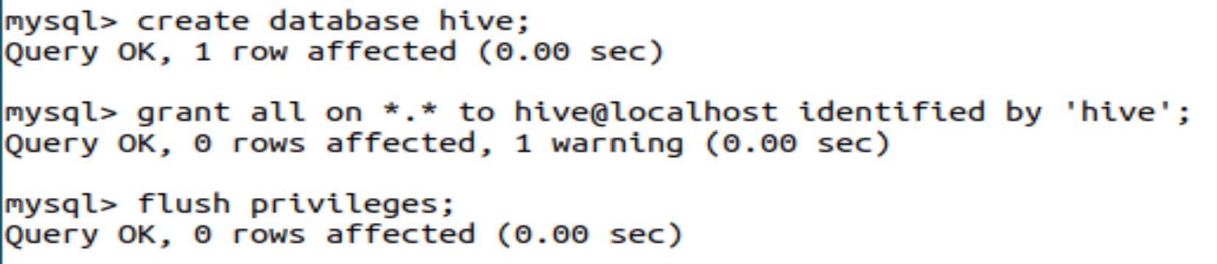

**驱动配置**

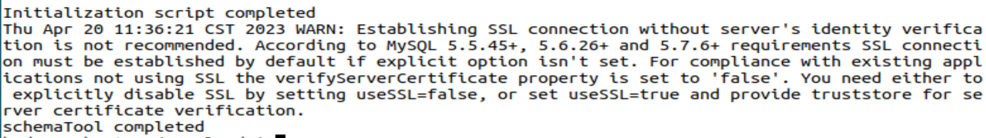

**启动Hive**

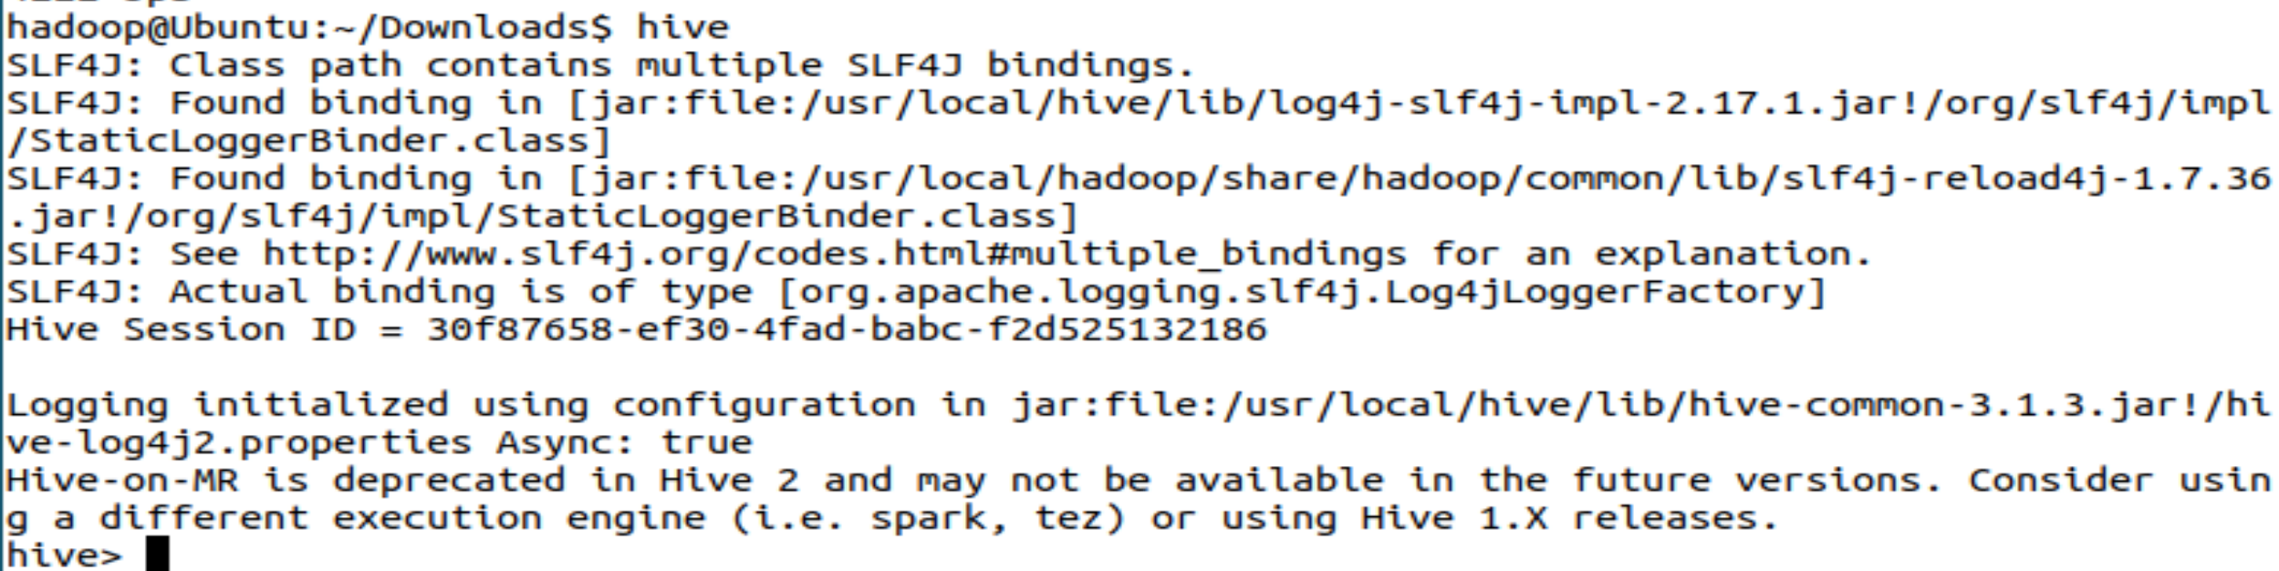

**实验**

**数据集下载，然后解压缩**

**1.创建内部表**

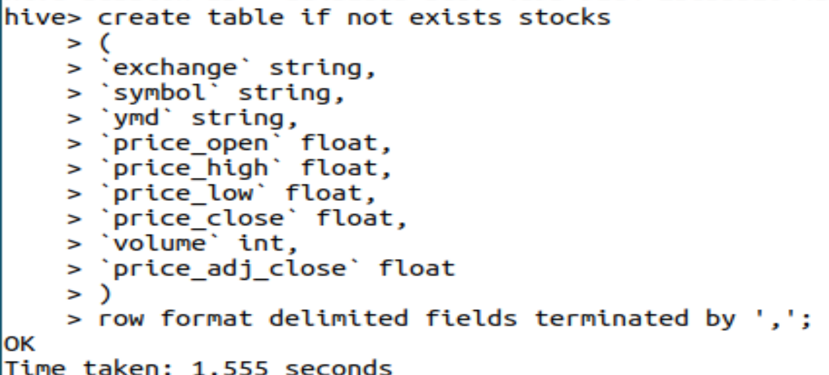

**建表成功**

**2.导入数据**



**3.创建外部分区表**

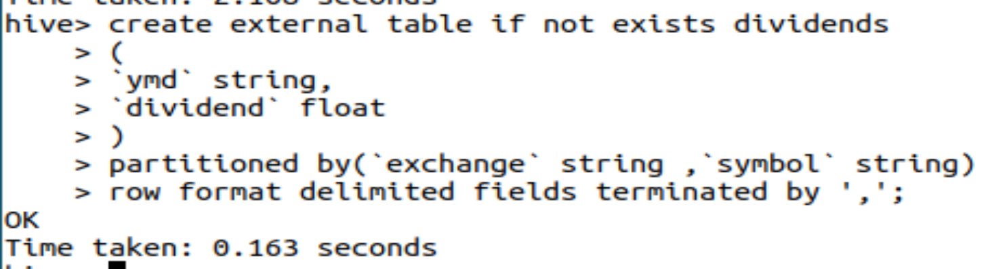

**4.未分区外部表**

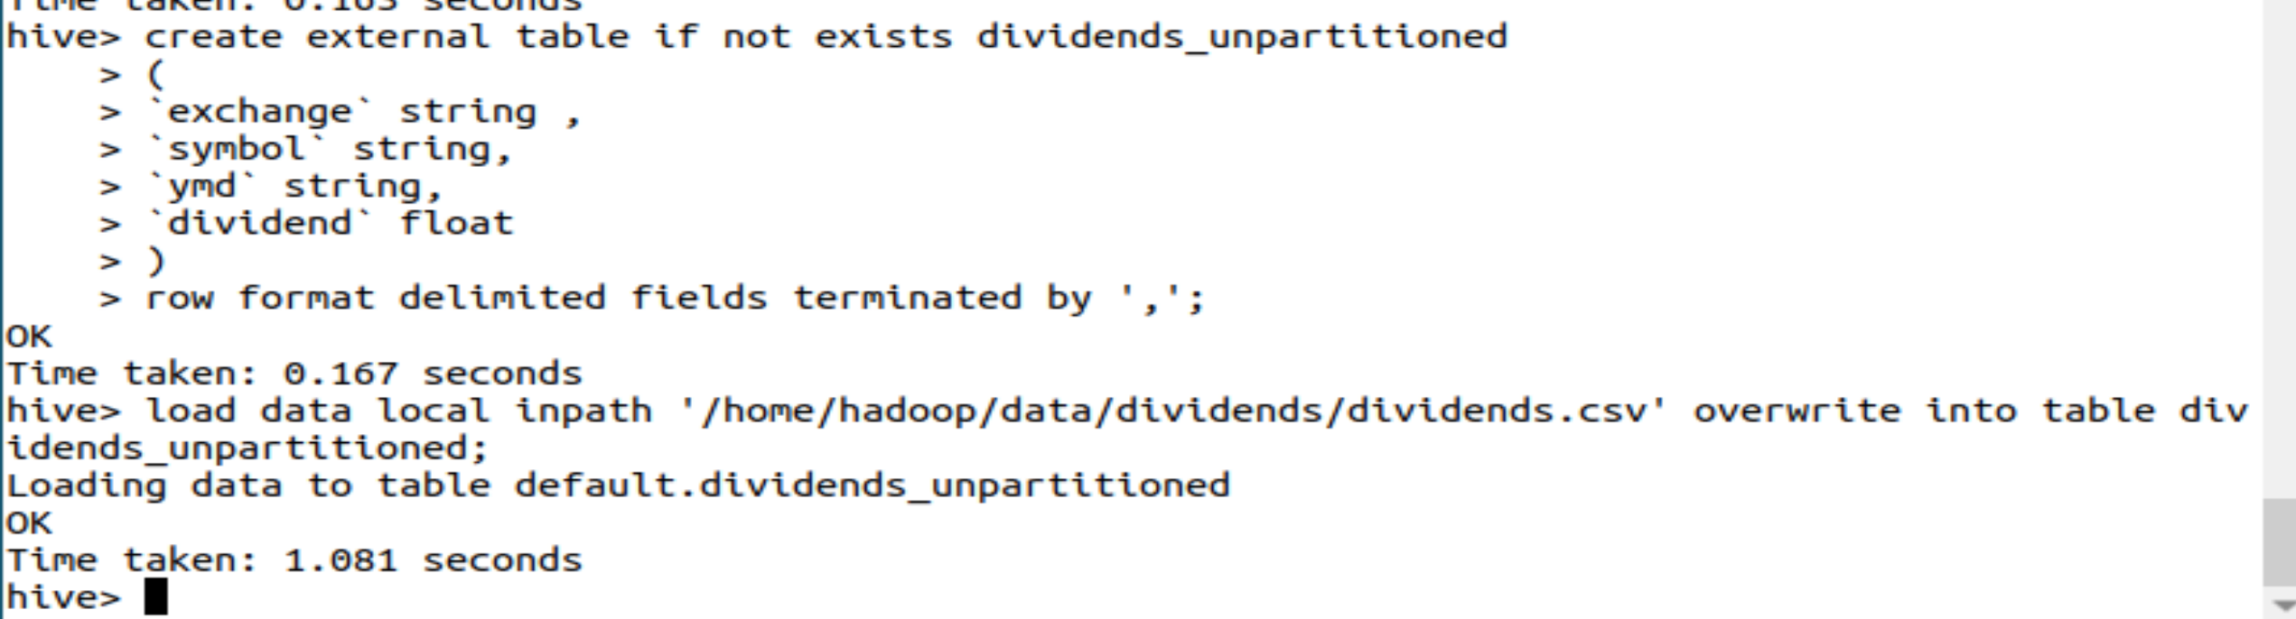

**5.查询语句**

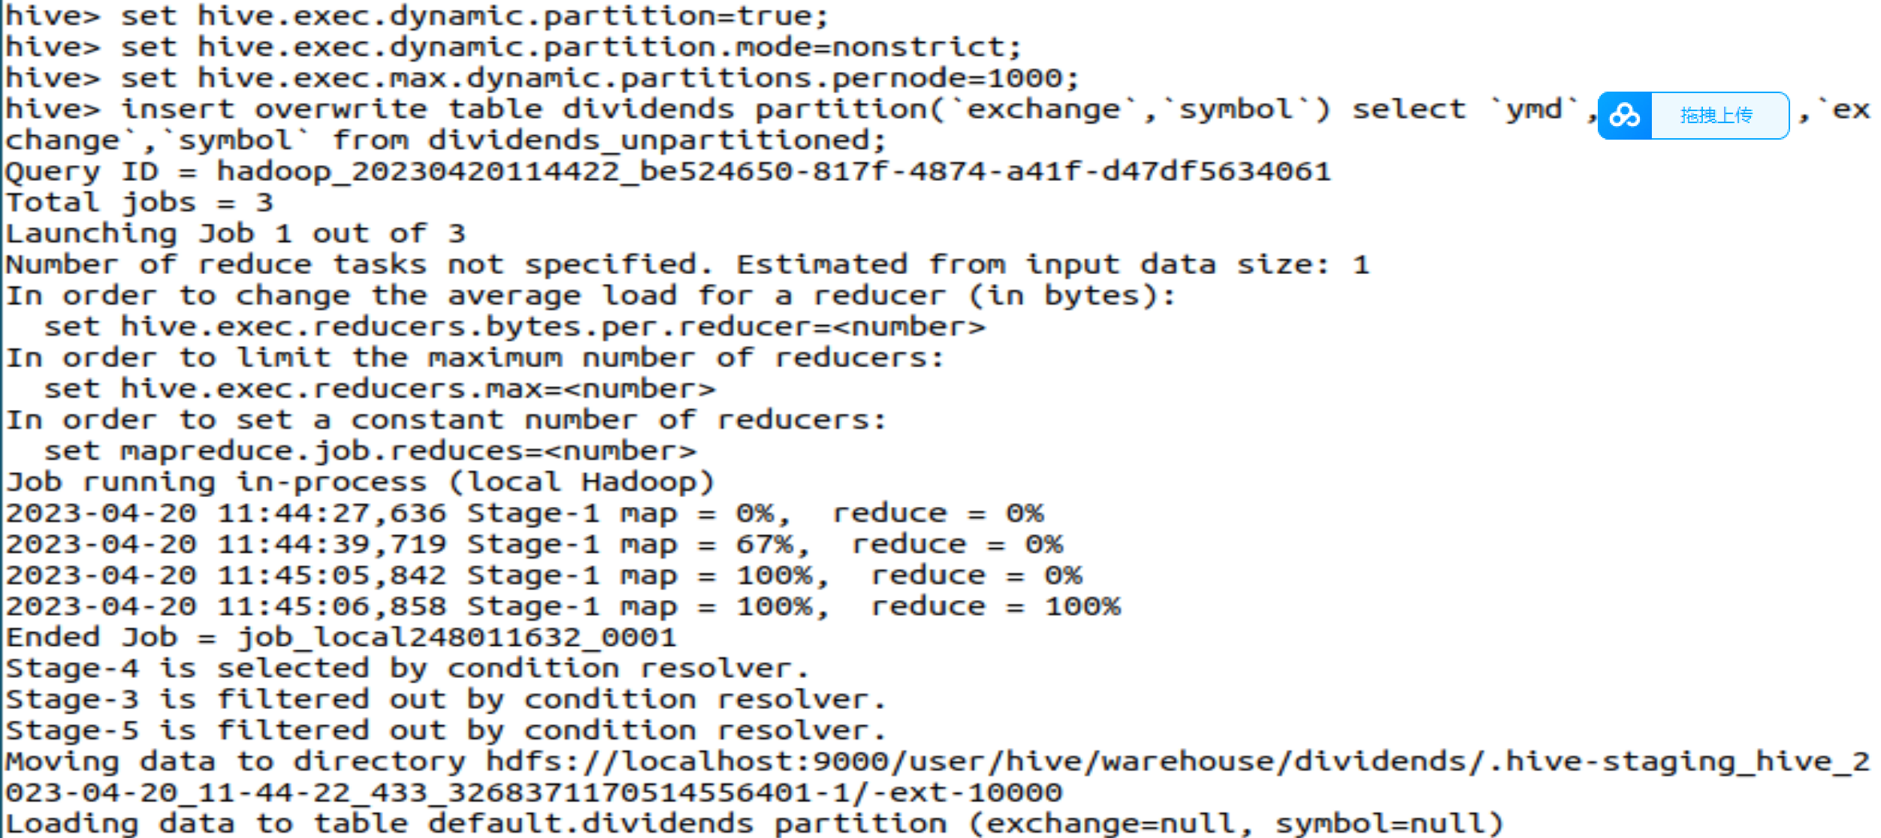

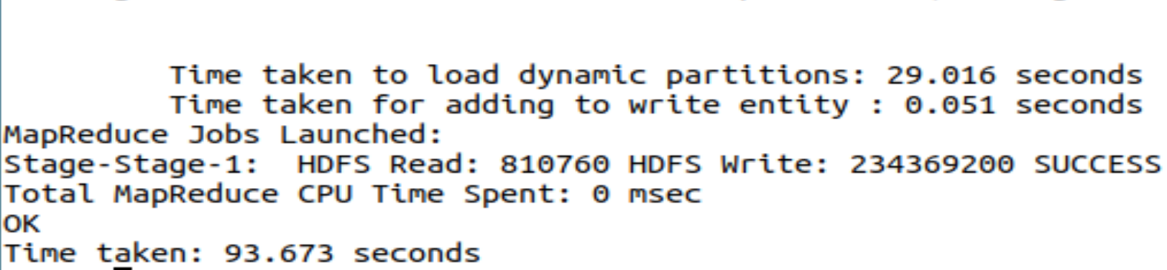

**6.查询收盘价**

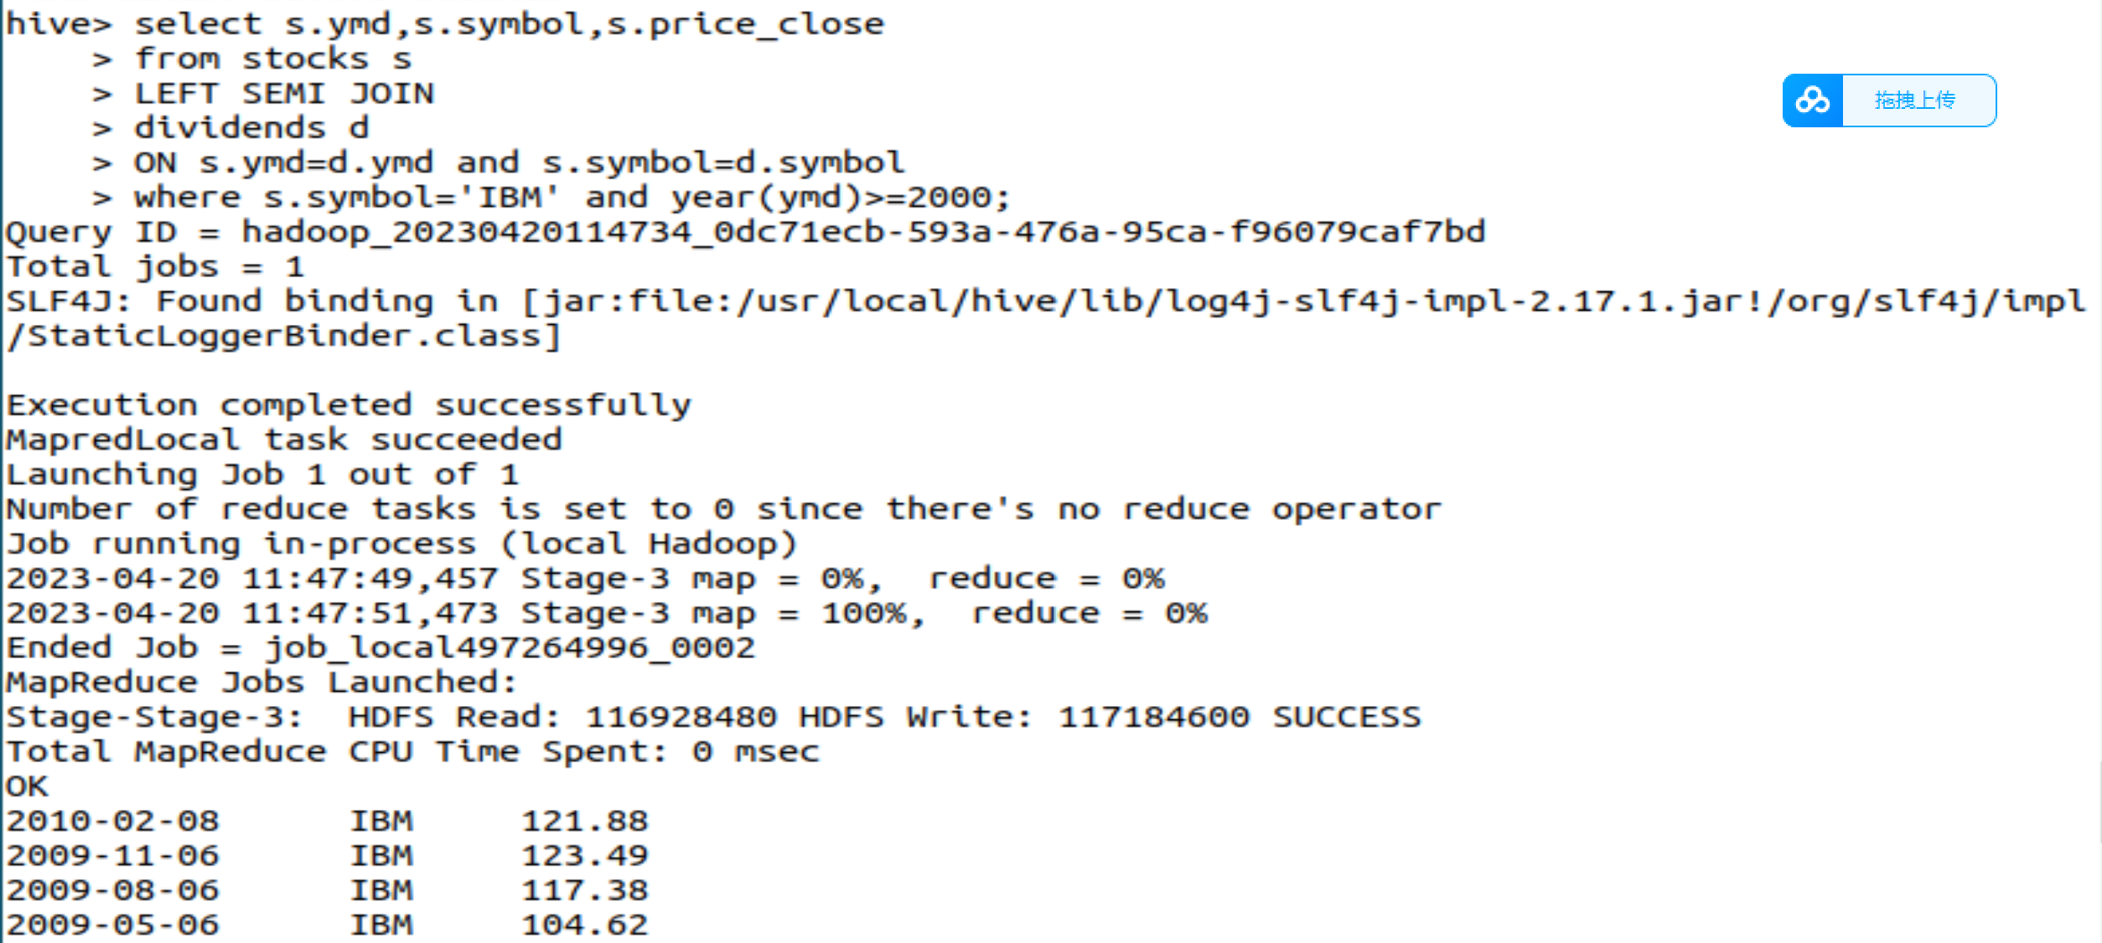

**7.查询苹果公司涨跌情况**

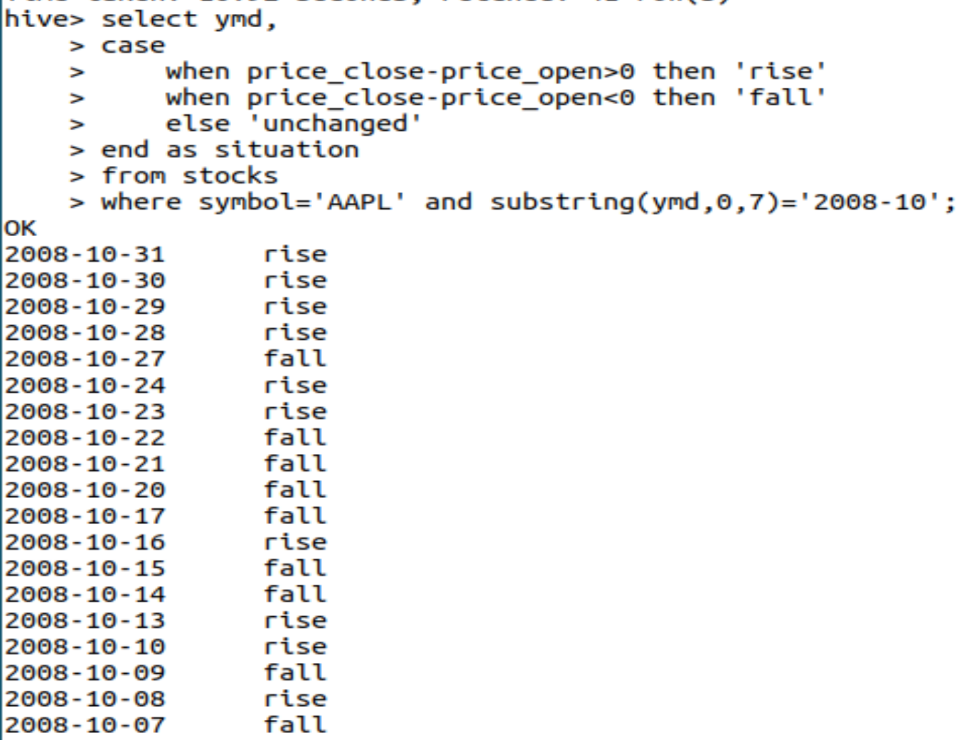

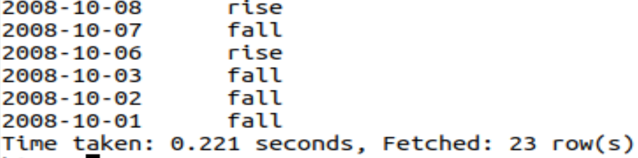

**8.查询差价**

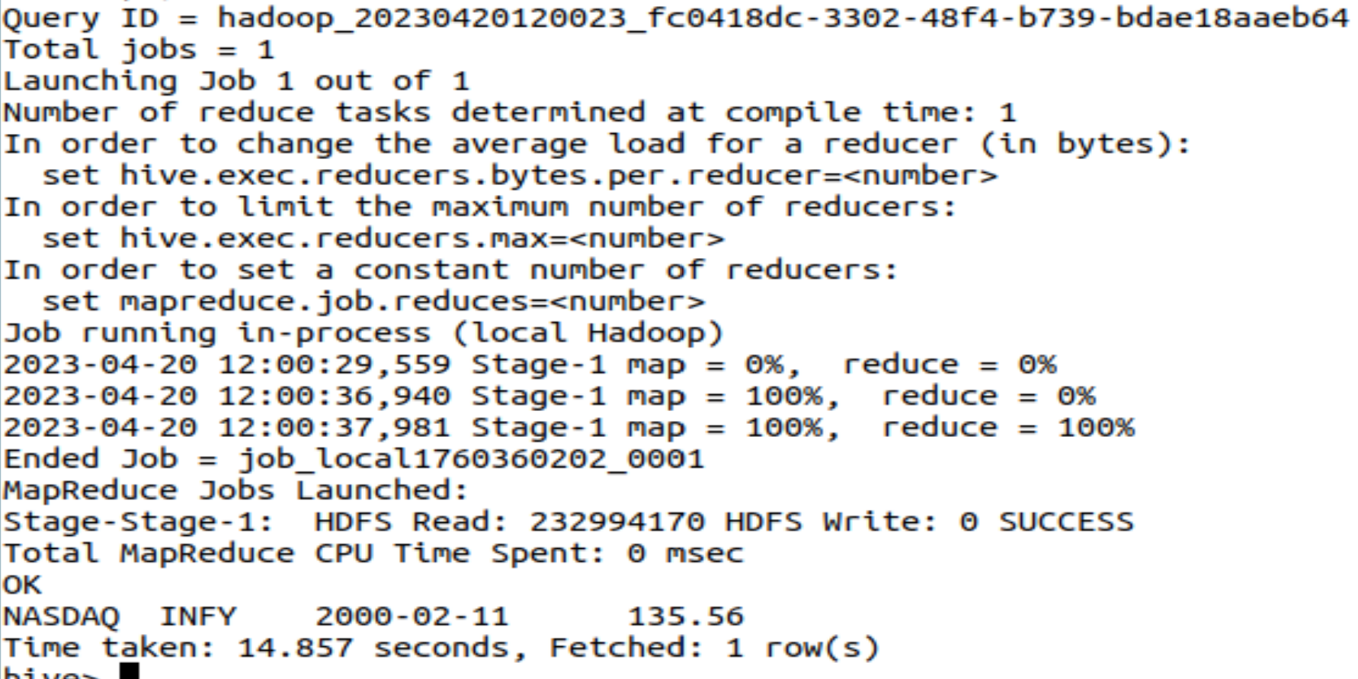

**9.查询收盘价大于50美元**

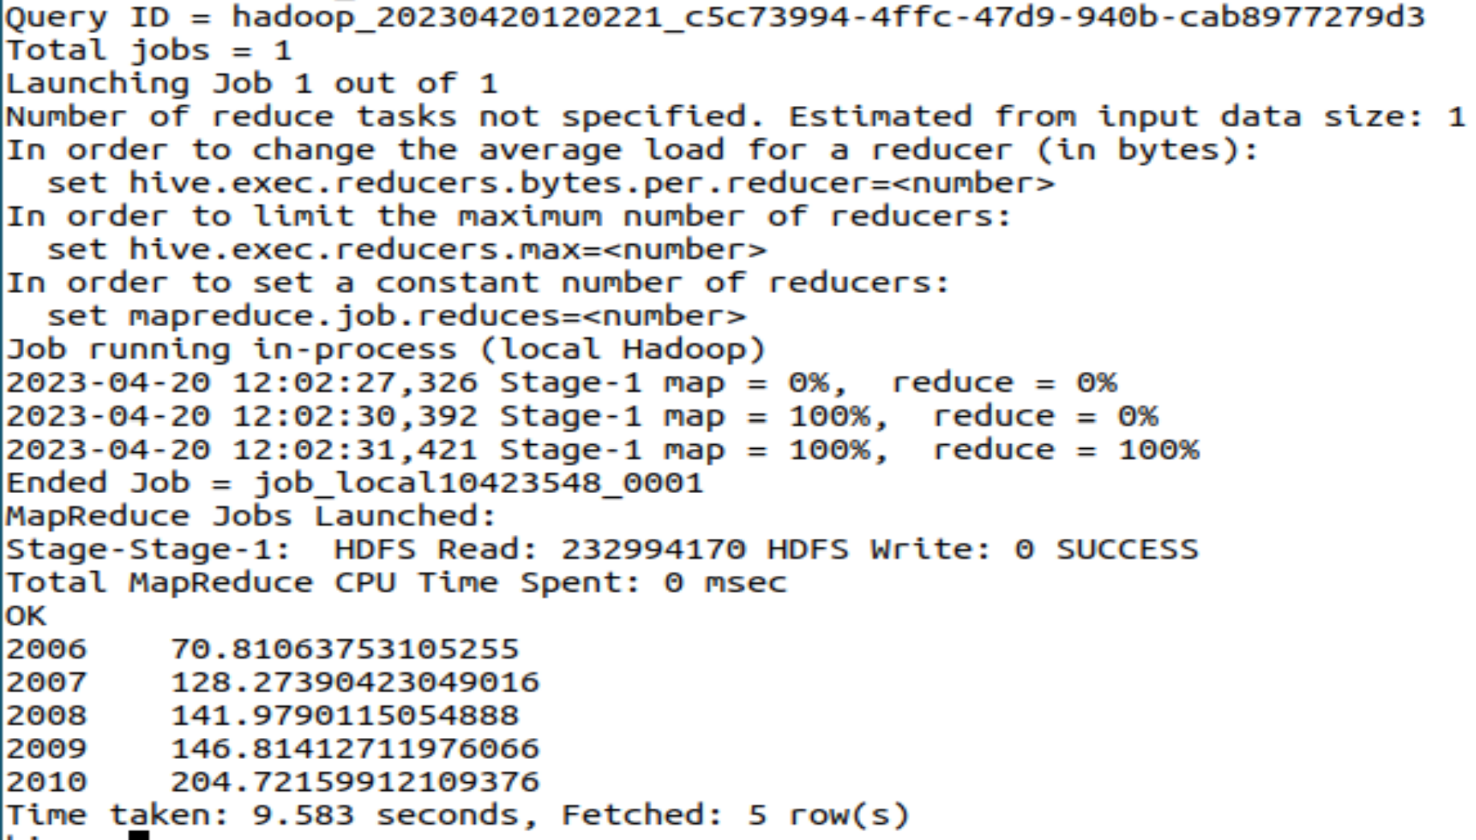

**10.年平均调整收盘价**

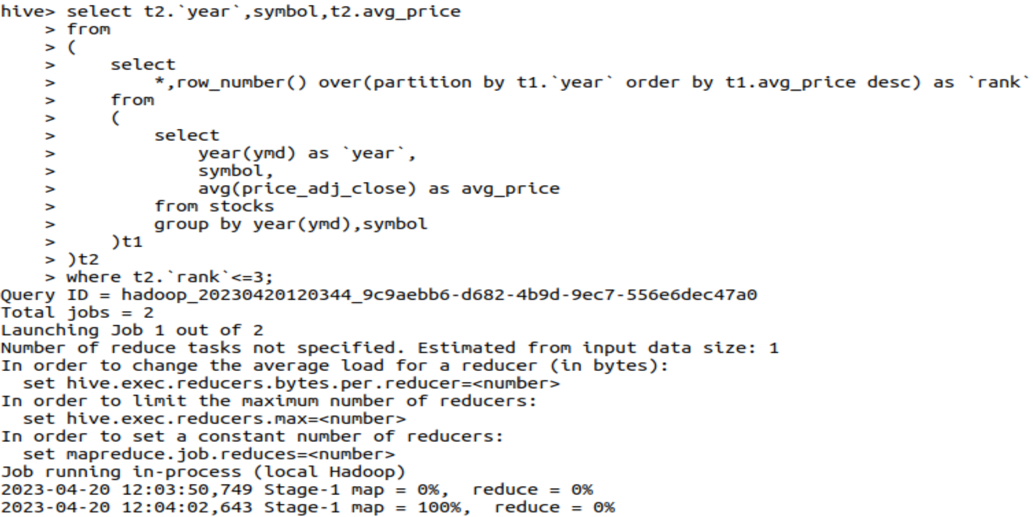

**因内存不足，无法启动。**

1. **思考讨论题或体会或对改进实验的建议**

**HiveQL与之前所学的SQL语言有诸多不同，这一点需要注意。**

1. **实验源代码**

**sudo tar -zxvf ./apache-hive-3.1.2-bin.tar.gz -C /usr/local # 解压到/usr/local中**

**cd /usr/local/**

**sudo mv apache-hive-3.1.2-bin hive # 将文件夹名改为hive**

**sudo chown -R hadoop:hadoop hive # 修改文件权限**

<?xml version="1.0" encoding="UTF-8" standalone="no"?>

<?xml-stylesheet type="text/xsl" href="configuration.xsl"?>

<configuration>

<property>

<name>javax.jdo.option.ConnectionURL</name>

<value>jdbc:mysql://localhost:3306/hive?createDatabaseIfNotExist=true</value>

<description>JDBC connect string for a JDBC metastore</description>

</property>

<property>

<name>javax.jdo.option.ConnectionDriverName</name>

<value>com.mysql.jdbc.Driver</value>

<description>Driver class name for a JDBC metastore</description>

</property>

<property>

<name>javax.jdo.option.ConnectionUserName</name>

<value>hive</value>

<description>username to use against metastore database</description>

</property>

<property>

<name>javax.jdo.option.ConnectionPassword</name>

<value>hive</value>

<description>password to use against metastore database</description>

</property>

</configuration>

create table if not exists stocks

(

`exchange` string,

`symbol` string,

`ymd` string,

`price_open` float,

`price_high` float,

`price_low` float,

`price_close` float,

`volume` int,

`price_adj_close` float

)

row format delimited fields terminated by ',';

create external table if not exists dividends_unpartitioned

(

`exchange` string ,

`symbol` string,

`ymd` string,

`dividend` float

)

row format delimited fields terminated by ',';

load data local inpath '/home/hadoop/data/dividends/dividends.csv' overwrite into table dividends_unpartitioned;

select s.ymd,s.symbol,s.price_close

from stocks s

LEFT SEMI JOIN

dividends d

ON s.ymd=d.ymd and s.symbol=d.symbol

where s.symbol='IBM' and year(ymd)>=2000;

select ymd,

case

when price_close-price_open>0 then 'rise'

when price_close-price_open<0 then 'fall'

else 'unchanged'

end as situation

from stocks

where symbol='AAPL' and substring(ymd,0,7)='2008-10';

select `exchange`,symbol,ymd,price_close-price_open as `diff`

from

(

select *

from stocks

order by price_close-price_open desc

limit 1

)t;

# 实验七 **Spark初级编程实践**

|  |  |  |  |  |
| --- | --- | --- | --- | --- |
| **地 点：** | B10楼 | 303房； | **实验台号：** |  |
| **实验日期与时间：** | 2023/6/1 | | **评 分：** |  |
| **预习检查纪录：** |  | | **实验教师：** | 焦青松 |

1. **实验目的**

**（1）.掌握使用Spark访问本地文件和HDFS文件的方法。**

**(2).掌握Spark应用程序的编写、编译和运行方法。**

1. **实验平台**

(1).操作系统:Linux

(2).Hadoop版本:3.3.5

(3).Spark版本:2.4.0

**实验步骤（包括实验结果/截图）**

**安装spark**

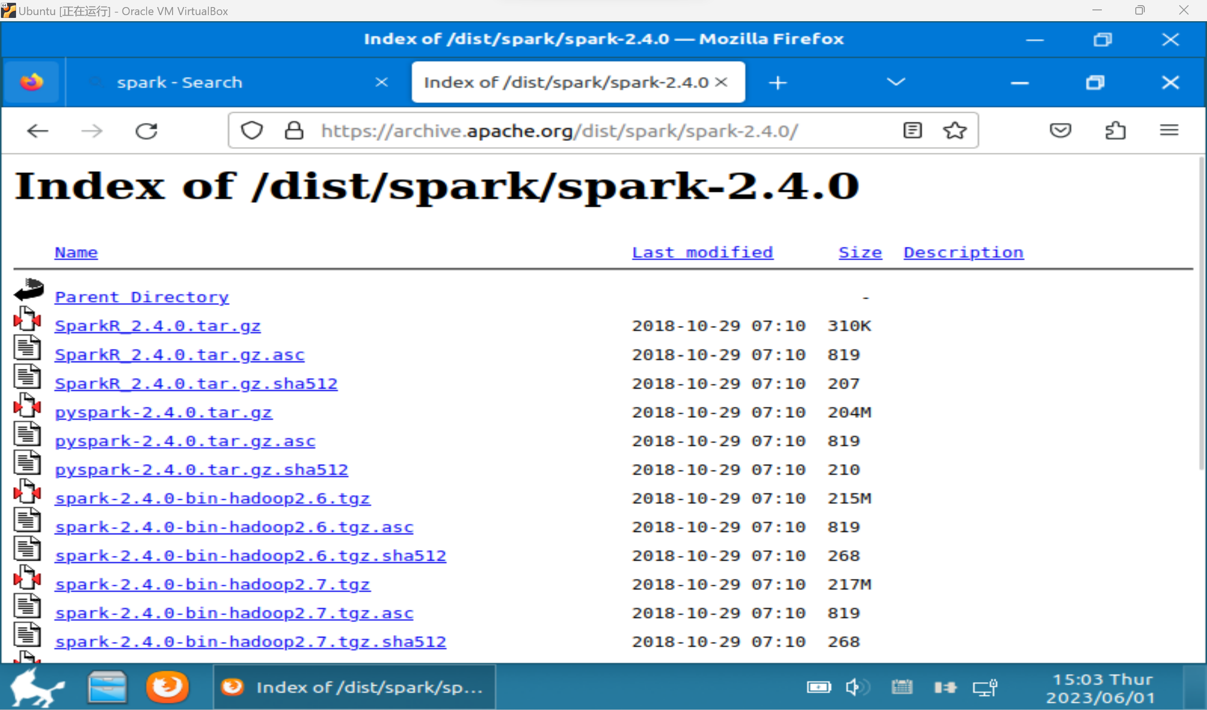

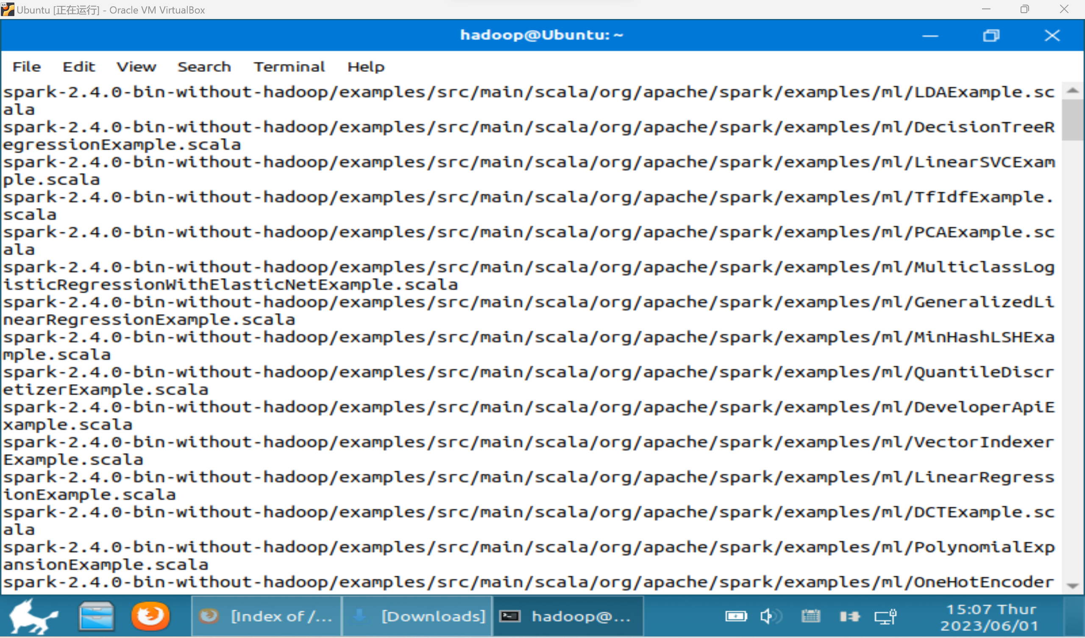

**配置相关文件**

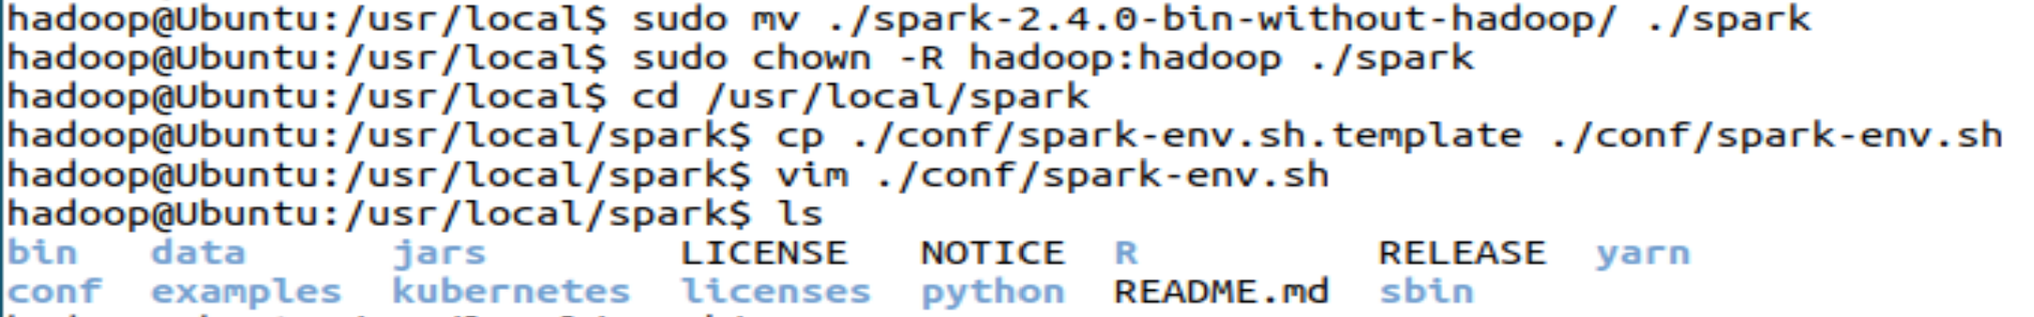

**安装成功**



**1.spark读取文件系统的数据**

**创建test.txt**

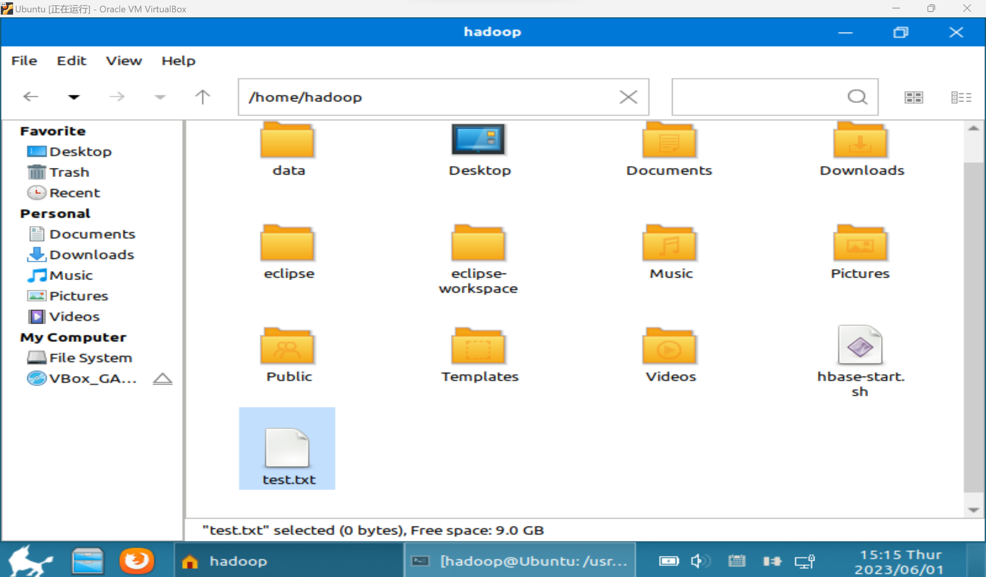

**内容一共6行**

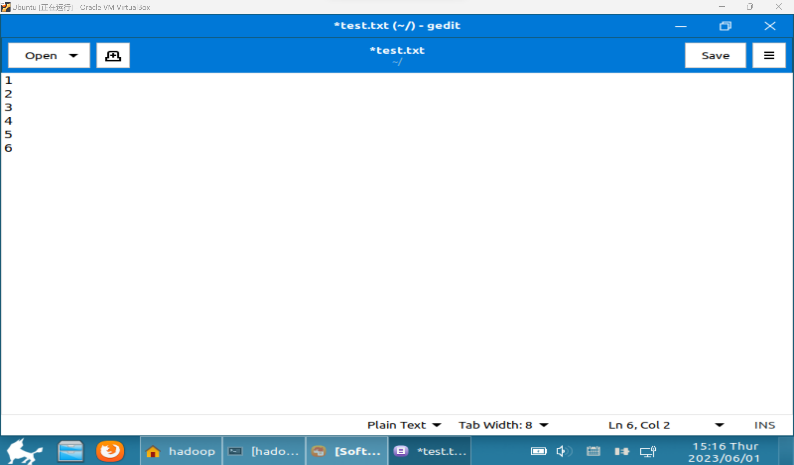

**编写程序**

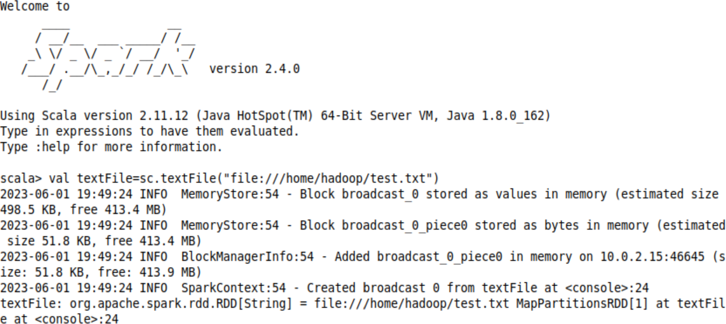

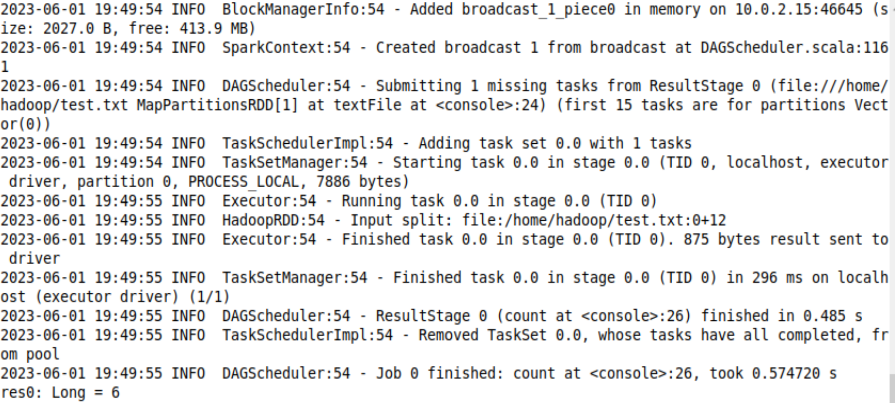

**2.编写独立应用程序实现数据去重**

**创建路径**

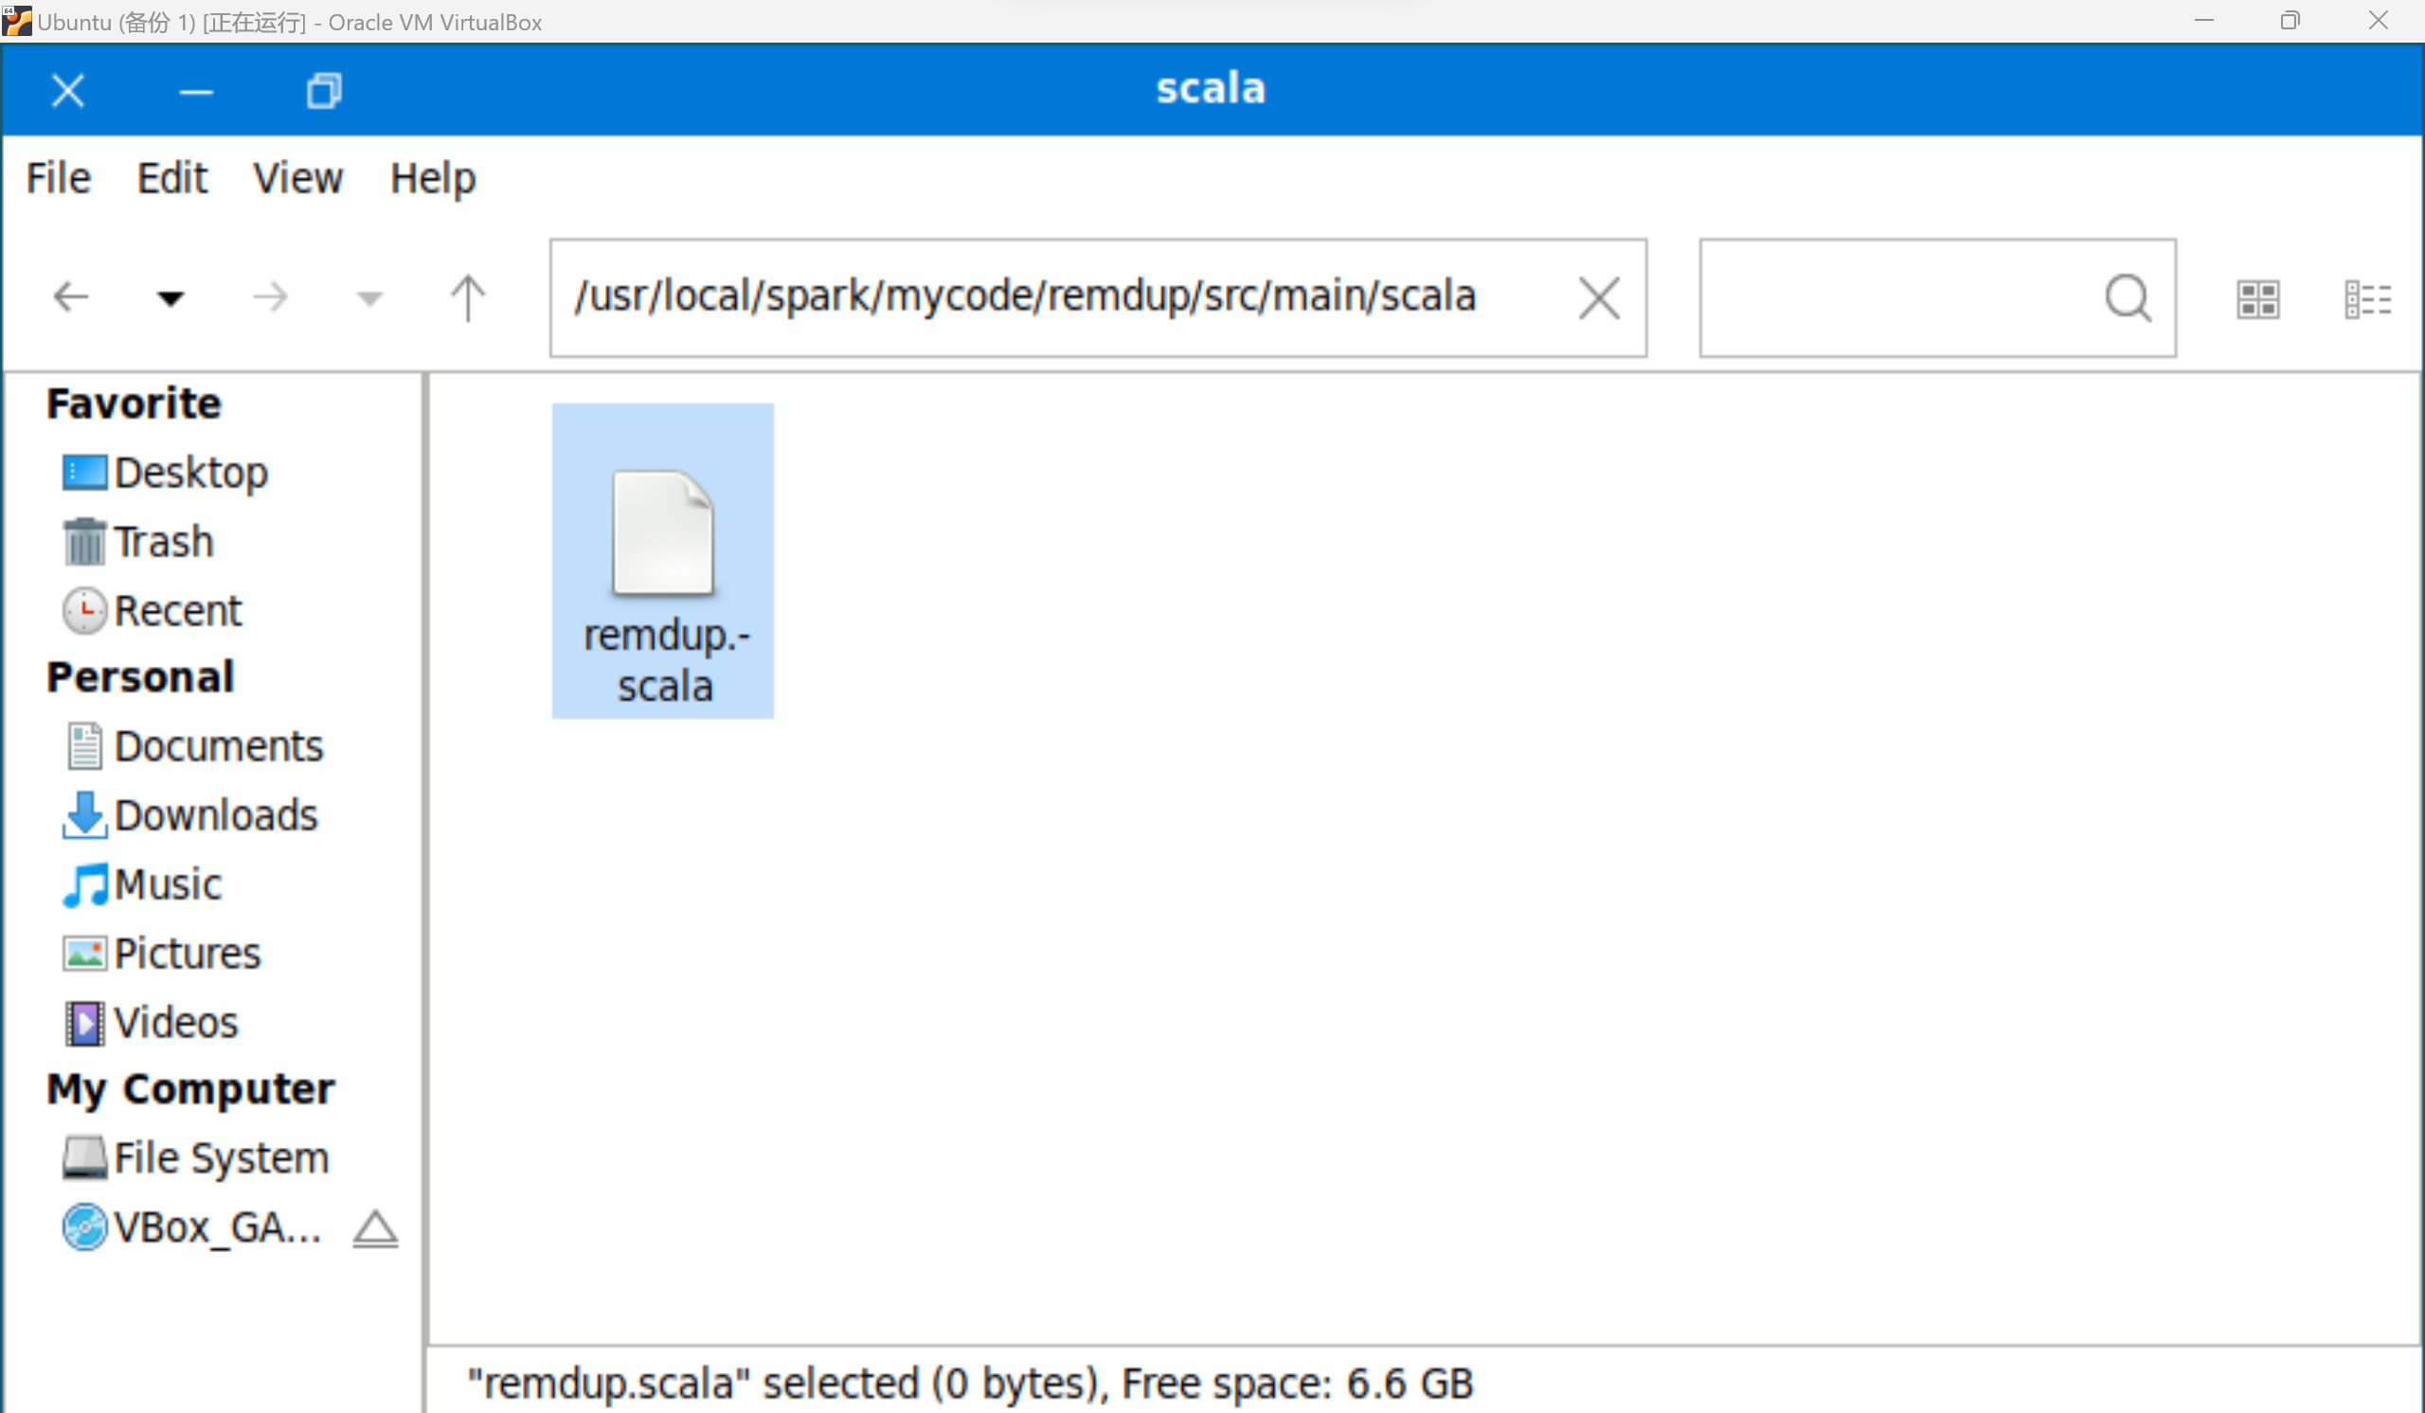

**编写代码**

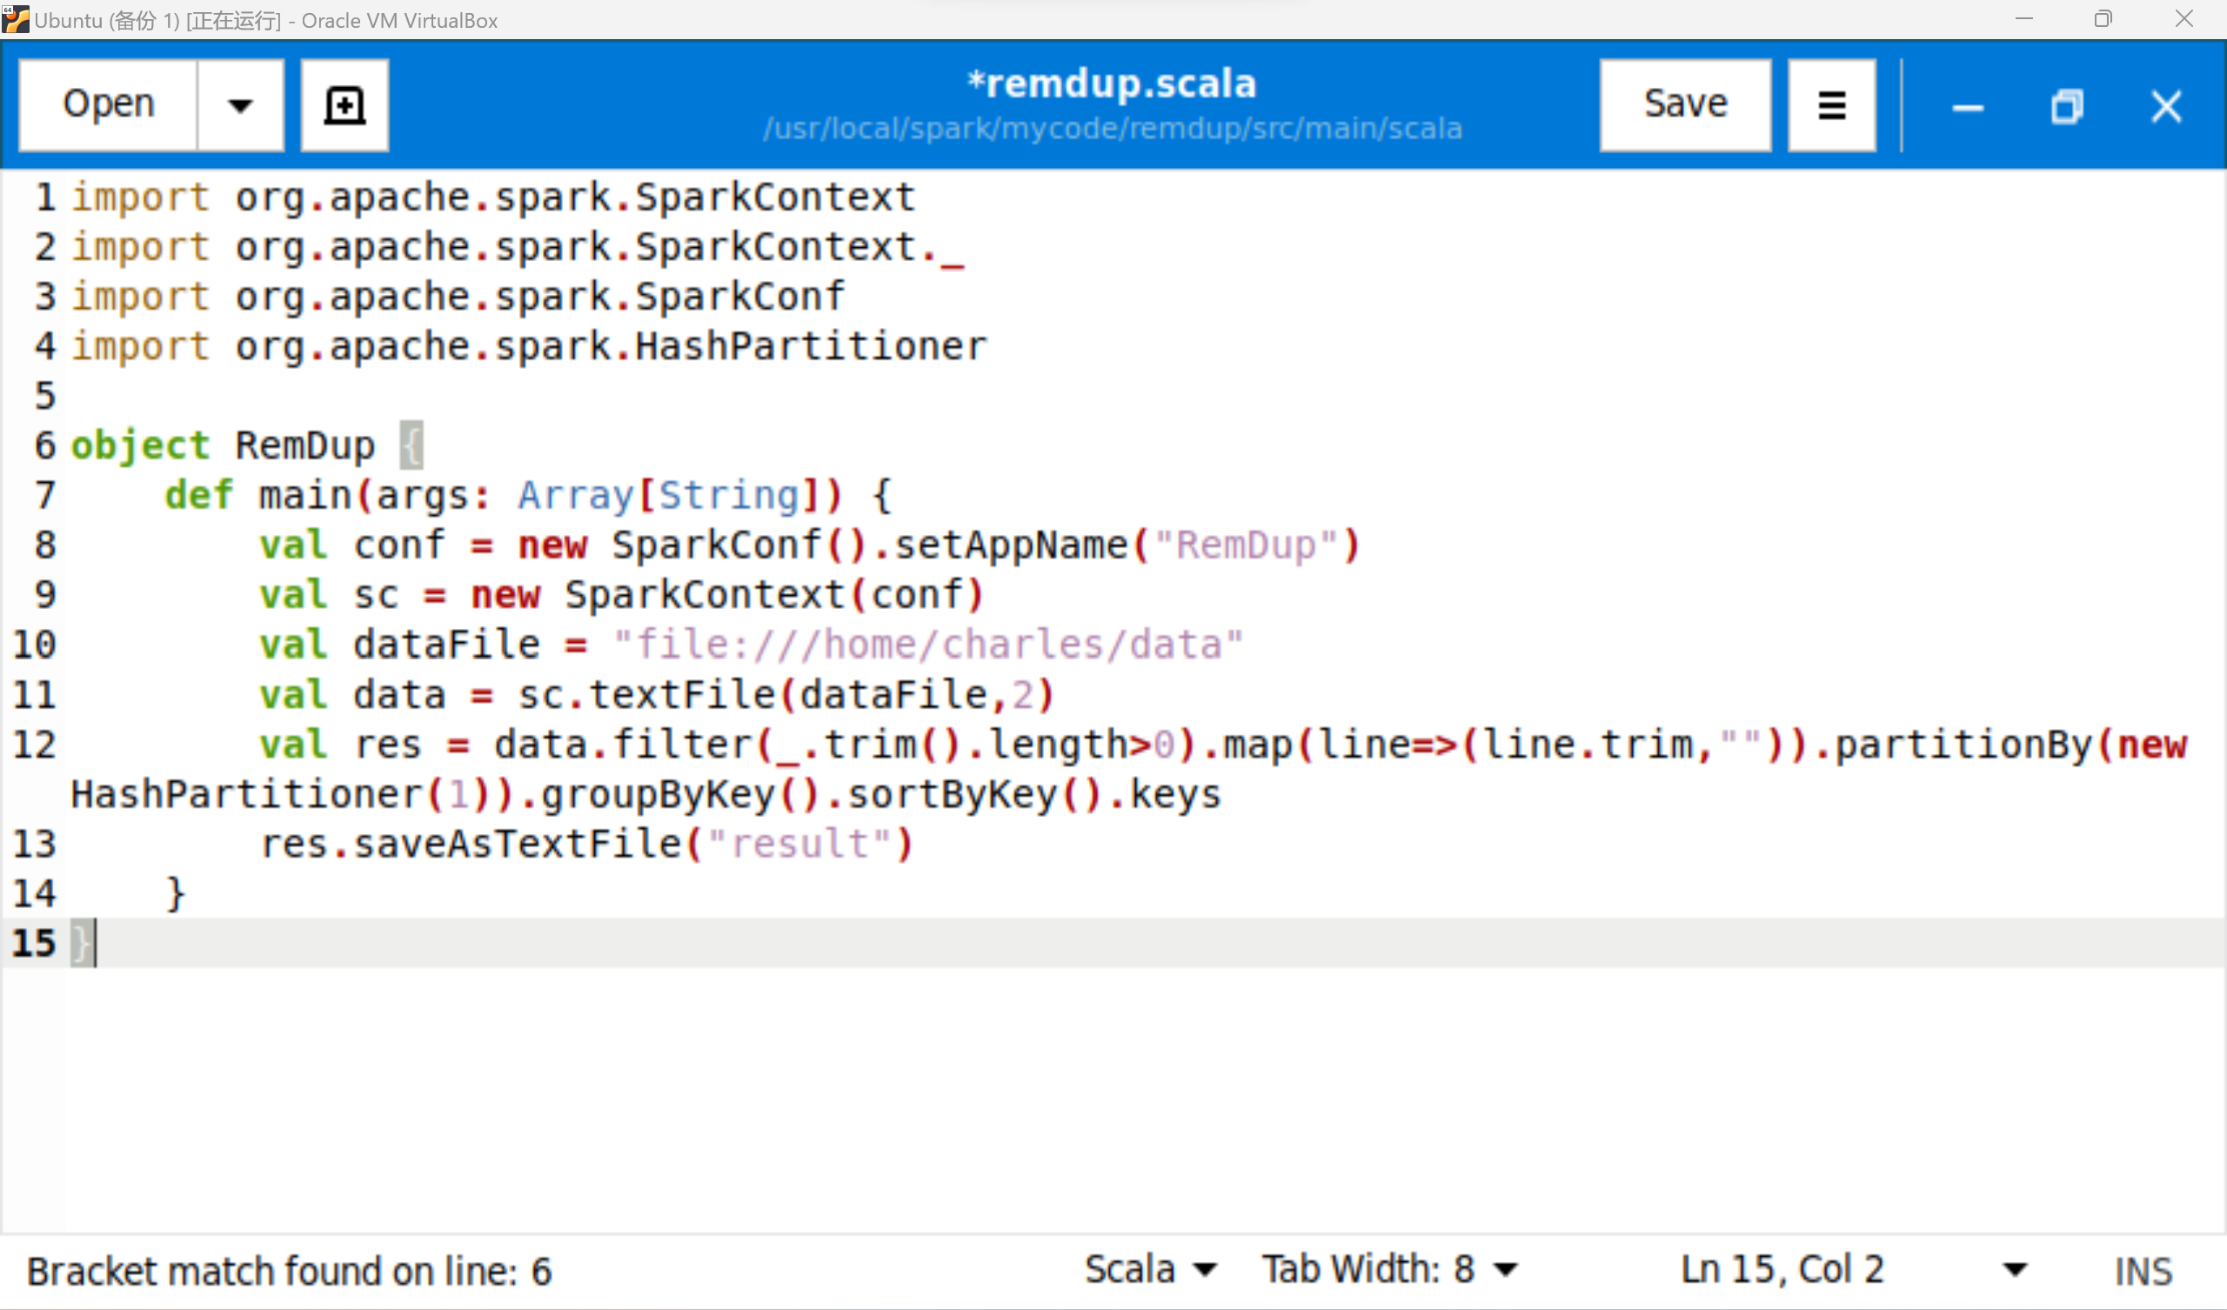

**3.编写独立应用程序实现求平均值问题**

1. **思考讨论题或体会或对改进实验的建议**

Apache Spark是一个围绕速度、易用性和复杂分析构建的大数据处理框架，最初在2009年由加州大学伯克利分校的AMPLab开发，并于2010年成为Apache的开源项目之一，与Hadoop和Storm等其他大数据和MapReduce技术相比，Spark有如下优势：

* Spark提供了一个全面、统一的框架用于管理各种有着不同性质（文本数据、图表数据等）的数据集和数据源（批量数据或实时的流数据）的大数据处理的需求
* 官方资料介绍Spark可以将Hadoop集群中的应用在内存中的运行速度提升100倍，甚至能够将应用在磁盘上的运行速度提升10倍。

1. **实验源代码**

**cd ~**

**sudo tar -zxvf ~/Downloads/spark-2.4.0-bin-without-hadoop.tgz -C /usr/local/**

**cd /usr/local**

**sudo mv ./spark-2.4.0-bin-without-hadoop/ ./spark**

**sudo chown -R hadoop:hadoop ./spark # hadoop是当前登录Linux系统的用户名**

**cd /usr/local/spark**

**cp ./conf/spark-env.sh.template ./conf/spark-env.sh**

**cd /usr/local/spark**

**bin/run-example SparkPi**

**cd ~ # 进入用户主文件夹**

**mkdir ./sparkapp # 创建应用程序根目录**

**mkdir -p ./sparkapp/src/main/scala # 创建所需的文件夹结构**

**import org.apache.spark.SparkContext**

**import org.apache.spark.SparkContext._**

**import org.apache.spark.SparkConf**

**import org.apache.spark.HashPartitioner**

**object RemDup {**

**def main(args: Array[String]) {**

**val conf = new SparkConf().setAppName("RemDup")**

**val sc = new SparkContext(conf)**

**val dataFile = "file:///home/charles/data"**

**val data = sc.textFile(dataFile,2)**

**val res = data.filter(_.trim().length>0).map(line=>(line.trim,"")).partitionBy(new HashPartitioner(1)).groupByKey().sortByKey().keys**

**res.saveAsTextFile("result")**

**}**

**}**

# 实验八 **Flink初级编程实践**

|  |  |  |  |  |
| --- | --- | --- | --- | --- |
| **地 点：** | B10楼 | 303房； | **实验台号：** |  |
| **实验日期与时间：** | 2023/6/1 | | **评 分：** |  |
| **预习检查纪录：** |  | | **实验教师：** | 焦青松 |

1. **实验目的**

**（1）.通过实验掌握基本的Flink编程方法。**

**(2).掌握用IntelliJ IDEA工具编写Flink程序的方法。**

1. **实验平台**

(1).操作系统:Linux

(2).Flink版本:1.9.1

(3).Intellij IDEA

**实验步骤（包括实验结果/截图）**

1. **思考讨论题或体会或对改进实验的建议**

## Flink 架构中的服务类型

下面是从Flink官网截取的一张架构图：

在Flink运行时涉及到的进程主要有以下两个： ***JobManager****：主要负责调度task，协调checkpoint已经错误恢复等。当客户端将打包好的任务提交到JobManager之后，JobManager就会根据注册的TaskManager资源信息将任务分配给有资源的TaskManager，然后启动运行任务。TaskManger从JobManager获取task信息，然后使用slot资源运行task；***TaskManager**：执行数据流的task，一个task通过设置并行度，可能会有多个subtask。 每个TaskManager都是作为一个独立的JVM进程运行的。他主要负责在独立的线程执行的operator。其中能执行多少个operator取决于每个taskManager指定的slots数量。Task slot是Flink中最小的资源单位。假如一个taskManager有3个slot，他就会给每个slot分配1/3的内存资源，目前slot不会对cpu进行隔离。同一个taskManager中的slot会共享网络资源和心跳信息。  
当然在Flink中并不是一个slot只可以执行一个task，在某些情况下，一个slot中也可能执行多个task，如下：

1. **实验源代码**

**<?xml version="1.0" encoding="UTF-8"?>**

**<project xmlns="http://maven.apache.org/POM/4.0.0"**

**xmlns:xsi="http://www.w3.org/2001/XMLSchema-instance"**

**xsi:schemaLocation="http://maven.apache.org/POM/4.0.0 http://maven.apache.org/xsd/maven-4.0.0.xsd">**

**<modelVersion>4.0.0</modelVersion>**

**<groupId>dblab</groupId>**

**<artifactId>FlinkWordCount</artifactId>**

**<version>1.0-SNAPSHOT</version>**

**<dependencies>**

**<dependency>**

**<groupId>org.apache.flink</groupId>**

**<artifactId>flink-java</artifactId>**

**<version>1.9.1</version>**

**</dependency>**

**<dependency>**

**<groupId>org.apache.flink</groupId>**

**<artifactId>flink-streaming-java_2.11</artifactId>**

**<version>1.9.1</version>**

**</dependency>**

**<dependency>**

**<groupId>org.apache.flink</groupId>**

**<artifactId>flink-clients_2.11</artifactId>**

**<version>1.9.1</version>**

**</dependency>**

**</dependencies>**

**package cn.edu.xmu;**

**import org.apache.flink.api.java.DataSet;**

**import org.apache.flink.api.java.ExecutionEnvironment;**

**public class WordCountData {**

**public static final String[] WORDS=new String[]{"To be, or not to be,--that is the question:--", "Whether \'tis nobler in the mind to suffer", "The slings and arrows of outrageous fortune", "Or to take arms against a sea of troubles,", "And by opposing end them?--To die,--to sleep,--", "No more; and by a sleep to say we end", "The heartache, and the thousand natural shocks", "That flesh is heir to,--\'tis a consummation", "Devoutly to be wish\'d. To die,--to sleep;--", "To sleep! perchance to dream:--ay, there\'s the rub;", "For in that sleep of death what dreams may come,", "When we have shuffled off this mortal coil,", "Must give us pause: there\'s the respect", "That makes calamity of so long life;", "For who would bear the whips and scorns of time,", "The oppressor\'s wrong, the proud man\'s contumely,", "The pangs of despis\'d love, the law\'s delay,", "The insolence of office, and the spurns", "That patient merit of the unworthy takes,", "When he himself might his quietus make", "With a bare bodkin? who would these fardels bear,", "To grunt and sweat under a weary life,", "But that the dread of something after death,--", "The undiscover\'d country, from whose bourn", "No traveller returns,--puzzles the will,", "And makes us rather bear those ills we have", "Than fly to others that we know not of?", "Thus conscience does make cowards of us all;", "And thus the native hue of resolution", "Is sicklied o\'er with the pale cast of thought;", "And enterprises of great pith and moment,", "With this regard, their currents turn awry,", "And lose the name of action.--Soft you now!", "The fair Ophelia!--Nymph, in thy orisons", "Be all my sins remember\'d."};**

**public WordCountData() {**

**}**

**public static DataSet<String> getDefaultTextLineDataset(ExecutionEnvironment env){**

**return env.fromElements(WORDS);**

**}**

**}**